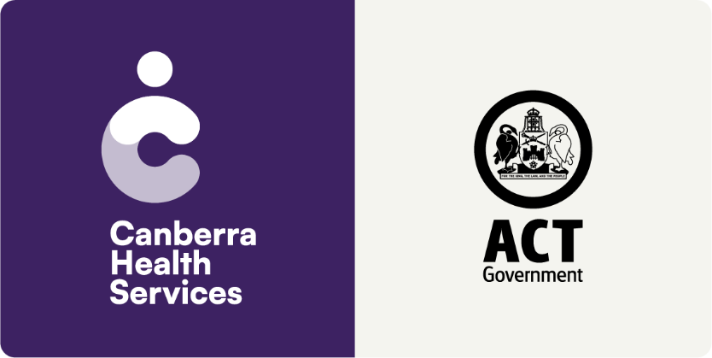

# Model of Care – Speciality Alcohol and Drug Services

Mental Health, Justice Health, Alcohol and Drug Services (MHJHADS).

August 2024, Version 1.0



#### Approvals

|  |  |  |  |
| --- | --- | --- | --- |
| Position | Name | Signature | Date |
| MHJHADS A/Executive Director | Deborah Plant |  |  |
|  |  |  |  |

#### Document version history

|  |  |  |  |  |
| --- | --- | --- | --- | --- |
| Version | Issue date | Issued by | Issued to | Reason for issue |
| 1.0 | XX | MHJHADS Executive Director Officer | Internal and external stakeholders | Public consultation |
|  |  |  |  |  |
|  |  |  |  |  |
|  |  |  |  |  |

Contents

1. Introduction 4

1.2 Background 4

1.3 Purpose of this document 4

1.4 Terminology 4

2. Vision and principles 5

2.1 Canberra Health Services vision, role and values 5

2.2 Speciality Services vision 6

2.3 Speciality Services principles 6

3. Benefits to be realised 8

4. Description of services 8

4.1 Withdrawal Services 9

4.2 Opioid Treatment Service 10

4.3 Consultation Liaison Service 11

4.4 Teams 12

5. Consumer population and eligibility 13

5.1 Withdrawal Services 13

5.2 Opioid Treatment Service 14

5.3 Consultation Liaison Service 14

5.4 Teams 14

6. Treatment and support interventions 15

7. Interdependencies 19

7.1 Legislation governing substance use treatment 20

7.2 External relationships 21

8. Monitoring and evaluation 23

8.1 Minimum data set 23

8.2 Health of the Nation Outcome Scales (HoNOS) 24

8.3 Australian Treatment Outcomes Profile (ATOP) 24

9. Workforce 25

9.1 Multidisciplinary team 25

9.2 Staffing profile 25

9.3 Accreditation and training 26

9.4 Research and collaboration 26

10. Leadership and governance 26

11. Records management 27

12. Abbreviations 27

13. References 29

14. Appendix A – Staffing Profile 30

## 1. Introduction

This Model of Care (MoC) for Canberra Health Services (CHS) Speciality Alcohol and Drug Services sets out the evidence-based framework describing the right care, at the right time, by the right staff member / team and in the right location across the continuum of care. A clearly defined and articulated MoC helps ensure that all staff are ‘viewing the same picture’, working towards common goals and most importantly, evaluating performance on an agreed basis.

This MoC:

* Outlines the principles, benefits and elements of care
* Provides the basis for how we deliver evidence-based care to every consumer, every day through integrated clinical practice, education and research
* Contains information of consumer flows (the areas from where consumers enter and exit the service) and service co-ordination, that is the linkages required for seamless consumer treatment.

A MoC is a dynamic document and will be reviewed and updated as required to support new evidence and improved ways of working. Any updates will include relevant change management principles and processes to ensure clear engagement and communication.

Detailed information on specific processes of how care is provided is outlined in operational procedures and relevant CHS policies, procedures and guidelines.

### 1.2 Background

This MoC is relevant to CHS Speciality Alcohol and Drug Services which include the:

* Withdrawal Services, which include the Withdrawal Unit and the Outpatient Alcohol Withdrawal Program
* Opioid Treatment Service
* Consultation Liaison Service
* Outpatient Medical Services (delivered by the ADS Medical Team and the ADS Allied Health Team).

### 1.3 Purpose of this document

This MoC aims to describe and guide service delivery within CHS Speciality Alcohol and Drug Services (hereafter, Speciality Services).

### 1.4 Terminology

The terms “substance/s”, “alcohol and/or other drugs” and “alcohol and other drugs” are used interchangeably in the literature. For the purpose of this MoC, the term “substance/s” or “substance use” includes alcohol, tobacco products (including vapes and e-cigarettes), licit (i.e. prescribed) and illicit drugs, medications and other substances that can be consumed, inhaled, injected or otherwise absorbed into the body with possible dependence and other detrimental effects. Substance, substance/s or substance use is used throughout this MoC in most instances where suitable.

There are also a number of terms used in the literature to describe people with substance use disorders or concerns (i.e. a person does not have a diagnosed disorder, however their substance use may be considered concerning by either themselves, their family members, carers or supporters or a health professional). For the purpose of this MoC, the term “substance use disorder” will be used to describe people with substance use disorders as well as concerns. A substance use disorder is defined as a treatable mental disorder that affects a person’s brain and behaviour, leading to their inability to control their use of substances[1]. This difficulty in managing / controlling substance use results in impairments to a person’s ability to engage within their environments, including social, functional and occupational impairments.

There are also a number of terms used in the literature to describe services which support people with substance use disorders. In order to differentiate between CHS Alcohol and Drug Services and other support services, the term alcohol and other drug (AOD) services will be used throughout this MoC.

## 2. Vision and principles

To ensure consistency across services provided by CHS, this MoC aligns with the CHS vision and values. This section provides an overview of the CHS vision, role and values. A clear vision and principles for Speciality Services which underpin this MoC are also outlined.

### 2.1 Canberra Health Services vision, role and values

Our vision and role reflect what we want our health service to stand for, to be known for and to deliver every day. The vision and role are more than just words, they are our promise to each other, to our consumers and their families and to the community. We all have a role to play in delivering on this promise:

* CHS vision: Creating exceptional health care together
* CHS role: To be a health service that is trusted by our community.

Our values together with our vision and role, tell the world what we stand for as an organisation. They reflect who we are now, and what we want to be known for. They capture our commitment to delivering exceptional health care to our community. Our values:

* We are reliable - we always do what we say
* We are progressive - we embrace innovation
* We are respectful - we value everyone
* We are kind - we make everyone feel welcome and safe.

### 2.2 Speciality Services vision

A dedicated vision for Speciality Services was developed with members of staff who work across these services. The vision provides a shared picture of Speciality Services and what they strive to deliver.

***“An expert substance use treatment service providing comprehensive and accessible care for the community”***

### 2.3 Speciality Services principles

The *National Framework for Alcohol, Tobacco and Other Drug Treatment 2019-2029* outlines six treatment principles that should underpin substance use interventions in Australia[2]. These treatment principles are used in many AOD services across Australia[3]. Service delivery within Speciality Services are underpinned by these treatment principles, which include:

1. Consumer-centred

*Treatment is tailored to the individual needs, preferences, values and goals of the consumer. Treatment recognises consumers’ diversity, and they are empowered to make decisions about their treatment planning and goal setting.*

1. Equitable and accessible

*All consumers have equal opportunities to seek and receive treatment that is suitable to their individual needs, preferences, values and goals, regardless of their presentation. There is no ‘wrong door’ to accessing Speciality Services.*

1. Evidence-informed

*Service delivery is based on the most current and emerging substance use research and evidence. Practices, policies and procedures are regularly reviewed to ensure they are reflective of evidence-based best practice in AOD service delivery.*

1. Culturally responsive

*Consumers’ cultural, ethnic and religious differences are recognised and respected. This means care is culturally responsive, safe and appropriate for every consumer engaged with Speciality Services.*

1. Holistic and coordinated

*Consumers experiencing substance use disorders often experience mental health, physical health and social concerns. Strong collaboration, partnerships and referral pathways ensure all consumer’s needs are addressed by the appropriate team in CHS.*

1. Non-judgemental, non-stigmatising and non-discriminatory

*Consumers receive care that is non-judgemental, non-stigmatising and non-discriminatory. They are treated with respect and dignity, regardless of their individual circumstances.*

Each treatment principle acknowledges the important role family members, carers and/or supporters can play within the consumer’s treatment journey, pending the consumer’s consent. In addition to the treatment principles described above, members of staff who work across Speciality Services emphasised that service delivery is also underpinned by trauma-informed care with recovery-oriented and harm minimisation approaches utilised. Thus, the three additional treatment principles for Speciality Services include:

1. Trauma-informed

*Understanding, recognising and responding to consumers’ trauma is at the core of service delivery. It is understood that the experience of trauma is unique and personal. The core trauma-informed principles of safety, trust, choice, collaboration, empowerment and respect for diversity are used in daily practice to support positive outcomes for consumers.*

1. Recovery-oriented

*Consumers’ recovery journeys are unique. In this context, recovery is defined as a process of change through which individuals improve their health and wellness, live a self-directed life and strive to reach their full potentia*l[4]. *It should be noted that recovery does not only apply to abstinence-based goals, but is more generally around health and wellbeing. It is acknowledged that recovery is possible for everyone and emphasises the importance of personal goals, hope and self-determination.*

1. Harm minimisation

*Harm minimisation is a public health approach intended to reduce the negative consequences of substance use without the consumer necessarily having to stop their use entirely*[5]*. This approach acknowledges that if consumers continue to use substances, the impacts of this use can be reduced through harm minimisation approaches.*

## 3. Benefits to be realised

This MoC aims to achieve the following:

* Improved awareness and understanding of the role and function of Withdrawal Services, the Opioid Treatment Service, the Consultation Liaison Service and the Outpatient Medical Services (delivered by the ADS Medical Team and the ADS Allied Health Team)
* Improved access to high quality, evidence-based services to support consumers with substance use disorders
* Improved consumer experience with consumers receiving the right care, in the right place, at the right time
* Improved consumer, family, carer and/or supporter engagement in care delivery
* Improved staff experience and satisfaction
* Increased positive feedback and reduced complaints received by the CHS Consumer Feedback and Engagement Team.

The range of benefits associated with Speciality Services will be assessed qualitatively and quantitatively, outlined in Section 8 – Monitoring and evaluation.

## 4. Description of services

* Withdrawal Services and the Opioid Treatment Service are located at Building 7, The Canberra Hospital (Palmer Street, Garran ACT)*
* The Consultation Liaison Service is offered to inpatients of The Canberra Hospital (TCH)
* The ADS Medical Team (hereafter, Medical Team) and ADS Allied Health Team (hereafter, Allied Health Team) provide a range of support as part of Speciality Services delivery
* All services are delivered by a team of experienced health professionals including doctors, nurse practitioners, nurses and allied health professionals including allied health assistants
* All services are voluntary
* All services aim to prevent or minimise substance use related health, social and economic harms by building safe, healthy and resilient people, families and communities, in line with the *National Quality Framework for Drug and Alcohol Treatment Services*, the *National Quality Framework for Alcohol, Tobacco and Other Drug Treatment 2019-2029*, the *National Drug Strategy 2017-2026* and the *ACT Drug Strategy Action Plan 2022-2026*.

*Building 7 is located some distance from TCH’s Emergency Department (ED). It also does not have access to a Medical Emergency Team (MET). This means the Withdrawal Unit is unable to accommodate certain presentations (i.e. those with complex physical, behavioural or mental health concerns). Current processes for the management of clinically deteriorating consumers admitted to the Withdrawal Unit is dependent on ACT Ambulance Services transfer to the ED. Once medically stable, consumers may be transferred back to the Withdrawal Unit from the ED, once approved by a member of the Medical Team.

### 4.1 Withdrawal Services

**Withdrawal Unit**

The Withdrawal Unit (WU) provides medically supervised detoxification in an inpatient setting for consumers attempting to reduce or stop their use of substance/s. The WU operates 24 hours a day, seven days a week and is located on Level 1 of Building 7. Depending on the substance/s the consumer is withdrawing from, expected length of stay in the WU is up to seven days.

The WU is a 10-bed unit, with eight of the rooms sharing a bathroom between two consumers. It also has a kitchen / dining space, a lounge area and an outdoor area. Aboriginal and Torres Strait Islander people have access to a specific room and culturally appropriate meals.

The WU provides a semi-structured educational and recreational program with the following offered:

* Individual psychosocial support
* Group therapy
* Relapse prevention education and recovery planning
* Smoking / vaping cessation
* Alcoholics Anonymous and Narcotics Anonymous meetings
* Exercise with an exercise physiologist
* Walks, yoga and Tai Chi
* Life skills, including a cooking group and financial advice
* Therapy dog
* Relaxation and mindfulness
* Referral to other CHS ADS (i.e. Counselling and Treatment Services) as well as to external AOD services.

**Outpatient Alcohol Withdrawal Program**

The Outpatient Alcohol Withdrawal Program (OAWP) allows eligible consumers attempting to reduce or stop their alcohol use to withdraw at home. Consumers participating in the OAWP are required to attend daily appointments (Monday – Friday) at Building 7, where they are reviewed by the Medical Team and assessed for a diazepam pack to take home. Consumers may attend these appointments with a family member, carer or supporter. The review includes daily breath testing to check that the consumer’s Blood Alcohol Concentration (BAC) is 0.0%, along with checking their vital signs. Generally, OAWP involvement is between four – five days. Depending on circumstances, a consumer may be offered a two day stay in the WU, followed by two or three days participating in the OAWP. If a consumer presents with a BAC above 0.0%, they may be offered an inpatient stay at the WU.

The following diagram details the typical journey for a consumer engaged with Withdrawal Services.

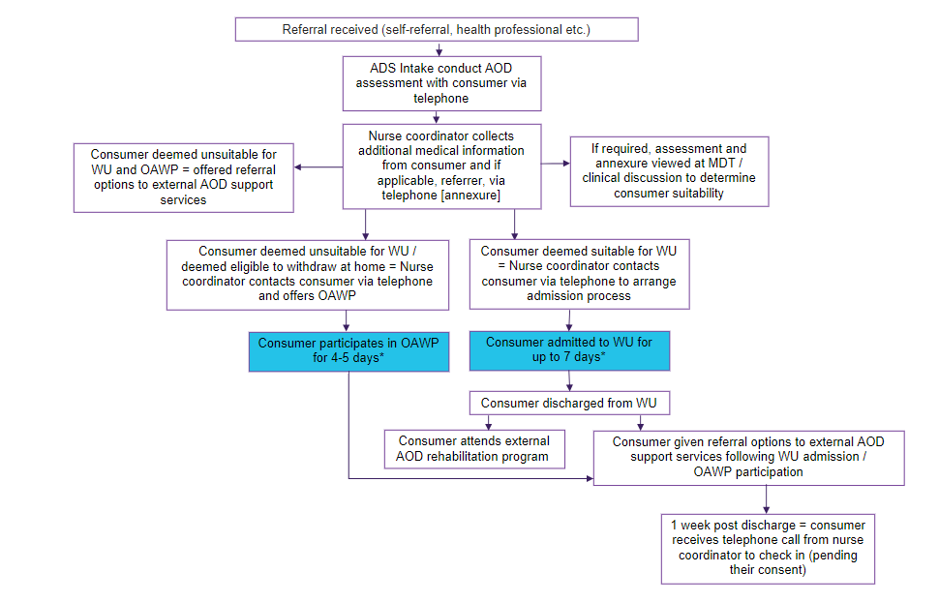

*\*Length of time in WU / OAWP may vary between consumers.*

### 4.2 Opioid Treatment Service

The Opioid Treatment Service (OTS) provides prescription and dosing of opioid pharmacotherapies, including Methadone and Buprenorphine (Suboxone, Buvidal or Sublocade), for opioid dependent people. It is located on Level 2 of Building 7.

For consumers wanting to commence on opioid pharmacotherapies, also referred to as Opioid Maintenance Therapy (OMT), the consumer is assessed by the Medical Team to determine their suitability. Following their assessment and suitability, there are three different options, known as tiers:

* **Tier 1:** The Medical Team sends the prescription to the OTS team and then the consumer regularly doses at Building 7.
* **Tier 2:** The Medical Team sends the prescription to a designated community pharmacy and then the consumer regularly doses at the community pharmacy.
* **Tier 3:** The consumer is assessed by a private prescriber (i.e. a General Practitioner) in the community and if deemed suitable, the private prescriber sends the prescription to a designated community pharmacy and then the consumer regularly doses at the community pharmacy. Tier 3 does not involve CHS ADS.

Consumers in Tiers 1 and 2 are regularly reviewed by the Medical Team while they undergo OMT, which includes an in-person review every three months at Building 7. There is no set length of time a consumer is on OMT. However, their OMT prescription may change over time, depending on their individual needs.

Dosing is available seven days a week at Building 7. Hours of dosing are available by ringing Building 7 reception on 02 5124 2591.

The OTS also provides referral to other CHS ADS (i.e. Counselling and Treatment Services, Allied Health Team) as well as to external AOD services.

For those consumers who were on OMT (specifically, Methadone or Buprenorphine – Suboxone) in the Alexander Maconochie Centre or the Bimberi Youth Justice Centre, their prescription can be used for one month following release. Consumers on Buprenorphine – Buvidal or Sublocade will need to contact ADS Intake to make an appointment to continue OMT.

The following diagram details the typical journey for a consumer engaged with the OTS.

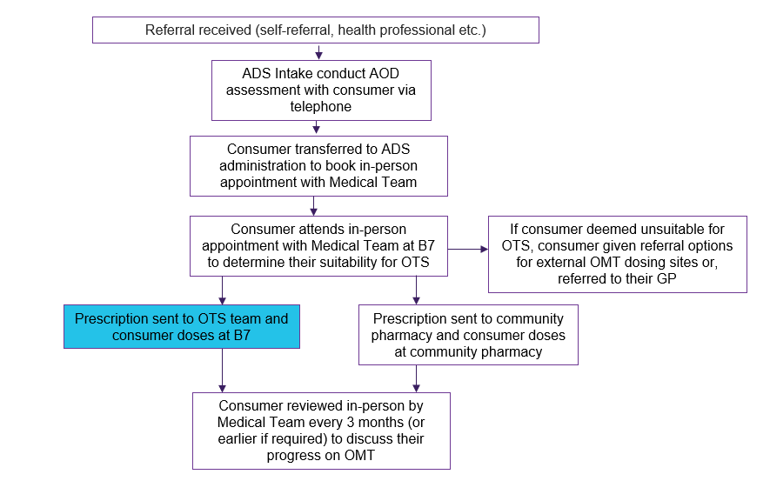

### 4.3 Consultation Liaison Service

The Consultation Liaison (CL) Service provides advice to consumers admitted to TCH who have been identified by their treating team (i.e. the team they were admitted under) as potentially benefitting from substance use support. The CL Service is a team of nurses, supported by doctors, who undertake the following:

* AOD assessments
* Relapse prevention education and harm minimisation information
* Recommendations on treatment for substance use disorders, including withdrawal support
* Referral to other CHS ADS (i.e. Counselling and Treatment Services, Allied Health Team) as well as to external AOD services.

The CL Service also provides outpatient support via the telephone to pregnant people engaged with TCH’s maternity services. The CL Service operates seven days a week.

The CL Team discuss support and referral options with the consumer and provide recommendations to the treating team to manage the consumer.

The following diagram details the typical journey for a consumer engaged with the CL Service.

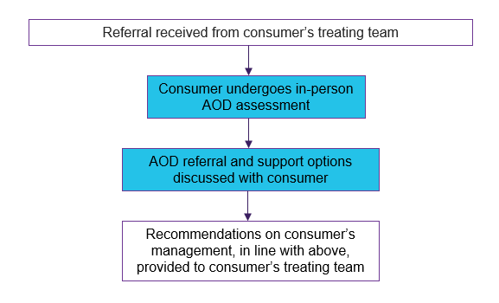

### 4.4 Teams

The Medical Team and Allied Health Team, which are part of the Outpatient Medical Services, intersect with all three Speciality Services. Key responsibilities of these teams are outlined below.

**Medical Team**

The Medical Team includes addiction medicine specialists, psychiatrists, nurse practitioners* and resident medical officers. The team are primarily responsible for:

* Conducting clinical reviews of consumers to determine their suitability for Withdrawal Services
* Conducting clinical reviews of consumers commencing on substance use pharmacotherapy (e.g. Diazepam, Methadone and Buprenorphine) as part of Withdrawal Services and OTS
* Conducting clinical reviews of consumers who are on OMT or engaging in Withdrawal Services
* Attending medical rounds as part of the WU and CL Service.

The Medical Team also provide one-off or short-term (depending on clinical indication and need) assessment and support to consumers. This includes support for consumers who present with co-occurring needs, that is, those presenting with substance use disorders and mental health conditions. Support may include relapse prevention education, harm minimisation information, recommendations on treatment and referral to relevant support services.

The Medical Team also provide a clinical consultancy service via the telephone to health professionals (within and external to TCH), providing assessments and treatment recommendations for consumers.

*Nurse practitioners are Registered Nurses with advanced tertiary clinical training at Master’s level and are the most senior clinical nurse in the health service.

**Allied Health Team**

The Allied Health Team includes psychologists, counsellors, occupational therapists, social workers and allied health assistants. The team provide inpatient and outpatient support to consumers engaged with Speciality Services. For consumers accessing inpatient treatment in the WU, the team facilitate individual psychosocial support, group therapy, relapse prevention education and recovery planning. For consumers who are accessing outpatient support following inpatient treatment at the WU, engagement with the CL Service or with the Medical Team, or, while they are on OMT, the team provide short-term psychosocial support and/or counselling for substance use. This is delivered either in-person at Building 7 (Level 2) or via the telephone and is available for up to six sessions.

## 5. Consumer population and eligibility

Specific eligibility criteria for each Speciality Service are listed below. Consumers must fulfil this criteria, in addition to consenting to participating in the relevant service / program, to be eligible.

### Withdrawal Services

**Eligibility criteria:**

* Aged 18 years and over
* Engaging in current substance use that is negatively impacting their life, and/or be dependent on the use of substances requiring medical assistance to reduce or stop use
* Have or working towards recovery goals.

**Priority access:**

* Pregnant people
* Persons who identify as Aboriginal or Torres Strait Islander
* Persons with a history of alcohol withdrawal seizures, withdrawal delirium, hallucinations or severe withdrawal syndromes
* Persons with a rehabilitation bed booked through an external provider that require a medicated detoxification prior to arrival.

**Exclusion criteria for the Withdrawal Unit*:**

* Risk of severe or complicated withdrawal that cannot be safely managed in the WU
* Withdrawing from substances where withdrawal syndrome cannot be safely managed in the WU (such as high use gamma-Hydroxybutyric (GHB) and benzodiazepine use)
* Requiring withdrawal management from opioids, except those who are on or initiating OMT
* Current acute illness or injury
* Current heightened suicide risk, such as suicidal ideation.

*\*Individual circumstances will be assessed upon receipt of referral.*

**Exclusion criteria for the Outpatient Alcohol Withdrawal Program*:**

* Risk of severe or complicated withdrawal (e.g. withdrawal seizures, withdrawal delirium)
* Current acute illness or injury
* Current heightened suicide risk, such as suicidal ideation.

*\*Individual circumstances will be assessed upon receipt of referral.*

### Opioid Treatment Service

**Eligibility criteria:**

* No age exclusion
* ACT resident
* Opioid dependent.

**Priority access:**

* Pregnant people
* Persons who identify as Aboriginal or Torres Strait Islander
* Persons released from the Alexander Maconochie Centre or Bimberi Youth Justice Centre within the last month.

### Consultation Liaison Service

**Eligibility criteria:**

* No age exclusion
* Engaging in current substance use that is negatively impacting their life, and/or be dependent on the use of substances
* Inpatient of TCH *or* pregnant people engaging in current substance use who are linked with maternity services as part of TCH.

### Teams

**Medical Team:**

* Referred by a health professional
* No age exclusion
* Engaging in current substance use that is negatively impacting their life, and/or be dependent on the use of substances and/or be at risk of relapsing.

**Allied Health Team:**

Eligibility criteria for outpatient support appointments with the Allied Health Team includes:

* Currently engaged or previously engaged (i.e. within the last three months) with Speciality Services
* No age exclusion
* Engaging in current substance use that is negatively impacting their life, and/or be dependent on the use of substances and/or be at risk of relapsing.

## 6. Treatment and support interventions

This section outlines the treatment and support interventions delivered as part of Speciality Services, depending on which service the consumer is engaged in. The goal of all treatment and support interventions is to work with the consumer to address their substance use, including the underlying reasons for use, in a safe and supportive environment. All treatment and support interventions are informed by current evidence of effective substance use prevention and treatment and are respectful of, and responsive to, the individual preferences, needs and values of the consumer. The consumer’s goals underpin all treatment and support interventions. Where suitable and appropriate (and pending the consumer’s consent), carers, family members and/or supporters are encouraged to be involved to support the consumer’s treatment journey.

6.1 AOD assessment

All consumers will undergo an assessment so their treating health professional / team can gain a thorough understanding of the consumer’s substance use, its impact on their life and their readiness for change. Consumers will be asked questions around their:

* Current and past substance use
* Social and family history
* Physical and mental health history
* Criminal and legal history
* Vulnerability to suicide, using the Suicide Vulnerability Assessment Test (SVAT) tool.

AOD assessments for Withdrawal Services and OTS are conducted by the ADS Intake Team, while AOD assessments for the CL Service are conducted by the CL team.

6.2 Additional information

For consumers entering the WU, additional medical information may be required such as recent pathology results and medical summaries. This is to ensure the consumer’s medical needs can be catered for. This information is collected by the nurse coordinator.

6.3 Withdrawal Services

Key objectives of Withdrawal Services include:

* Preventing or managing severe medical complications (e.g. seizures) that may arise from stopping or reducing use of substances
* Interrupting periods of heavy or dependent use of substances
* Reducing psychological and physical distress which can result from substance use
* Providing linkages (i.e. referrals) to ongoing treatment (e.g. counselling, rehabilitation).

**Withdrawal Unit**

While engaged with the WU, consumers have access to medical treatment to manage any symptoms of their withdrawal, as well as any medical complications that may arise from stopping or reducing use of substances. Consumers are also offered a range of educational and recreational programs as part of their withdrawal journey (see Section 4 – Description of services for full details). The educational programs, which are delivered by the Allied Health Team, include individual psychosocial support and group therapy, which incorporates relapse prevention education and recovery planning.

**Individual psychosocial support**

Psychosocial support is designed to provide practical assistance and personalised support to assist people to achieve their recovery goals[6]. This support aims to assist consumers with the emotional, social and behavioural challenges associated with substance use disorders. Depending on the consumer and their individual needs, it may involve working with the consumer to build capacity and stability in the following areas6.

* Social skills and relationships (i.e. friendships, family connections)
* Managing daily living needs
* Financial management including budgeting
* Finding and maintaining housing / accommodation support
* Vocational skills and goals
* Education and training goals
* Maintaining physical and mental wellbeing
* Building broader life skills (e.g. confidence and resilience).

Consumers are also provided with referrals to appropriate support services. The ultimate goal of psychosocial support is for the consumer to receive comprehensive care that addresses both the mental and social aspects of their substance use, ultimately supporting their long-term recovery and improving their quality of life.

**Group therapy**

Social milieu (i.e. the social environment) can be a powerful agent for change. Group therapy fosters social connection and allows for peer feedback and reflection, as well as accountability and support between consumers[7]. Consumers can share their insights about their treatment journey, expectations, challenges and progress. Group therapy sessions are structured and typically go for one hour. Evidence-based techniques and therapies will be used depending on the group, such as problem solving, motivational interviewing and Cognitive Behaviour Therapy.

**After care**

Following discharge from the WU, consumers receive a telephone call from the nurse coordinator (pending their consent). The purpose of this call is to check in with the consumer to see how they are managing (i.e. with either their integration back into the community or with their additional rehabilitation journey) and provide support where required.

**After care – Southside Community Step Up-Step Down (SC-SUSD)**

Following discharge from the WU, some consumers attend the SC-SUSD program as part of their recovery journey. Those consumers are engaged with the Allied Health Team for the duration of their engagement with the SC-SUSD program. The Allied Health Team are responsible for providing psychosocial support and/or counselling to those consumers, for a period of six weeks. The Allied Health Team’s involvement is in accordance with the following:

Inpatient SC-SUSD consumers:

* Individual psychosocial support is provided as required
* If there are any new/increased mental health concerns during the consumer’s SC-SUSD admission, SC-SUSD staff refer the consumer to CHS Access Mental Health service

Outpatient SC-SUSD consumers:

* Consumers are able to attend fortnightly outpatient appointments with the Allied Health Team, where the primary focus is relapse prevention and/or harm reduction
* If there are any new/increased mental health concerns identified by SC-SUSD staff during the outpatient treatment period, SC-SUSD staff refer the consumer to CHS Access Mental Health service
* If there are any new/increased mental health concerns identified by the Allied Health Team during the outpatient treatment period, the Allied Health Team refer the consumer to the CHS Access Mental Health service.

**Outpatient Alcohol Withdrawal Program**

Engagement in the OAWP involves a brief intervention while consumers are reviewed by the Medical Team as part of their daily appointments. Brief interventions are structured, consumer-centred and non-judgemental sessions of a shorter duration[8]. Based on a harm minimisation approach, a brief intervention aims to reduce a consumer’s risk of harm when engaging in substance use, reduce the level of use and/or, achieve a substance-free life. Further, brief interventions promote a continuum of care by integrating prevention, intervention and treatment. The purpose of brief interventions delivered as part of OAWP is to educate consumers on the harms and effects associated with substance use, including education on harm minimisation approaches, and offer referrals to relevant support services. All brief interventions are supported by self-help materials, which include ‘take home’ information on substance use and contact information for relevant support services.

6.4 Opioid Treatment Service

The OTS offers a form of substitution treatment (i.e. methadone and buprenorphine). Substitution treatment involves the prescription of a drug with similar properties to the drug of dependence, although with a lower degree of risk[9]. Receiving regular medication, in the form of methadone or buprenorphine, is designed to reduce opioid withdrawal, cravings and substance use. During dosing, consumers are opportunistically observed by the OTS team who look for any signs or symptoms of withdrawal or intoxication. For those consumers who do require additional support, such as relapse prevention, harm minimisation education or referral to support services, this is offered at the time of dosing.

Engagement in the OTS also involves a brief intervention when consumers are reviewed by the Medical Team as part of their in-person review every three months. Brief interventions are described above in the Outpatient Alcohol Withdrawal Program section.

6.5 Consultation Liaison Service

Hospital drug and alcohol consultation liaison services have a key role in the assessment and management of drug and alcohol related conditions during hospital presentations and/or during care.[10] The central aim of these types of services is to enhance the safety, clinical outcomes, quality and efficiency of services for consumers with substance use disorders in hospital settings. Further, early engagement and appropriate treatment and referral can assist in reducing complications that may arise from substance use.

6.6 Medical Team

The primary role of the Medical Team is to provide clinical oversight and direction for all consumers engaged with Speciality Services. In addition to their clinical work (e.g. determining consumer suitability for Withdrawal Services, commencing consumers on pharmacotherapy etc.), the Medical Team may provide support such as relapse prevention education, harm minimisation information, recommendations on treatment and referral to relevant support services.

6.7 Allied Health Team

For consumers accessing outpatient support following inpatient treatment at the WU, engagement with the CL Service or with the Medical Team, or, while they are on OMT, the team provide short-term psychosocial support and/or counselling, depending on the consumer’s need. Psychosocial support is outlined above in the Individual psychosocial support section (Section 6.3 – Withdrawal Services).

**Counselling**

Counselling is the most common type of treatment for problematic substance use[11]. There are many different approaches to counselling, including brief intervention (described earlier in the document). Counselling is a therapeutic intervention, designed to assist with the psychological and social challenges of reducing or managing substance use. Counselling also aims to improve a consumer’s overall wellbeing and address their related personal and social issues. Sessions are structured and typically last for one hour. Health professionals work collaboratively with the consumer in a way that respects their experience, expertise, perceptions and treatment goals. Depending on the consumer, various evidence-based techniques or therapies are used, such as, but not limited to:

* Problem solving, which involves working with the consumer to develop their problem solving skills so they can address the issues they may encounter while trying to reduce or manage their substance use
* Motivational interviewing, which involves working with the consumer to help strengthen their motivation and readiness to change. Acceptance and compassion underpin motivational interviewing
* Cognitive Behavioural Therapy, which involves working with the consumer to understand the connections between their thoughts, feelings and actions and increase their awareness for how these may impact their substance use, including their recovery.

For consumers who have needs for longer-term support, the Allied Health Team are able to assist with referral to longer-term supports, consistent with a stepped care model.

## 7. Interdependencies

In addition to Speciality Services, CHS Alcohol and Drug Services (ADS) is comprised of three other services, which include the Police and Court Diversion Service, Counselling and Treatment Services and the Drug and Alcohol Sentencing List. These are outlined in the Diversion and Therapy Services MoC. Relationships exist across all CHS ADS, which allows consumers to be referred between services and programs, where indicated and where they are eligible.

### 7.1 Legislation governing substance use treatment

All Speciality Services staff are required to comply with legislation that is relevant to AOD service delivery. In the ACT, this includes the *Human Rights Act 2004*, the *Medicines, Poisons and Therapeutic Goods Act 2008,* the *Drugs of Dependence Act 1989,* the *Mental Health Act 2015*, the *Children and Young People Act 2008* and the *Carers Recognition Act 2021.*

**Human Rights Act 2004**

The *Human Rights Act 2004* is the foundational human rights framework for the ACT. It protects and promotes the human rights of all people within the jurisdiction. In the context of AOD services, this legislation ensures that the rights of consumers with substance use disorders are respected and upheld. It sets the standard for the ethical and dignified treatment of people with substance use disorders, safeguarding their fundamental human rights. This includes rights related to privacy, dignity, freedom from discrimination and access to adequate healthcare.

**Medicines, Poisons and Therapeutic Goods Act 2008**

The *Medicines, Poisons and Therapeutic Goods Act 2008* is legislation designed to regulate the control, handling and distribution of medicines, poisons and therapeutic goods in the ACT. This legislation aims to ensure the safe and effective use of substances, promote and protect public health and safety and prevent misuse. It also aims to balance the availability of essential medicines and therapeutic goods with the need to protect people and the community from the potential risks associated with their use.

**Drugs of Dependence Act 1989**

The *Drugs of Dependence Act 1989* is legislation designed to regulate and control the use, possession, distribution and manufacture of drugs in the ACT that have a high potential for dependence and misuse. This legislation establishes a framework to manage these substances to promote and protect public health and safety.

**Mental Health Act 2015**

Many consumers engaged with Speciality Services present with co-occurring needs, that is, substance use disorders and mental health conditions. The *Mental Health Act 2015* provides the legal framework for the assessment, treatment and care of people with mental health conditions in the ACT. Its central function is to balance consumers rights and needs with the community's protection. It also aims to ensure that mental health interventions are delivered with a focus on the least restrictive interventions and respect for consumer rights.

**Children and Young People Act 2008**

Some consumers who access Speciality Services are young people (i.e. under the age of 18 years). The *Children and Young People Act 2008* provides a comprehensive legal framework for the care and protection of children and young people within the ACT. This legislation aims to ensure that any children or young people engaged with Speciality Services are safe and that their best interests are promoted through all processes and decisions.

**Carers Recognition Act 2021**

The *Carers Recognition Act 2021* is legislation that acknowledges and values the vital role of carers in the ACT. In the context of AOD services, this legislation ensures that carers' contributions and needs are integrated into the treatment and support plans for consumers. It sets the standard for involving carers in the care process, recognising their essential support in achieving positive health outcomes and enhancing the overall effectiveness and inclusivity of the services provided.

### 7.2 External relationships

Successful operation of Speciality Services relies on relationships with a range of agencies, services and organisations external to CHS ADS. These relationships ensure consumers are appropriately referred into and out of Speciality Services. Further, they ensure that consumers receive comprehensive and holistic care – meaning their recovery journey does not stop when they leave a particular service or program. Key relationships are described in the table below. It should be noted that this is not an exhaustive list.

|  |  |  |
| --- | --- | --- |
| **Agency / service / organisation** | **Primary role** | **Function** |
| **Opioid Treatment Service** | | |
| Justice Health Services | Facilitator | Detainees on OMT in the Alexander Maconochie Centre or the Bimberi Youth Justice Centre can use their prescription, obtained through Justice Health Services (division of MHJHADS) for a period of time. *See Section 4.2 – Opioid Treatment Service for specific details.* |
| Interstate opioid treatment providers | Referrer | Interstate opioid treatment providers can refer consumers who have relocated to the ACT from other states or territories to ensure they can continue on an OMT program following their relocation. |
| **All – Withdrawal Services, Opioid Treatment Service and Consultation Liaison Service (or specified)** | | |
| CHS Aboriginal Liaison Service | Support for Aboriginal and Torres Strait Islander consumers | Aboriginal Liaison Officers (ALOs) are available to provide emotional, social and cultural support to Aboriginal and Torres Strait Islander consumers engaged with Specialty Services.  If available, ALOs may assist with orientation of Aboriginal and Torres Strait Islander consumers into the WU. |
| CHS inpatient wards / departments at TCH | Referrer | Clinicians (or similar) working within inpatient wards / departments at TCH can refer their patients [consumers] to the CL Service. Pending the consumer’s consent, the CL Service can send referrals to Withdrawal Services and OTS. |
| CHS mental health teams / programs | Mental health assessment and care | Many consumers with substance use disorders also present with mental health conditions. There are times where consumers may need to be referred to these teams / programs for a more thorough mental health assessment and ongoing care. Further, there may be times where consumers are receiving care from CHS mental health teams / programs, including those who have been made involuntary under the *Mental Health Act 2015*, as well as from CHS ADS. Co-case management between the consumers’ treating healthcare teams (e.g. mental health and ADS) occurs to support the consumer to engage in both services. |
| GPs and other primary care professionals | Referrer + oversight of consumer’s physical and mental health | Referrer: Can refer consumers to Withdrawal Services and OTS.  Consumers are encouraged to regularly see a GP who can provide long-term oversight and management of their physical and mental health. |
| Private clinicians | Care and therapy post service / program engagement | Consumers may need additional counselling / therapy beyond what can be provided by Specialty Services. Private clinicians (e.g. psychologists, social workers, counsellors etc.) can provide this in an ongoing manner. |
| Non-government AOD services / programs – community and residential (e.g. Directions Health Services, Karralika Programs etc.) | Referrer + care and therapy post service / program engagement | Referrer: Can refer consumers to Withdrawal Services.  Consumers who need additional counselling / therapy beyond what can be provided by Specialty Services can be referred to these services / programs. Consumers who are not suitable for Specialty Services can be referred to these services / programs as an alternative. Further, some consumers who attend the WU transition to a residential program following their inpatient stay. |
| Non-government mental health services / programs – community and residential (e.g. Headspace, Beyond Blue etc.) | Care and therapy post service / program engagement | Consumers who need additional counselling / therapy beyond what can be provided by Specialty Services can be referred to these services / programs, particularly if additional mental health support is required. Consumers who are not suitable for Specialty Services can be referred to these services / programs as an alternative. |
| Aboriginal and Torres Strait Islander programs / services (e.g. Gugan Gulwan Youth Aboriginal Corporation, Winnunga Nimmityjah Aboriginal Health and Community Services) | Support for Aboriginal and Torres Strait Islander consumers | Aboriginal and Torres Strait Islander consumers who need additional counselling / therapy beyond what can be provided by Specialty Services can be referred to these services / programs. Consumers who are not suitable for Specialty Services can be referred to these services / programs as an alternative. |

## 8. Monitoring and evaluation

Speciality Services are committed to ongoing improvement and contributing to the evidence base to support consumers with substance use disorders. The following section details the minimum data set and outcome measures that are used in Speciality Services. Key Performance Indicators are outlined in each service’s operational procedures.

### 8.1 Minimum data set

The *ACT Data Collection for Alcohol and Other Drug Treatment Services* is mandatorily reported to the Australian Institute of Health and Welfare annually. Information collected as part of the minimum data set includes the following:

|  |  |
| --- | --- |
| **Data item** | **Frequency** |
| Enrolment date  Enrolment reason | Commencement of episode |
| Consumer type  Living arrangement  Usual accommodation  Primary drug of concern  Method of use  Consumer injecting status  Other drugs of concern  Main treatment type  Treatment delivery setting  Other treatment type  Previous treatment received  Diagnosed with mental illness  Hepatitis C treatment  Opioid overdose reversal  Nicotine replacement therapy | First service contact between consumer and treatment provider when assessment and/or treatment occur |
| End date  Closed reason | End of treatment |

### 8.2 Health of the Nation Outcome Scales (HoNOS)

The Health of the Nation Outcome Scales (HoNOS) is a brief, 12-item clinical assessment tool that rates various parameters of psychiatric symptoms and psychosocial functioning on a scale. HoNOS is used across the CHS MHJHADS division.

### 8.3 Australian Treatment Outcomes Profile (ATOP)

The Australian Treatment Outcomes Profile (ATOP) is a 22-item clinical assessment tool that assesses various parameters of substance use and general health and wellbeing over the past 4 weeks. It is a patient reported outcome measure (PROM) and clinical risk screening tool, eliciting responses directly from consumers[12].

## 9. Workforce

The Speciality Services workforce is diverse and multidisciplinary. Staff have a range of qualifications, skills, knowledge and experience to deliver comprehensive services to support consumers with substance use disorders. This section details the workforce model for Speciality Services and includes three subsections which provide an overview of the multidisciplinary team, staffing profile and workforce training requirements.

### 9.1 Multidisciplinary team

Care is delivered by experienced health professionals who are appropriately trained and passionate about working in the AOD sector. This includes staff from diverse professional backgrounds who provide comprehensive, discipline-specific and evidence-based treatment and support. This approach involves collaborative efforts and combined expertise to offer access to therapeutic interventions, holistic treatment formulation and comprehensive clinical reviews. The future peer workforce will involve active collaboration and partnership with consumers, carers, families and supporters.

### 9.2 Staffing profile

Speciality Services require a skilled workforce adept at assessing, treating and caring for people with substance use disorders. Staff include:

* Doctors (addiction medicine specialists, psychiatrists, resident medical officers and primary care specialists)
* Nurses (including nurse practitioners)
* Psychologists
* Social workers
* Counsellors
* Allied health assistants

In addition, a number of administration staff support service delivery.

Speciality Services provide opportunities for students to complete placements under the supervision of staff who meet relevant CHS and Australian Health Practitioner Regulation Agency (AHPRA) supervisor requirements.

The staffing profile is outlined in Appendix A.

### 9.3 Accreditation and training

Professional development, supervision and clinical training are essential to delivering high quality care, and adequate time and resources are provided to meet staff learning and teaching needs. This includes opportunities for supervision and establishing and promoting linkages with other AOD services to support staff development.

AHPRA and other professional bodies oversee clinical disciplines that have specific requirements for continuing professional development and supervision. Staff must adhere to these requirements to maintain their professional registration or accreditation / credentialing. CHS has also supported the continued maintenance of clinical competence for health professionals not covered by AHPRA by endorsing the National Code of Conduct for Healthcare Workers.

It is recognised that there are core skills needed by staff to provide substance use support and treatment. Speciality Services promote ongoing training and professional development for staff, including supervision, engagement with the Strengths, Engagement and Development (SED) plans, training and education based on identified areas of need and the National Safety and Quality Health Service (NSQHS) standards.

Orientation includes familiarising new staff with service components and work duties, as well as orientating them to the principles of care and culture underpinning the MoC. All new staff are provided with the MHJHADS orientation booklet as an essential element of their induction to CHS and to the MHJHADS division. All staff complete mandatory education specific to their discipline and role as per CHS, MHJHADS and local policies and procedures. It is an expectation that all staff remain current in their mandatory training and maintain currency with their annual training as identified by the organisation.

### 9.4 Research and collaboration

Speciality Services are committed to building the knowledge and evidence base in AOD treatment by contributing to and engaging in research and academic forums. Staff are encouraged to pursue post graduate qualifications relevant to substance use disorders and to participate in academic teaching and research opportunities. Quality improvement and research activities are actively sought and supported as are attendance and participation in local and national research forums and conferences. Speciality Services acknowledges it is part of a broader network of AOD services and has a role to play in contributing to national benchmarking and research activities and the body of academic literature in the field. Research and evaluation may be undertaken by staff and/or in partnership with universities with relevant ethics approvals obtained.

## 10. Leadership and governance

Speciality Services, which are part of CHS ADS, are under the governance of the MHJHADS Executive Director. The ADS Operational Director and the ADS Clinical Director are responsible for the governance of CHS ADS and in turn, Speciality Services. This can be seen in the organisational chart below.

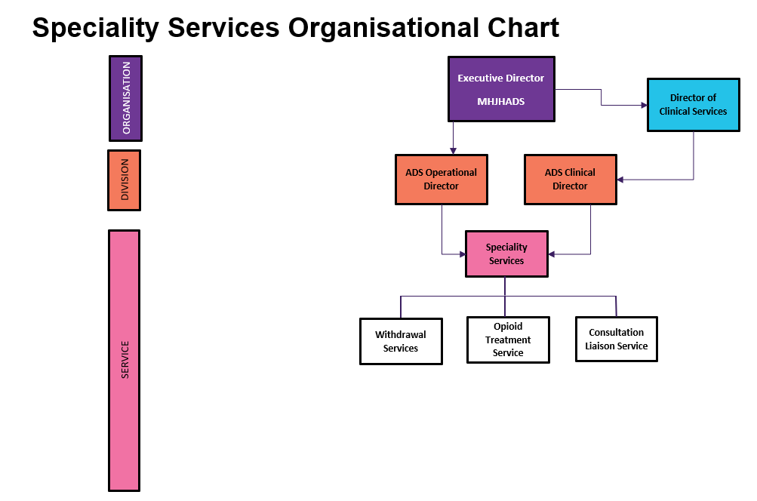

## 11. Records management

Records are managed as per the *Health Records (Privacy & Access) Act 1997* (ACT) and CHS policies and procedures. Following relevant consultation, this finalised document and any further updates will be electronically stored on the CHS intranet site – ‘Models of Care’, to ensure accessibility for all staff. The MoC will be publicly accessible through the CHS website.

## 12. Abbreviations

|  |  |
| --- | --- |
| **Abbreviation** | **Meaning** |
| ADS | Alcohol and Drug Services |
| AHPRHA | Australian Health Practitioner Regulation Agency |
| ALO | Aboriginal Liaison Officer |
| AOD | Alcohol and other drug |
| ATOP | Australian Treatment Outcomes Profile |
| BAC | Blood Alcohol Concentration |
| B7 | Building 7 |
| CHS | Canberra Health Services |
| CL | Consultation Liaison |
| ED | Emergency Department |
| GHB | Gamma-hydroxybutyrate |
| HoNOS | Health of the Nation Outcome Scales |
| MET | Medical Emergency Team |
| MDT | Multidisciplinary team |
| MHJHADS | Mental Health, Justice Health and Alcohol and Drug Services |
| MoC | Model of Care |
| NSQHS | National Safety and Quality Health Standards |
| OAWP | Outpatient Alcohol Withdrawal Program |
| OMT | Opioid Maintenance Therapy |
| OTS | Opioid Treatment Service |
| PROM | Patient Reported Outcome Measure |
| SED | Strengths, Engagement and Development |
| SC-SUSD | Southside Community Step Up-Step Down |
| SVAT | Suicide Vulnerability Assessment Test |
| TCH | The Canberra Hospital |
| WU | Withdrawal Unit |

## 13. References

1National Institute of Mental Health. (2024). *What does it mean to have substance use and co-occurring mental disorders?* Substance use and co-occurring mental disorders. Retrieved from: [Substance Use and Co-Occurring Mental Disorders - National Institute of Mental Health (NIMH) (nih.gov)](https://www.nimh.nih.gov/health/topics/substance-use-and-mental-health#:~:text=Substance%20use%20disorder%20(SUD)%20is,most%20severe%20form%20of%20SUD)

2Australian Government. (2019). *National Framework for Alcohol, Tobacco and Other Drug Treatment*. Retrieved from: <https://www.health.gov.au/resources/publications/national-framework-for-alcohol-tobacco-and-other-drug-treatment-2019-29>

3Victoria State Government Department of Health. (2024). *Alcohol and other drug treatment principles.* Alcohol and other drug service standards and guidelines. Retrieved from:[Alcohol and other drug treatment principles (health.vic.gov.au)](https://www.health.vic.gov.au/aod-service-standards-guidelines/alcohol-and-other-drug-treatment-principles)

4Substance Abuse and Mental Health Services Administration (SAMHSA). (2024). *SAMHSA’s working definition of recovery.* Retrieved from: <https://store.samhsa.gov/sites/default/files/pep12-recdef.pdf>

5Turning Point. (2007-2024). *What is harm minimisation?* Understanding addiction. Retrieved from: [What is harm minimisation? | Counselling Online](https://www.counsellingonline.org.au/understanding-addiction/What-is-harm-minimisation)

6Gold Coast Primary Health Network (GCPHN). (2024). *Psychosocial support.* Retrieved from: <https://gcphn.org.au/commissionedservices/specialist-mental-health-community-support-services-psychosocial-support/>

7Pappas, S. *Group therapy is as effective as individual therapy, and more efficient. Here’s how to do it successfully*. Monitor on Psychology. 2023. Vol 54. No.2. Retrieved from: <https://www.apa.org/monitor/2023/03/continuing-education-group-therapy>

8Mattoo, SK, Prasad, S, Ghosh, A. *Brief intervention in substance use disorders*. Indian J Psychiatry. 2018 Feb;60(Suppl 4):S466-S472. doi: 10.4103/0019-5545.224352. PMID: 29540915; PMCID: PMC5844156.

9Commonwealth of Australia. (2014). *National Guidelines for Medication-Assisted Treatment for Opioid Dependence*. Retrieved from: <https://www.health.gov.au/sites/default/files/national-guidelines-for-medication-assisted-treatment-of-opioid-dependence.pdf>

10NSW Government. (2015). The Hospital Drug & Alcohol Consultation Liaison Model of Care. Retrieved from: <https://www.health.nsw.gov.au/aod/professionals/Pages/hosp-DA-consult-moc.aspx>

11Australian Institute of Health and Welfare. (2023). Alcohol and other drug treatment services in Australia annual report. Counselling. Retrieved from: [Alcohol and other drug treatment services in Australia annual report, Counselling - Australian Institute of Health and Welfare (aihw.gov.au)](https://www.aihw.gov.au/reports/alcohol-other-drug-treatment-services/alcohol-other-drug-treatment-services-australia/contents/treatment-types/counselling)

12NSW Government. (2024). *Australian Treatment Outcomes Profile*. AoD Clinical Outcomes and Quality Indicators Program. Retrieved from: [AoD Clinical Outcomes and Quality Indicators Program | South Eastern Sydney Local Health District (nsw.gov.au)](https://www.seslhd.health.nsw.gov.au/aod-clinical-outcomes-and-quality-indicators-program)

## 14. Appendix A – Staffing Profile

|  |  |  |  |  |  |  |
| --- | --- | --- | --- | --- | --- | --- |
| Position Title | | Classification | Budgeted FTE (2024) | | Head Count (2024) | Comments |
| **Leadership** | | | | | | |
| Assistant Director of Nursing | RN 4.2 | | | 1 | 1 |  |
| Rostering Manager | RN 3.2 | | | 1 | 1 |  |
| **Withdrawal Unit** | | | | | | |
| **Nursing** | | | | | | |
| Nurse Unit Manager | | RN 3.2 | 1 | | 1 |  |
| Clinical Nurse Educator | | RN 3.1 | 1 | | 1 |  |
| Nurse Coordinator | | RN 3.1 | 1 | | 1 |  |
| Registered Nurses Level 2 | | RN2 | 6.22 | | 7 |  |
| Registered Nurses Level 1 | | RN1 | 4.84 | | 5 |  |
| Enrolled Nurse | | EN | 1 | | 1 |  |
| **Opioid Treatment Service** | | | | | | |
| **Nursing** | | | | | | |
| Nurse Practitioner | | RN 4.2 | 0.63 | | 0 | Vacant |
| Clinical Nurse Consultant | | RN 3.1 | 1 | | 1 |  |
| Registered Nurses Level 2 | | RN 2 | 6.47 | | 7 |  |
| Registered Nurses Level 1 | | RN 1 | 1.74 | | 2 |  |
| Enrolled Nurse | | EN | 0.63 | | 1 |  |
| **Consultation Liaison Service** | | | | | | |
| **Nursing** | | | | | | |
| Nursing Practitioner | | RN 4.2 | 1 | | 1 |  |
| Registered Nurses Level 2 | | RN2 | 2.27 | | 3 |  |
| Registered Nurse Level 1 | | RN1 | 0.74 | | 1 | Vacant |
| **Medical Team** | | | | | | |
| Clinical Director | | Medical Officer | 1 | | 0.6 |  |
| Consultants | | Medical Officer | 3 | | 1.9 | Vacant (x1) |
| Psychiatrist | | Medical Officer | 0.5 | | 0.2 |  |
| Registrar (Psychiatrist) | | Medical Officer | 1 | | 1 |  |
| Resident Medical Officer | | Medical Officer | 1 | | 1 |  |
| **Allied Health Team** | | | | | | |
| **Health Professionals** | | | | | | |
| Allied Health Manager | | HP4 | 1 | | 1 |  |
| Allied Health Clinicians | | HP3 | 2 | | 1.8 |  |
| Allied Health Assistant | | AHA3 | 1 | | 1 |  |
| Co-occurring Care Clinician | | HP3 | 1 | | 1 | Vacant |
| **Nursing** | | | | | | |
| Co-occurring Care Nurse | | RN 3.1 | 1 | | 1 | Vacant |
| **Administration** | | | | | | |
| Administration Officers | ASO3 | | 3 | | 3 |  |

This work is subject to copyright. Apart from any use permitted under the Copyright Act 1968, no part may be reproduced by any process without written permission from the Territory Records Office, GPO Box 158 Canberra ACT 2601.

Information about the directorate can be found on the website: [www.canberrahealthservices.act.gov.au](http://www.canberrahealthservices.act.gov.au)

|  |  |
| --- | --- |
| Icon of a moth to represent Acknowledgement of Country**Acknowledgement of Country**  Canberra Health Services acknowledges the Ngunnawal people as traditional custodians of the ACT and recognises any other people or families with connection to the lands of the ACT and region. We acknowledge and respect their continuing culture and contribution to the life of this region.  © Australian Capital Territory, Canberra 2024 | **Icon of a person inside a circle, accessibility iconAccessibility** Phone iconcall (02) 5124 0000  **Interpreter logo Interpreter** Phone iconcall 131 450  [canberrahealthservices.act.gov.au/accessibility](https://www.canberrahealthservices.act.gov.au/accessibility)  **Philadelphia Pride Flag, Transgender Pride Flag, Intersex Flag** |

1. National Institute of Mental Health. (2024). *What does it mean to have substance use and co-occurring mental disorders?* Substance use and co-occurring mental disorders.
2. Australian Government. (2019). National Framework for Alcohol, Tobacco and Other Drug Treatment 2019-2029.
3. Victoria State Government Department of Health. (2024). Alcohol and other drug treatment principles. Alcohol and other drug service standards and guidelines.
4. Substance Abuse and Mental Health Services Administration (SAMHSA). (2024). SAMHSA’s working definition of recovery.
5. Turning Point. (2007-2024). What is harm minimisation? Understanding addiction.
6. Gold Coast Primary Health Network (GCPHN). (2024). *Psychosocial support.*
7. Pappas, S. Group therapy is as effective as individual therapy, and more efficient. Here’s how to do it successfully. Monitor on Psychology. 2023. Vol 54. No.2.
8. Mattoo, S.K., Prasad, S., & Ghosh, A. (2018). Brief intervention in substance use disorders. Indian Journal of Psychiatry. Vol 60. No. 4.
9. Commonwealth of Australia. (2014). National Guidelines for Medication-Assisted Treatment for Opioid Dependence.
10. NSW Government. (2015). The Hospital Drug & Alcohol Consultation Liaison Model of Care.
11. Australian Institute of Health and Welfare. (2023). Alcohol and other drug treatment services in Australia annual report. Counselling.
12. NSW Government. (2024). *Australian Treatment Outcomes Profile*. AoD Clinical Outcomes and Quality Indicators Program.