Canberra Health Services
Nursing and Midwifery Workforce Plan
People and Culture
Workforce Strategy and Planning
2022 - 2023

Contents
CEO forward 1
Introduction 2
Development of the plan 3
Our current workforce 4
Supply analysis 5
Key drivers of workforce demand 7
Personal leave rates 7
Type 2 vacancies 7
Premium labour spend 7
Specials 8
Skill mix variants 8
Dependence of local talent pool 8
Future workforce areas of priority 9
Key drivers of workforce supply needs 9
Population growth 9
Increasing comorbidities 9
Emergency department presentations 9
Inpatient demands 9
Nurse/midwife-to-patient ratios 10
Canberra Hospital expansion 10
Digital Health Record 10
Aboriginal and/or Torres Strait Islander commitment 10
Bridging the gap in our workforce 11
Workforce opportunities 12
Development of Nursing professionalism framework 12
Foster and embed a strong culture of staff wellbeing and safety 12
Centralise workforce management 13
Career pathways 13
Clinical and corporate leadership 13
Improving systems 13
Strong marketing and talent sourcing 13
Solution formation 14
Implementation and monitor progress 15
Attachment A - Nursing and Midwifery Workforce Plan 18

Attachment B – Implementation and Monitoring 30
Attachment C – Key informing documents 33
Attachment D – Consultation process and contributors 34

CEO forward
I am pleased to introduce the Canberra Health Services (CHS) Nursing and Midwifery Workforce Plan 2022 – 2023. This plan has been designed and developed using a co-design process involving input and feedback from across the services. This plan is focused on meeting the current and future needs of the community we serve, continuing to deliver exceptional healthcare and making CHS a great place to work.
The plan has been developed to ensure that we build a sustainable workforce that is future fit and prepared for the changing pressures of healthcare delivery. In the coming years our workforce will not only need to meet the increasing service demands of an ageing population, higher rates of chronic disease and larger population but also the impacts of new infrastructure and technology.
The initiatives detailed in this plan will be implemented throughout the life of this plan focussing on:
- Attracting high calibre talent to ensure that CHS is recognised as an organisation that is seen as a great place to work. Our Nursing and Midwifery workforce are recognised as highly skilled and consummate professionals. We will live our organisations values and promote ourselves as an attractive employer.
- Recruiting through the engagement of proactive recruitment processes aligned to our strategic organisational needs. Our recruitment practices will reflect best practice and make engagement of potential applicants seamless.
- Developing our Nurses and Midwives by supporting them to achieve their career aspirations. We will provide education, research, advocacy and leadership opportunities to develop and progress the careers of every nurse and midwife ensuring that CHS offers a career not just a job.
- Retaining our Nurses and Midwives by fostering an environment that motivates our staff, encourages creative thinking, and fosters challenging opportunities, balanced with workforce stability and strong work-life benefits.
The Nursing and Midwifery Workforce Plan has been aligned to the CHS Strategic Plan 2020 – 2023 and the CHS Clinical Services Plan. Designed to solidify the foundations of this workforce, the initiatives will ensure that our workforce is well trained, supported, and well prepared for the challenges and opportunities that await us.

Introduction
The health professional’s workforce is fundamental to the delivery of quality healthcare, with nurses and midwives being the largest health professional workforce in Australia (Universities Australia, 2019) and at Canberra Health Services (CHS). They operate according to a rigorous set of standards of practice and ethical and professional conduct to delivery exceptional healthcare to the community. In recent years this workforce has faced recurrent labour market shortages as well as out-dated organisational structures that are no longer meeting the needs of a modern nursing and midwifery workforce. We also know that the workforce is ageing and is continuing to attempt to meet the increasing service demands of an ageing population.
The Canberra Health Services Strategic Plan (2020-2023) identifies one of the challenges faced by CHS is the ability to attract, recruit and retain high calibre talent. By 2023, our goal is to have a positive workplace environment by enhancing our culture, improving our attraction and retention, capability, safety and cross unit collaboration in order to deliver quality care to our patients.
A report into Australia’s health workforce indicates that there will be a significant shortage of nurses nationally by 2025 despite increases in nursing student commencement and completions (Health Workforce Australia, 2014). This is already being experienced at CHS particularly in the Midwifery and Mental Health Nursing workforce.
CHS Nursing and Midwifery workforce has grown by 11% in the past four years, however CHS recognises that the increasing regional population growth combined with an ageing population combating more complex comorbidities and chronic disease complications will place increased burden on this workforce to meet the required healthcare needs of the community (Canberra Health Services, 2021). Our future workforce demand indicates that a growing gap in our workforce particularly relating to skill mix and will continue to widen unless we as an organisation take measures to remediate this workforce. Nurses and Midwives account for approximately 44% of the overall CHS Workforce. Based on feedback throughout the development of this plan, staff have expressed a desire to be supported to work to the top of their scope of practice, enhanced professional development opportunities and greater emphasis on succession planning.
Workforce planning for this cohort is crucial to ensure that strong succession planning is in place to ensure a supported and flexible transition to retirement for our aging and retiring workforce while investing in the development of our nurses and midwives. This Workforce Plan aims to ensure that our nurses and midwives feel supported and empowered to work within their full scope of practice whilst developing new and required skills to meet the community’s healthcare needs.
Critical analysis of the feedback received through the consultation process and understanding of the challenges and opportunities captured in this document have informed the key objectives and initiatives for the nursing and midwifery workforce plan.

Development of the plan
The development of this plan is centred on the concepts of understanding the business and its strategic priorities, analysing the workforce capacity and capability required to meet the business needs and setting a direction for the future that may be planned, achieved, and measured. To ensure the workforce plan is successful, it must be underpinned with strong Governance, Leadership, and Engagement across all levels of the workforce.
Figure 1- CHS Workforce Methodology

The CHS Nursing and Midwifery Workforce Plan was developed with a focus on making CHS a great place to work for all Nurses and Midwives which is a key strategic priority for CHS in line with the CHS Strategic plan 2020-2023 and other key informing documents (Attachment C). A process of consultation with staff, managers and union representative was undertaken (Attachment D) to help identify, analyse, and develop initiatives to improve the workforce for our staff and ultimately our patients. To deliver exceptional healthcare, the Nursing and Midwifery workforce plan has been developed in line with a focus on making CHS a great place to work with the five guiding principles as outlined in the Our People Framework.

Our current workforce
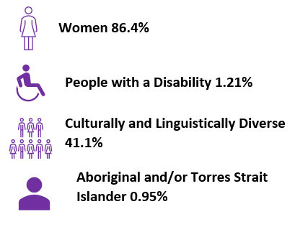
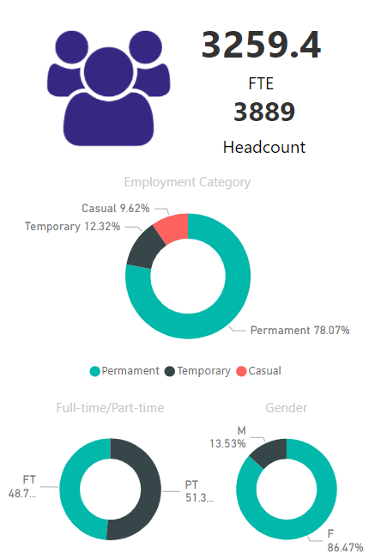

Nursing and Midwifery Workforce by role type

Supply analysis
Nurses and Midwives employed across CHS is primarily female (86.3%) with just under 50% working in a full-time capacity. This workforce mix has historically led to issues related to long term leave requiring backfill. Since July 2020, there has been 14% rise in maternity leave, however, there has been an 18% decrease in the rate of Long Service Leave being taken which is attributed to the lockdowns being experienced across the nation during 2020 and 2021. When this cohort does take Long Service Leave, individuals average a total of 265 hours per FTE, placing strain on managers to fill rosters. As a result of staff taking Maternity and/or Long Service leave, advertised vacancies are often temporary in nature. In the last two years, the workforce has had to quickly adapt to changing COVID-19 service pressures further perpetuating the increase and dependant on casual and temporary.

The dependence on casual and temporary workforce is not uncommon across the health workforce sector and is predicted to become more common. Within our own organisation there is an ongoing vacancy deficit, causing an increasing dependency on premium labour.
Nurses and Midwifes as a Health Profession are in short supply around Australia and internationally with a predicted shortfall in this workforce of 112, 983 by 2030 (productivity scenario) (Health Workforce Australia, 2014), however growth predictions undertaken following the outbreak of COVID-19 indicate that by 2025, there will be moderate growth in Registered Nursing an Midwifery roles across Australia (Labour Market Information Portal, 2020).
Within the Canberra Region a steady, if not slightly increasing, supply of Nursing and Midwifery graduates from the University of Canberra and the Australian Catholic University with 320 Nursing students and 35 Midwifery students due to graduate in 2022. COVID-19 has delayed progression in some training programs due to the availability of clinical placements, however this is expected to be resolved during 2022. In 2022, CHS increased graduate Registered Nursing employment opportunities by 11.3% to increase our baseline workforce and retained skilled workforce within the ACT.
The inherent workforce within Canberra anecdotally tends to be cyclic in nature, with a large proportion of the wider workforce moving to the region working with Federal government departments such as Defence. This can cause tenure issues for the Nursing and Midwifery workforce who arrive in the region as a partner of a cyclic workforce employee.
Recruitment in recent years indicate hiring managers dependence on recruitment from the local area with only 10% of vacancies advertised through national means. Over the last 10 years, interstate migrations to the ACT indicate an average net gain of 300 people to the population and a 4% decrease in overseas migration to the ACT (Australian Bureau of Statistics, 2021). Historical methods of attracting the required workforce have provided a net increase in 78 permanent employees in the past two years with 69% of advertised roles filled with internal candidates (table 2). Whilst this shows progression of our staff across the organisation, we are failing to attract new talent and the majority of those placed in these roles were only done so on a temporary basis.

With a high proportion of Nursing and Midwifery staff registered with the Australian Health Practitioners Regulatory Agency (AHPRA) working at CHS, we need to attract new talent to the organisation by engaging with those not already in the ACT and surrounding areas.
Since 2019, there has been an increasing trend of staff moving to part time employment from full time FTE, with 11.9% of the full-time workforce changing their work pattern to part-time. Consultation conducted throughout the development of this plan indicate that staff are choosing this option to achieve a better work life balance and the ability to manage increased work pressure. The turnover rate for Nursing and Midwifery across the organisation during FY2020/21 was 7.79% which has increased since FY 2019/20 with predictions that COVID-19 burnout will increase the retirement rate of this workforce (Bernthal-Jones, 2020).
From those leaving our workforce during the 2020-21 financial year, the top three reasons for leaving CHS were new employment opportunity, change in personal circumstances or retirement. The highest separation rates within this cohort are seen amongst Midwives, Registered Nurses working in Mental Health and Enrolled Nurses, however a significant number of casual Enrolled Nurses were recruited during 2020 in response to the COVID-19 pandemic who have since separated.
The highest separations rate for this workforce was felt within the Mental Health, Justice Health and Alcohol and Drugs Service with 19.05% of those separating having been employed in this area. This coupled with the high rate of Midwives leaving CHS, indicate that Mental Health Nursing and Midwifery are key areas of priority for workforce supply.

Key drivers of workforce demand

Personal leave rates
Personal leave amongst the Nursing and Midwifery cohort is significant with an average of 185.96 FTE monthly being absent due to personal leave (this does not include COVID related leave). The organisational average days for staff accessing personal leave is 13 days per FTE, Nursing and Midwifery staff currently 14.37 days per FTE.

Type 2 vacancies
Over the past 2 financial years the amount of Maternity, LWOP and Long Service Leave taken has increased by 13%. Across the Nursing and Midwifery workforce, an average of 6% are on long-term leave leading to a demand to backfill these vacancies. Known as Type 2 vacancies, these roles are temporary in nature and have historically been filled with internal staff. These internal movements further perpetuate Type 2 vacancy issues with 69% of all vacancies filled through internal applicants meaning a small net increase in our workforce. To resolve this issue, alternate methods to fill short term vacancies need to be considered.

Premium labour spend
During financial year 2020/21, the cost to CHS in Nursing and Midwifery overtime exceeded $11, 740, 000 and agency spend was $3, 255, 634. This equates to an average monthly cost of $1, 249, 636.

Specials
The demand for Nursing and Midwifery staff to provide specialised 1:1 care to patients has increased in recent years. Throughout the 2020/21 financial year there were 9336 recorded episodes of specialised care provided. To date in this financial year there has been an average monthly increase in the demand for specialist 1:1 nursing care by 11% against the previous year. Whilst all nursing and midwifery staff fulfill this type of nursing care, 87% of these shifts are undertaken by Assistants-in-Nursing. With only 5% of the total Nursing and Midwifery workforce comprised of AINs, this places a significant burden or effort to a small cohort of the team.

Skill mix variants
In recent years, CHS has struggled to attract appropriate skill mix of staffing in specific areas of need. This may be due to decreased local training opportunities in the Canberra region, demand outstripping supply or the inability of staff to step into more senior and/or complex roles. Significant skills deficits are known within Midwifery, neonatal intensive care, niche specialties, mental health nursing and educators to the workforce.

Dependence of local talent pool
CHS currently employs 44% of all Nurses and Midwives registered with AHPRA living in the ACT. In recent years the local education providers have shown a 111% increase in Registered Nursing graduations to 2022, however there has been a decrease in Midwifery and Enrolled Nursing graduation by 22% and 8% respectively. Indications from these providers are without an increase in clinical placement opportunities, enrolments will need to remain static. Of those that graduated in 2021, CHS offered graduate placements to 27% of local graduates YTD. Whilst CHS has strong links with local Nursing and Midwifery providers, further work needs to be undertaken in collaboration with the ACT Heath Directorate to increase clinical placement opportunities, and fund graduate placement roles across the organisation.

Future workforce areas of priority
The demand for quality and timely healthcare is a key driver for our workforce. The ACT and surrounding regions are of Australia’s healthiest communities with better health and socioeconomic indicators compared to national averages and a lower proportion of the population with chronic disease risk factors (Canberra Health Services, 2021). Between 2016 and 2019, the Australian population increased by 4.9%, comparatively Nursing and Midwifery graduates increased at five times the rate of the population (Australian Institute of Health and Welfare, 2019).

Key drivers of workforce supply needs

Population growth
The population projection for the ACT indicates an expected annual growth of 1.6% to 2030 (Canberra Health Services, 2021)

Increasing comorbidities
The growing and ageing population, coupled with rising morbidity of chronic disease means the demand for Nursing skills will be an area of continuing workforce growth in the coming years. The changing demographics of our community and the increasing prevalence of chronic diseases and mental health issues will drive the demand for nursing care to be adapted to meet the demand into more specialist areas, such as Chronic Disease management, community care and disease prevalence and enhanced scopes of practice beyond the traditional (Deloitte Access Economics, 2018).

Emergency department presentations
The CHS Clinical Services Plan (2021) indicates a predicted 4% growth annually in emergency department presentations.

Inpatient demands
The CHS Clinical Services plan predicts that CHS will experience growth in overall inpatient separations of 3% per annum (this includes multi-day and same day), with the highest growth for multi-day episodes by volume being surgical, medical, rehabilitation and aged care, mental health, alcohol and drugs and cancer (Canberra Health Services, 2019)

Nurse/midwife-to-patient ratios
The ACT Government commitment to implement mandated minimum Nurse/midwife-to-patient ratios. Phase one of this commitment commenced in February 2022 affecting general medical and surgical wards as well as acute aged care and adult mental health units at CHS. In order to meet this commitment, CHS is expected to increase of Nursing and Midwifery workforce by 55 FTE.

Canberra Hospital expansion
The Canberra Hospital is undergoing a large modernisation project across many clinical areas provide increased surgical, interventional, treatment spaces and critical care beds to the community.

Digital Health Record
The implementation of the Digital Health Record across CHS in late 2022 will have a significant impact on our Nursing and Midwifery workforce. Indications are that over 490 Nurse and Midwives will be required to act as Superusers throughout the implementation during which time they will be supplementary to the clinical workforce. The implementation is expected to take up to three months.

Aboriginal and/or Torres Strait Islander commitment
Aboriginal and/or Torres Strait Islanders have a higher impact than other Australians in relation to chronic and communicable diseases, infant health, mental health and life expectancy. CHS has made a commitment through Together Forward to improve access to services and health outcomes for these members of our community.
The key drivers of this workforce demand indicate an early growth of xx% FTE over the next xx years (CSB & DHR numbers are to be added). This assumption of workforce increase excludes the increase in population and service demand growth which will further impact the demand on our current workforce. The key drivers of our workforce demand coupled with our high turnover of staff and difficulty recruiting in the Midwifery and Mental Health sectors directs the focus the actions of the nurse and midwifery workforce into the following areas of expected growth:
- Midwifery
- Community and preventative health (including hospital in the home, critical outpatient services)
- Mental health

- Surgical and interventional areas
- Indigenous health
- Increasing our casual pool

Bridging the gap in our workforce
Discussions with staff from across the Nursing and Midwifery workforce have identified key areas that need to be addressed to grow the workforce and prepare them for the predicted growth in service demand.
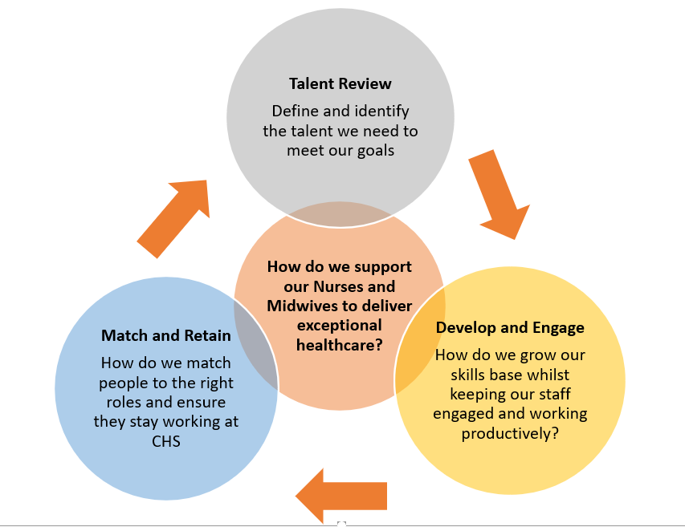

Utilising the method above, the key directions identified for attention throughout focus sessions held in 2021 were:
- Improving our culture and enabling Nurses and Midwives to be proud of the role they play in our patient’s journey
- Enabling nurses and midwives to work to the top of their scope
- Simplified recruitment processes and ability for the workforce to be more agile
- Ability for staff to move across various areas of the organisation to broaden their skills and achieve professional and personal growth.
- The need to align our training with structured career pathways that incorporate education, knowledge and experience
- Support for mid-level managers and staff through the development and application of clinical and corporate leadership programs.
- Improving our information and data systems to make caring for our patients more time effective and simpler
- Finding the best people for our roles through offering alternate ways of working and a strong marketing campaign that highlights not only the benefits of working at CHS but living in Canberra.
The feedback provided details areas of the Nursing and Midwifery workforce that CHS staff want provided to address the areas of workforce supply and demand areas of concerns.

Workforce opportunities
Every challenge provides our organisation an opportunity to assess how we are delivering healthcare and improve upon it to ensure that our patients receive exceptional clinically appropriate and best practice health care. Attachment A provides further details of the emerging opportunities for CHS and how they will benefit not only the workforce but our patients.

Development of Nursing professionalism framework
Through the development of a professionalism framework, Nurses and Midwives will be able to demonstrate what professionalism looks like in everyday practice and display to managers, patients and our community the key attributes displayed by CHS Nurses and Midwives through key attributes. The framework will enable Nurses and Midwives to deliver exceptional care through the collective evidence-based review and input to new models of care, nurses and midwives being able to work to the top of their scope to ensure quality patient experience and improvement of service delivery.

Foster and embed a strong culture of staff wellbeing and safety
Nurses and Midwives will cultivate positive workplace culture through their strong leadership and professionalism enabling work environments that are:
- Vision and values led
- Psychologically safe, focused on staff health and wellbeing and free of occupational violence and unacceptable behaviours
- Empowered to support capability development of all staff to deal with the ever changing and complex health care environments.

Centralise workforce management
By centralising key areas of workforce management, staff will be better supported to develop their skills and move across the organisation to broaden their clinical skills and knowledge. Centralisation will also allow for strategic placement of graduates; tighter management of premium labour spend the ability to align strategic workforce needs with recruitment and talent acquisition.

Career pathways
Through the alignment of training and application of strategic workforce shortages to university education within the region, CHS will work towards ensuring that staff are supported to develop their career through career pathways that incorporate education, knowledge and experience.

Clinical and corporate leadership
Partnership with the Australian National University Academy of Clinical Leadership will enable our clinical staff to improve and enhance their clinical leadership skills. The implementation of the CHS Management and Leadership program will ensure that our workforce is not only clinical competent to lead, but also have the foundational corporate skills to deliver exception healthcare.

Improving systems
The digitisation of our health records and implementation of new human resource information systems will improve our efficiency and effectiveness ensuring that our patients’ journey is reduced with better outcomes.

Strong marketing and talent sourcing
CHS offers competitive pay rates and conditions to our staff, however the benefits of living and working in Canberra need to be optimised to ensure potential candidates are aware that CHS offers job security, flexible working hours, safe working conditions and engaging and rewarding work.

Solution formation

In order to develop a nursing and midwifery workforce that is future focused and able to provide the care required to our community, we need to implement strategic objectives that will address identified issues relating to Recruitment and retention, Culture, Training and Education, Professional Practice and Contemporary Models of Care.

It is proposed that some actions detailed throughout the life of this plan be implemented quickly to effect organisation reform to meet pending strategic priorities with others being undertaken across the life of the plan due to the size of initiatives and/or complexities involved in implementation. All actions are broken down into three phases: Foundations, Building and Future Focused.

Within these phases, specific actions will be the focused to ensure the growth and stability of our workforce.

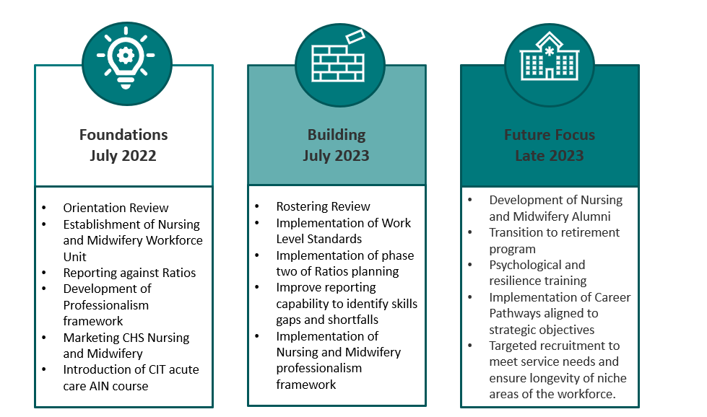

Actions that are earmarked for development and/or implementation by June 2022 are:

- Development of reporting ability for CHS to advise against compliance with Ratio’s.
- Support new nurse and midwives through reinvigoration of our orientation and onboarding processes.
- Implementation of Acute Care Assistant in Nursing students aligned with the CHS Training Strategy.
- Establishment of a centralised Nursing and Midwifery Workforce Unit to strategically coordinate all aspects of workforce management for this cohort in the coming years, including:
  - Rostering
  - Recruitment
  - Staff Mobility
  - Career progression
  - Staff Development
- Development of Nursing and Midwifery professionalism framework.
- Alignment of transition to professional practice graduates to areas of strategic workforce need.
- Development of a robust Nursebank service to reduce premium labour spend.

The implementation of each of these actions will require dedicated leadership, communication and change management processes to ensure success and engagement of the workforce. An overview of objectives is detailed at Attachment A.

Implementation and monitor progress

The implementation of actions listed within this workforce plan will be undertaken as individual projects. These projects will have a key lead with SMART measures of success so that progress may be monitored, and implementation reviewed to ensure that the actions have achieved the desired goals.

Each action will require individualised change management approach, communication strategy and risk management (Attachment C) to ensure that changes being implemented allow staff to be engaged and supported through implementation whilst still delivering exceptional healthcare at the operational level.

Attachment A - Nursing and Midwifery Workforce Plan
To ensure that we are able to deliver exception healthcare to our patients that is safe in an environment where our staff feel supported and empowered, all actions in this plan are aligned with the principles of the Our People framework, the actions are detailed below.

Principle 1 – Strong leadership and a positive workplace culture
 | Action | Attract, Recruit & Retain | Culture & Leadership | Capability | Collaboration | Safe Work | Inherent Risk Rating | CHS Lead | Key Partners | Timeframe | Measure of Success
1.1 We have leaders that are equipped to manage effectively in a complex environment | 1.1a Develop and implement training, in addition to the current Leadership and Management training, to address Nursing and Midwifery training gaps for new and emerging leaders |  |  |  |  |  | CHS Organisational  National Standards | People and Culture | EDNMPSS  DONs  ACT CNMO | December 2022 | 20% of workforce who attends and engaging in training program
 | 1.1b Implement internal communication methods that are effective, concise, and targeted |  |  |  |  |  | CHS Organisational  National Standards | EDNMPSS | All Nursing and Midwifery Staff | December 2022 | Implementation of effective and simplified communication pathway within the organisation
 | 1.1c Support new Nurses and Midwives on commencement at CHS through an intensive orientation period that includes completion of mandatory and required education and supernumerary shifts. |  |  |  |  |  | CHS Organisational | People and Culture | EDNMPSS  QSII | Feb 2023 | Development and implementaiton of structured, focused orientation and onboarding process by September 2022.
1.2 Our structural approach to the Nursing and Midwifery workforce is consistent and enables a professional workforce. | 1.2a Implement work level standards for nurses and midwives and apply them consistently across the organisation, including job evaluation, reviewing current positions descriptions and recruitment criteria |  |  |  |  |  | CHS Strategic | EDNMPSS | ACT CNMO  People and Culture | December 2022 | Endorsement and Implementation of Nursing and Midwifery WLS within CHS by December 2022.
 | 1.2b Commence the review and/or assessment of clinical skills when recruiting staff to positions. |  |  |  |  |  | CHS Organisational | People and Culture | EDNMPSS  DONs | August 2022 | Review of Selection Committee training to include clinical skills assessment throughout recruitment by August 2022
 | 1.2c Revision of key roles and functions to determine required skill mix and develop training to meet required skill mix |  |  |  |  |  | CHS Organisational | DONs | EDNMPSS  People and Culture | October 2022
 | 1.2e Development of team-based nursing models of care ensuring staff are working to the top of their scope |  |  |  |  |  | CHS Organisational | DONs  ADONs | EDNMPSSPeople and Culture | December 2022

Principle 2 – We work collaboratively
 | Action | Attract, Recruit & Retain | Culture & Leadership | Capability | Collaboration | Safe Work | Risk Rating | CHS Lead | Key Partners | Timeframe | Measure of Success
2.1 We have strong partnerships with tertiary and vocational education providers | 2.1a Provision of input to training programs for Bachelor of Nursing and Enrolled Nursing courses |  |  |  |  |  | CHS Strategic | EDNMPSS | DONs  ACT CNMO | December 2022 | Preliminary meetings to occur with relevant educational facilitites no later than December 2022
 | 2.1b Investigation into the use of pre-qualified registered nurses/nursing students being employed as Assistant of Nursing while undertaking their qualifications |  |  |  |  |  | CHS Organisational | EDNMPSS | ACT CNMO  DONs  People and Culture | July 2022 | Development of policy to engage nursing students at CHS in AIN roles by July 2022
 | 2.1c Collaboration with Universities and CIT to direct clinical placement opportunities to priority areas to build interest and sustain the workforce CHS requires |  |  |  |  |  | CHS Strategic | People and Culture | EDNMPSS  DONs  ACT CNMO | March 2023 | 20% Increase in Student placements in priority areas of the workforce (MHJHADS and WYC)
 | 2.1d Guest lecturing opportunities for CHS Nursing and Midwifery Staff at CIT and universities. |  |  |  |  |  | CHS Strategic | People and Culture | EDNMPSS  DONs  ACT CNMO | February 2023 | Development and implementation of honorary appointments and reciprocal employment at CIT/Universities to commence 2023 educational year.
 | 2.1e Encourage and support staff through the provision of honorary contracts to teach on the Enrolled Nursing program at CIT. |  |  |  |  |  | CHS Strategic | People and Culture | EDNMPSS  DONs  ACT CNMO | February 2023
 | 2.1f Commencement of nurse led research working towards promoting CHS as a centre of excellence in nurse led research. |  |  |  |  |  | CHS Strategic | EDNMPSS | ED Research and Partnership  DONs | August 2023 | Alignment with CHS Research Strategy to develop nurse led research stream
We have technology that supports our workforce | 2.1g Revision of roster practices and development of innovative rostering techniques to streamline service delivery and agility of workforce that supports budgetary freedom |  |  |  |  |  | CHS Organisational | EDNMPSS | CFO  DONs  NIMs Team  People and Culture | August 2022 | Implementation of ProAct analytics module and modification and simplification of roster templates by August 2022

Principle 3 – Attract, recruit and retain high calibre talent.
 | Action | Attract, Recruit & Retain | Culture & Leadership | Capability | Collaboration | Safe Work | Risk Rating | CHS Lead | Key Partners | Timeframe | Measure of Success
3.1 We have a workforce that is agile, with the right people with the right skills in the right place at the right time. | 3.1a Establishment of an Organisation wide Nursing and Midwifery Workforce Unit to strategically coordinate all aspects of workforce management.  This will involve the collaboration of the following elements of the workforce:  - Nursing Informatics Management Service  - Rostering  - Recruitment (including organisational wide bulk recruitment)  - Implementation of organisational wide recruitment strategies  - Collective use of merit lists to fill vacancies  - Staff Mobility and Secondments  - Placement of RN Level 1 Year 2 applicants based on strategic needs  - Transition to Practice Program  - After Hours Hospital Management |  |  |  |  |  | CHS Strategic  National Standards | EDNMPSS | DONs  ACT CNMO  People and Culture | June 2022 | 5% decrease in orgnisational wide sick leave.  Decrease in vacancy rates by 30%.  Reduction in premium labour spend by 40%  Increase in staff retention over the next 2 years.  Increase in new graduate positions consistent with service growth
 | 3.1c Ratify Nursing and Midwifery staffing levels to ensure delivery of safe healthcare to our patients across the service to meet service demand, including:  - Meeting Ratios framework  - Ability to accurately report against Nurse ratios compliance  - Review and management of leave across the organisation |  |  |  |  |  | National Standards | EDNMPSS | DONs  ACT CNMO  People and Culture | December 2022 | Review 30% of all nursing workforce models by December 2022
 | 3.1d Increase funded Enrolled Nursing placements and support transition to practice for enrolled nursing staff. |  |  |  |  |  | National Standards | EDNMPSS | CFO  All Nursing and Midwifery Staff | May 2022 | 10% increase in EN placements across the organisation
 | 3.1e Development of Nursing and Midwifery Professionalism framework |  |  |  |  |  | CHS Organisational | EDNMPSS | All Nursing and Midwifery Staff | May 2022 | Workshop to commence development to be held in April 2022
3.2 Implementation of a strong culture of succession planning and development | 3.2a Develop and implement a transition to retirement program that will support nurses and midwives as they transition out of the workplace and into retirement, embedding strong succession planning particularly in specialty or niche areas of Nursing and Midwifery. |  |  |  |  |  | CHS Strategic | People and Culture | ACT CNMO  EDNMPSS  DONs | December 2023 | Develop, implement a and promote a formalised transition to retirement program that is supported by all members of the organisation.
 | 3.2b Establish a CHS Nursing and Midwifery Alumni to:  - recognise and reward the contribution of our staff and  - to provide support and mentorship to the next generation of Nurses and Midwives |  |  |  |  |  | CHS Organisational | People and Culture | ACT CNMO  EDNMPSS  DONs | December 2023 | Commencement of Nursing Alumni in support and supernumerary roles by December 2023.
 | 3.2c Establish monthly meetings with divisional Human Resource Business Partners and Assistant Directors of Nursing to discuss HR Matters and coach hiring managers. |  |  |  |  |  | CHS Organisational | People and Culutre | Divisional EDs  ADONs | May 2022 | Regular monthly meetings established across 50% of the organisation by May 2022
3.3 We promote CHS and the ACT as a great place to work and live | 3.3a Development and implementation of CHS as a great place to work through strong positive marketing campaigns |  |  |  |  |  | CHS Strategic | CHS Communications | EDNMPSS  DONs  ACT CNMO  People and Culture | July 2022 | Development and commencement of national marketing campaign to promote living in Canberra and working at CHS
3.4 We are recognised as an inclusive organisation which represents the community that we serve | 3.4a Increase the number of identified and targeted positions across the diversity spectrum so that all staff are well represented within the workforce. |  |  |  |  |  | National Standards  CHS Organisational | People and Culture | EDNMPSS  DONs | June 2022 | 1% increase in targeted and identified roles by June 2022
 | 3.4b Provide support to staff who identify as a member of a minority sector of the community through the establishment of staff networks, mentorship and support through the Workforce Inclusion Manager and associated frameworks. |  |  |  |  |  | CHS Organisational | People and Culture | All Executive Staff | December 2021 | Development and communication to all staff detailing staff networks, including details of facilitated events

Principle 4 – Safe working environment
 | Action | Attract, Recruit & Retain | Culture & Leadership | Capability | Collaboration | Safe Work | Risk Rating | CHS Lead | Key Partners | Timeframe | Measure of Success
4.1 We ensure our workforce is safe psychologically and physically | 4.1a Provide education and support to Nurses and Midwives to ensure they have the psychological support they need when they need it through early intervention psychologists and staged debriefing coaching and programs |  |  |  |  |  | CHS Organisational | People and Culture | EDNMPSS  DONs  Workforce Resolution and Support Services | July 2022 | Implementation of Early intervention psychological services by Feb 2022.  Development and roll out of manager training to 20% of the organisation by July 2022.
 | 4.1b Development/promotion of career resilience training to ensure a robust and sustainable workforce. |  |  |  |  |  | CHS Organisational | EDNMPSS | People and Culture | July 2023 | Through the use of ACTPS led training support and encourage staff to undertake resilience training. By June 2023, resilience training will be incorporated into relevant career progression pathways.

Principle 5 – Develop the workforce capability
 | Action | Attract, Recruit & Retain | Culture & Leadership |  | Capability | Collaboration | Safe Work | Risk Rating | CHS Lead | Key Partners | Timeframe | Measure of Success
5.1 Support and Guide our Nurses and Midwives to achieve their career aspirations. | 5.1a Develop well defined career pathways for Nurses and Midwives |  |  |  |  |  |  | CHS Strategic | EDNMPSS | DONs  ACT CNMO  People and Culture | September 2022 | Implementation of career pathways for 30% of Nursing and Midwifery roles.
 | 5.1b Develop transition pathways for AINs and EN to continue their professional development to become RNs or RMs in a supported environment |  |  |  |  |  |  | CHS Strategic | EDNMPSS | DONs  ACT CNMO  People and Culture | July 2023 | Formalised pathways and support networks implemented through EDNMPSS office
 | 5.1c Development of greater staff mobility within the health service to enhance personal and professional satisfaction and enable cross divisional education |  |  |  |  |  |  | CHS Strategic | EDNMPSS | DONs  ACT CNMO  People and Culture | March 2023 | Implementation of a strategically aligned approach to staff mobility by March 2023.
5.2 Ensure our Nurses and Midwives have the skills and knowledge to provide safe quality healthcare. | 5.2a Expand the Transition to Practice Program for Nurses and Midwives to ensure the strategic placement of nurses to areas of greatest workforce demand and support second year placements. |  |  |  |  |  |  | CHS Organisational | EDNMPSS | DONs  ACT CNMO  People and Culture | September 2022 | Align second year placement of TPPP graduates to meet organisational need.
 | 5.2b Implementation of protected education time for all Nurses and Midwives |  |  |  |  |  |  | National Standards | EDNMPSS | DONs  ACT CNMO | December 2022 | Development of proactive rostering to ensure protected education time is articulated by December 2022 and implemented by July 2023.
 | 5.2c Support the development of key areas of the workforce through the strategic allocation of scholarship programs aligned to the strategic needs of the organisation |  |  |  |  |  |  | CHS Organisational | EDNMPSS | ACT CNMO  DONs | March 2023 | Identification and coordination of scholarship approval to meet strategic needs.

Attachment B – Implementation and monitoring

Risk management
The workforce risk table identifies the future workforce risk and mitigations based on information about the available workforce, projected population growth and relevant research. Based on the four levels of risk within CHS, the workforce table identifies the level of risk and a rating against the risk matrix.
The four levels of risk in CHS are outlined below:
- CHS Strategic: risks that impact negatively on our ability within CHS to deliver on our strategic priorities/plan
- CHS Organisational: risks that effect or have impact on large portions of or the entire organisation
- Divisional: risks that effect or have impact on one division’s ability to deliver at a local level
- National Standards: risks that have an impact on CHS meeting the National Standards criteria to gain service wide accreditation.
More than one level of risk may apply to an initiative.
The Risk matrix (below) consists of four levels of risk: extreme, high, medium or low.
 |  |  | Consequence
 |  |  | Insignificant | Minor | Moderate | Major | Catastrophic
 |  |  | 1 | 2 | 3 | 4 | 5
Likelihood | 5 | Almost Certain | Medium | High | High | Extreme | Extreme
 | 4 | Likely | Medium | Medium | High | High | Extreme
 | 3 | Possible | Low | Medium | Medium | High | Extreme
 | 2 | Unlikely | Low | Medium | Medium | High | High
 | 1 | Rare | Low | Low | Medium | Medium | High

Details of the risks allocated to individual initiative are detailed in the Action Plan at Attachment A.

Change management
To ensure the success of each activity detailed throughout this workforce plan, strong change management and communication strategies are key. The Prosci method of change management will be utilised throughout the implementation of projects scaled to the size of the action being implemented. The Prosci method details the requirements for change management success at an organisational level through 3 phases: Prepare Approach, Manage Change and Sustain Outcomes.
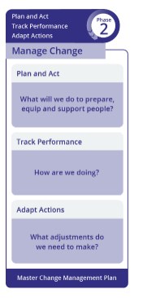
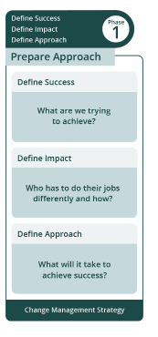
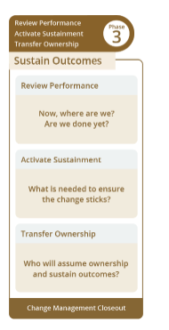

At an individual level, change will only be successfully implemented in staff understand the importance of the proposed changes, why they are happening and how they will benefit from the changes. To successful change process at an individual level the ADKAR model (Awareness, Desire, Knowledge, Ability and Reinforcement) will be utilised to equip our staff with the right information, motivation and ability to the changes proposed.
A | Awareness – Of the need for Change
D | Desire – To participate and support the change
K | Knowledge – On how to change
A | Ability – To implement desired skills and behaviour
R | Reinforcement – To sustain the change

Communication and engagement
As with each change management process, communication for individual actions will also need to be coordinated and tailored to meet the desired outcomes. Communication may be undertaken through formal and/or informal means as required to ensure engagement of the target audience. It is anticipated that the Executive Director, Nursing and Midwifery, Directors of Nursing, People and Culture and CHS Communications will be key champions in ensuring strong engagement and communications across the organisation.

Attachment C – Key informing documents

Canberra Health Services Strategic Plan (2020–2023) - The CHS Strategic Plan sets a clear path forward for the organisation to deliver against our vision of creating exceptional health care together for our consumers, their families, and carers.
Canberra Health Service Corporate Plan (2021 – 2022) – Outlines our strategic priorities for the 2021/22 Financial year

Canberra Health Services Clinical Governance Framework – is the foundation of exceptional care and it is vital to ensuring that everyone who accesses our services is safe.
Canberra Health Services Exceptional Care Framework – describes how we deliver exceptional care.
Canberra Health Services Managing Risk for Exceptional care – Risk management framework 2020-2023
Canberra Health Services Our People Framework – Defines what we mean by our strategic priority of ‘a great place to work’.
Canberra Health Services Clinical Service Plan – Outlines the future service directions and actions we intend to take to meet community expectations and service demand pressures.
National Safety and Quality Health Service Standards (NSQHS) - The NSQHS provide a nationally consistent statement of the level of care consumers can expect from health service organisations. Six specific actions to meet the needs of Aboriginal and Torres Strait Islander peoples have been included in the second edition of the NSQHS.
Nurse/Midwife to Patient Ratios Framework (TBA)
ACTPS Nursing and Midwifery Enterprise Agreement 2020-2022

Attachment D - Consultation process and contributors
In order to engage such a large workforce, a variety of formal and informal methods were utilised to hear what our Nurses and Midwives felt were our greatest challenges and our opportunities.
Dedicated sessions were undertaken with Directors of Nursing (DONs) at various stages throughout the development of this plan. At these sessions, the DONs were involved in the development of the direction of the workforce plan, hearing feedback from the workforce and guiding the future direction for this cohort.
Focus groups were also held throughout the first half of 2021. These sessions were open to all staff to attend as well as Union delegates. 18 two-hour focus groups were undertaken across various areas of the organisation (listed below) with 7% of the workforce attending these sessions.
In addition, various online surveys were utilised for staff unable to attend focus group sessions to gauge the issues and future opportunities of the workforce. This resulted in an additional 10% of this workforce providing feedback and thoughts in relation to the workforce planning for this cohort.
Attendees and contributors to this plan came from the various areas listed below.
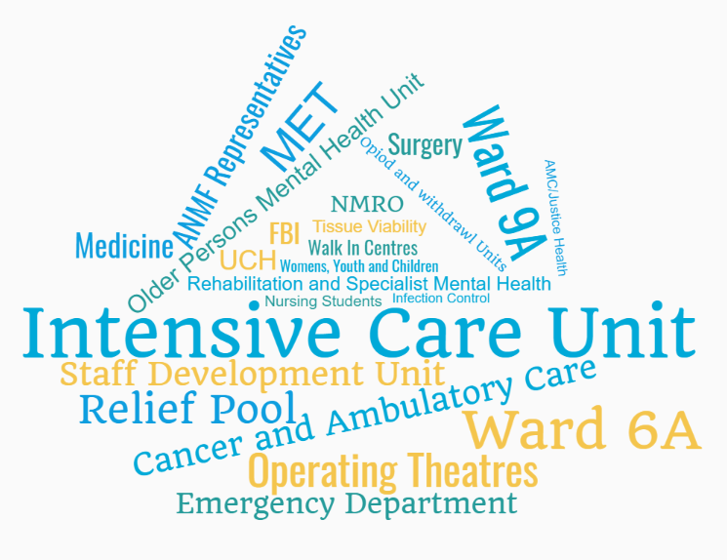

Acknowledgement of Country
Canberra Health Services acknowledges the Traditional Custodians of the land, the Ngunnawal people. Canberra Health Services respects their continuing culture and connections to the land and the unique contributions they make to the life of this area. Canberra Health Services also acknowledges and welcomes Aboriginal and/or Torres Strait Islander peoples who are part of the community we serve.
Accessibility (how to get this information in other ways)
If you want to receive this information:
in larger print
or hear it in audio
please telephone (02) 5124 0000.
If you need translating and interpreting service – please telephone 131 450.
National Relay Service phone 133 677 then ask for 133 427.
For further accessibility information, visit: www.health.act.gov.au/accessibility
The ACT Government is committed to making its information, services, events and venues, accessible to as many people as possible.
www.health.act.gov.au | Phone: 132281 | Publication No XXXXX
© Australian Capital Territory, Canberra xxxxxxx 2021

