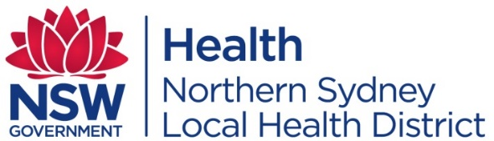

Mr Gerard Hayes
The General Secretary
Health Services Union (HSU)
Level 2, 109 Pitt Street
Sydney NSW 2000

Via email: info@hsu.asn.au; Matthew.Ramsay@hsu.asn.au
Attention: Matthew Ramsay

Dear Mr Hayes,

RE: NSLHD Child and Youth Mental Health Service – Hornsby Northern Beaches Service Restructure Proposal

I write with reference to a proposed restructure of the Northern Sydney Local Health District (NSLHD) – Mental Health, Drug and Alcohol, Child and Youth Mental Health Service Hornsby Service Structure.
This involves the proposed split of the Hornsby and Northern Beaches sectors, with the creation of an additional Service Manager position. It is proposed that this new position will be responsible for the management of the Hornsby Sector, and the current Service Manager position will retain responsibility of the Northern Beaches Sector.

I invite you to provide any feedback, comments, questions or concerns on this proposal. The consultation period will run for two weeks from the date of this letter. Feedback can be emailed to Ayisha.Chitakunye@health.nsw.gov.au.

I wish to confirm the Australian Salaried Medical Officers’ Federation NSW (ASMOF), NSW Nurses and Midwives Association (NSWNMA) and Child and Youth Mental Health Service staff have been provided with this proposal on the same date as this letter.

Further, in accordance with the NSW Health Policy Directive Consultative Arrangements (PD2019_059), I wish to extend the opportunity for a Union Specific Consultative Committee (USCC) meeting to discuss the proposal in detail (if requested or deemed required).

I wish to advise if you do not provide any feedback on the proposal within the two weeks from the date of this letter it will be deemed there are no concerns with the proposal, and I will progress to implementing the restructure accordingly.

Thank you for your support in advance. If you require any additional information, I can be contacted at Ayisha.Chitakunye@health.nsw.gov.au. Alternatively, Danielle Chidiac, Senior HR Business Partner, can be contacted at Danielle.Chidiac@health.nsw.gov.au.

Yours sincerely

Ayisha Chitakunye
Service Director, Child and Youth Mental Health Service
NSLHD Mental Health, Drug and Alcohol

Date: 21November 2022

Attachments: Child and Youth Mental Health Service Restructure Consultation Paper
Current NSLHD Child and Youth Mental Health Service Organisational Chart
Proposed NSLHD Child and Youth Mental Health Service Organisational Chart
NSLHD CYMHS Service Manager PD

