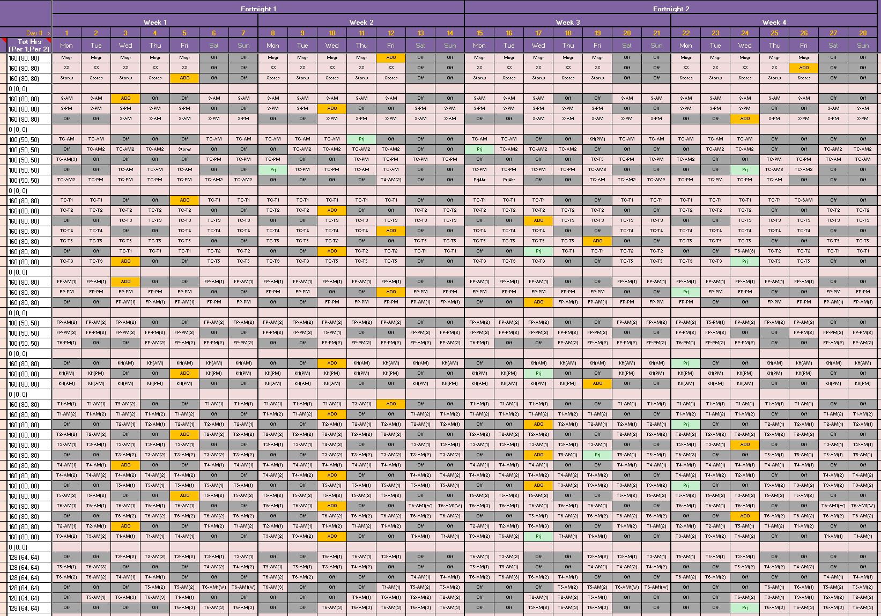

Master Roster V5 Sept 2020

