Canberra Health Services
Consultation Paper

CHS Nursing and Midwifery Workforce Plan
People and Culture

Background
Canberra Health Services (CHS) is focussed on the delivery of high quality, effective, person-centred care. It provides acute, sub-acute, primary, and community‐based health services to the Australian Capital Territory (ACT)—a catchment of approximately 400, 000 people. It also services the surrounding Southern New South Wales region which includes the Bega Valley, Bombala, Cooma-Monaro, Eurobodalla, Goulburn, Mulwaree, Palerang, Queanbeyan, Snowy River, Upper Lachlan Shire and the Yass Valley.
In order to do this, we need to grow and develop a sustainable workforce that is future fit and prepared for the changing pressures of healthcare delivery. In the coming years our workforce will not only need to meet the increasing service demand of an ageing population, higher rates of chronic disease and larger population but also the impacts of new infrastructure and technology.
A workforce plan for Nursing and Midwifery is crucial to ensure that strong succession planning is in place to ensure a supported and flexible transition to retirement for our aging and retiring workforce while investing in the development of our early and mid-career nurses and midwives. This Workforce Plan aims to ensure that our nurses and midwives feel supported and empowered to work within their full scope of practice whilst developing new and required skills to meet the community’s healthcare needs.
To meet these challenges, CHS has developed the Nursing and Midwifery Workforce Plan (Attachment A) to outline our current challenges, future opportunities and plan to address and meet the ever-changing demands on our workforce to ensure that they are able to deliver quality care and meet their career goals.
Whilst the plan has been developed to address common issues across the organisation, there will be a focus on the following areas within CHS to match expected areas of growth:
- Midwifery
- Community and preventative health (including hospital in the home, critical outpatient services)
- Mental Health
- Surgical and interventional areas
- Indigenous health
- Increasing our casual pool
- Intensive Care
- Emergency Nursing

To ensure that our goals are achievable, they have been broken into three phases for implementation across the life of the plan. These phases with key actions are detailed below:
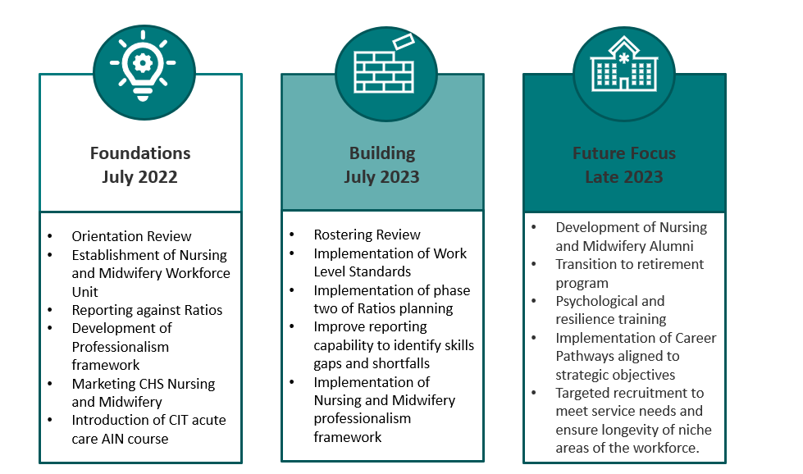

Purpose
The CHS Nursing and Midwifery Workforce Plan, including methodology, development, implementation, and measures of success is attached. The purpose of this paper is to invite feedback from all stakeholders to the plan and those that have contributed to the plan to ensure:
- The plan reflects the current state of our workforce
- The actions detailed within the plan are relevant and are designed to improve the attraction of staff to CHS, enhance the development of our current staff and ensure that we are able to retain staff once they commence with CHS.
- That the future demands detailed for this workforce are captured and addressed.
- The actions detailed within the plan, will improve the sustainability and attraction of nurses and midwives to CHS.

Consultation
Whilst this plan has been developed through focus groups, surveys, and discussions with various staff, Manages, ANMF Representatives, your feedback, suggestions and questions will assist in further refining the direction of the plan.
Consultation is open to all internal and external stakeholders.
Feedback is to be in writing and emailed to CHS.WorkforcePlanning@act.gov.au.
Feedback is due by 5.00pm Friday 25 March 2022.

