.
RETURN TO WORK PROGRAM
STATEMENT

Alino Living is committed to preventing injury and illness in the workplace and supporting the recovery of our workers from work related injury & illnesses in accordance with the State Insurance Regulatory Authority’s (SIRA) Guidelines for workplace Return to work Programs and as required under the following legislations;
- WHS Act 2011 & WHS Regulations 2017
- Workers Compensation Act 1987
- Workplace Injury Management and Workers compensation Act 1998
- Workers Compensation Regulations 2016

Alino Living recognizes the substantial benefits to be gained from rehabilitation principles and practices and is committed to implementing them in the workplace. We support a flexible approach to this return-to-work program so that, where reasonably able, the rehabilitation needs of an individual can be accommodated. Alino Living endeavors to promote the Health Benefits of good work to drive a positive workplace culture for workers and those recovering at work. (further information can be found at www.racp.edu.au)

The Health & Safety at work is a shared responsibility between Alino Living and its workers. When an injury occurs, contributing factors will be identified Through incident investigation processes. Alino Living will review its WHS policies and procedures in order to identify the gaps and implement improvement strategies to reduce the risks of injury reoccurrence. This return to work program will be reviewed every 2 years by the Return to work Co-Ordinator in consultation with staff and Unions and available for staff to access electronically at their desire via ACE intranet.

DEFINITIONS

Workers Compensation: A System that provides support and assistance during recovery of a work related injury or illness. Workers Compensation includes payments to workers to cover their wages while they are not fit for work and medical expenses and rehabilitation associated with the injury/illness. The worker, Treating Doctor and insurer case manager will act as your support team sometimes in collaboration with a Rehabilitation Provider to tailor a return to work program to assist in your full recovery. Workers Compensation payments are calculated by the insurer using a formula and the injured workers pre-injury average weekly earnings. Further information can be accessed on the SIRA website www.sira.nsw.gov.au
Worker: Under the Workplace Injury Management and Workers Compensation Act 1998, a worker is defined as a person who has entered into or works under a contract of service or a training contract with an employer (whether by way of manual labour, clerical work or otherwise, and whether the contract is expressed or implied, and whether the contract is oral or in writing).
Significant Injury: Defined in (Section 42) of the Workplace Injury Management & Workers Compensation Act 1998 as a workplace injury that is likely to result in the worker having incapacity for work (whether total or partial) for a continuous period of more than seven days
Recover at Work/Return to Work Co-Ordinator (RTWC): This a competent person with the relevant training, skills and experience to co-ordinate the return to work of an injured employee.
NTD: A nominated treating doctor (NTD) is the medical practitioner nominated by an injured worker (normally a GP) to manage a workers’ recovery from injury and to assist in their safe return to employment.
Injury Management Plan (IMP): This is a plan developed by the Insurer for managing all aspects of getting an injured worker the treatment and rehabilitation they require to allow them to return to work in a timely and safe manner. This includes treatment, rehabilitation, re-training, claims management and employment management.
Rehabilitation Provider: An approved workplace Rehabilitation Provider must be deemed suitable by SIRA to offer specialized recovery services that assist an injured worker to return to work. Workers can choose an approved rehabilitation provider of their choice or select the employers nominated provider.
Suitable Duties: These meet an workers capacities, skills and experience, taking into account any medical limitations. Providing suitable duties may involve modifying duties, providing alternative ones or changing hours while on a return to work plan.
Injury Management Consultants (IMC’s) are facilitators who will assist Insurers, workers, and Treating Doctors to find solutions to relevant issues within the Return to Work Plan (Recover at Work Plan).
Icare: (Insurance & Care NSW) delivers insurance and care services to the people of NSW, under the states’ Workers Compensation Scheme. Icare supports the long-term care needs of injured workers to improve their quality of life outcomes, including helping people return to work.
EML (Scheme agent) is the scheme agent tasked with managing the day to day running’s of the claim on behalf of Icare. A claims manager is appointed to each individual claim as the contact on behalf of the insurer.

Legislation References In NSW: we are bound by a number of Legislative Acts & Regulations concerning Work Health & Safety and Workers Compensation.

Act:
Work Health and Safety Act 2011 (NSW)
Workers Compensation Act 1987 (NSW)
Workplace Injury Management and Workers Compensation Act 1998 (NSW)
Regulation:
Work Health and Safety Regulation 2017 (NSW)
Workers Compensation Regulation 2016 (NSW)
Codes: NSW Codes of Practice
Regulator:
State Insurance Regulatory Authority (SIRA) regulates the workers compensation scheme in NSW
SafeWork NSW – Regulates work health and safety in NSW

Further to this, the Workplace Injury Management & Workers Compensation Act 1998 along with the Workers Compensation Regulation 2016
Aim to:
- assist in ensuring the health, safety and welfare of workers especially when it comes to preventing work-related injuries
- facilitate the prompt treatment & management of injuries, to enable injured workers to return to work as soon as possible
- provide injured workers with income support during their injury, payment for permanent impairment or death, and payment for reasonable treatment and other related expenses

WORKPLACE ARRANGEMENTS

Alino Livings Nominated Return to work Coordinator is:
Jakara Gasson
Safety & Wellness Co-Ordinator
Lake haven Court - 5 Stratford Avenue Charmhaven
Phone: 02 4394 0555 Email: jgasson@alinoliving.com.au
Or if not available,
Kylie Clifford
People Experience Co-Ordinator
Lake haven Court - 5 Stratford Avenue Charmhaven
Phone: 02 4394 0555 Email: kclifford@alinoliving.com.au

Alino Livings nominated and preferred Rehabilitation Provider is:
SIS Rehab
Address: 62 O’Connell Street, Parramatta NSW 2150
T: 1300 790 713 | F: 02 9890 8330
Email: Info@sisrehab.com info@sisrehab.com
Web: www.sisrehab.com
*The injured worker will be consulted on rehabilitation involvement and alternatively may decide to nominate their own preferred provider.

Alino Livings nominated Insurance broker is:
Warren Saunders
Address: Level 2, 550 Princes Hwy, Kirrawee NSW 2232
T: (02) 9587 3500
Email: tashh@wsib.com.au
Web: www.warrensaudners.com.au

RESPONSIBILITIES

Role of Recover at work/ Return to work Coordinator:
The RTW Coordinator is the representative for Alino Living in providing workplace based rehabilitation and recover at work strategies.
The RTW Coordinator will be involved in all aspects of the workplace based rehabilitation and is the first point of contact for the injured worker, and the workers managers and is responsible for:

- Compile the initial notification and related information and notify Insurer/Claims Manager directly, of a workplace injury with 48 hours of Alino Living becoming aware. The 48 hours, is inclusive of any form of notification to direct managers/supervisors, and should be communicated in a timely manner to the RTW Co-Ordinator.
- Provides information to injured workers regarding the process, obligations of all key parties, worker rights (including disputes) and the recovery at work process.
- Inform the Worker of the procedure that the Worker must follow should they wish to change their Nominated Treating Doctor.
- Consult with the Worker, and Nominated Treating Doctor when referring to a Rehabilitation Provider. They must inform the Worker that they have the right to select their own Rehabilitation Provider (NSW). The injured worker can request to select their preferred choice of rehabilitation services by contacting the insurer who will assist in selecting an approved provider of choice
- Development and management of recover at work plans in consultation with the NTD, rehabilitation provider (if involved), the manager/Supervisor and the worker.
- Document the workers capacity and the duties available in line with their medical restrictions (if any), goals, timeframes and review dates.
- Maintaining communication and transparency between injured workers, management, treatment providers and the claims manager
- Participation (if required) in case conferences with NTDs, while also allowing injured workers due privacy in their consultations with their NTD
- Implementing the RTW program
- Keeping injury and recover at work statistics
- Keeping confidential case notes and records in line with laws and guidelines
- Promoting the health benefits of good work to the workforce
- Contribute to the improvement of relevant policies and systems (reviewed annually)

Role of direct Manager/Supervisors:
- Notify RTW Co-Ordinator immediately, once becoming aware of injury on behalf of the injured worker, whether a formal report, verbal or written.
- Provide supervision and support to the injured worker in the workplace
- Ensure the worker is complying with the Recover at work plan when completing suitable duties and raises any concerns with the RTW Coordinator
- Maintain regular contact with the RTW Co-Ordinator
- Participate in Case conferences and/or medical reviews with the RTW Co-coordinator, injured worker and NTD or Rehabilitation Case manager when required for the purpose of identifying additional and/or ongoing suitable duties at each step of the plan.
- Maintain regular contact with the worker, to ensure consistent support during the recovery process

Role of Employer:
- Ensures that reasonable access to the workplace and injured workers is provided to all key parties
- Appoints a RTW Co-Ordinator with relevant skills and training to provide support to injured workers during their recovery process and liases with the workers support team
- Ensures the Organisation holds correct and valid Workers insurance policy
- Maintains a compliant return to work program, that is easily accessible to all workers and is reviewed through consultation processes every 2 years
- Maintains records of all work-related injuries I.e. register of injuries
- Provides suitable alternative duties as far as is practicable when a worker is unable to return to work
- Maintains a workers confidentiality
- Promptly passes on any payments/entitlements received by the insurer for the worker
- Improves relevant policies and systems where possible and promotes the health benefits of good work to the workforce

The Insurer/Claims manager is required to:
- Ensure Employers are made aware of their legislative obligations in relation to the Insurer’s Injury Management Plan
- Make early contact with the worker, employer and nominated treating doctor after receiving notification of a claim to determine appropriate assistance required to the worker
- Authorizes and arranges payment for “reasonably necessary” medical and related expenses and vocational programs (where appropriate)
- Determines the workers payment entitlements under a worker's compensation claim and commences such payments with employer to meet their obligations to support the worker during their recovery.
- Arranges assessments or services to help determine a workers capacity or fitness for work, or identify suitable employment
- Monitors the progress of rehabilitation cases and completes formal reviews where required

The Treating Doctor is required to:
- Access the workers injury and provide immediate medical intervention to assist to worker to recover
- Determine and advise the workers capacity of work, and documents a certificate of capacity outlining any work restrictions
- Recommend appropriate medical and other treatment that will help the worker recover from their injury
- Regularly review the workers capacity at least every 28 days, and adjust the certificate of capacity as required based on the workers ongoing recovery goals. In some case this may be greater than 28 days
- Communicate the workers treatment and recovery needs to the RTW Co Ordinator and their support team
- Provide information to the Insurer and Employer to assist in the development of the workers Injury management plan
Approved Rehabilitation Provider will:
- Conduct workplace or functional assessments to determine detailed information about workers capacity, available suitable work options and pre injury work
- Communicate regularly with the worker, NTD and RTW Co-Ordinator to establish suitable recovery goals and develop an achievable recover at work plan. This may be regularly updated to suit the workers evolving recovery goals and updated capacity
- Collaborate with the workers support team to identify barriers and strategies to reduce any barriers to tailor a workers recover at work plan
- Provide advice on suitable changes to work environment or work process to reduce work demands
- Communicate with the worker and employer to educate about their obligations and/or health benefits of work and managing injury in the workplace
- Conduct vocational assessments to identify, prepare and assist a worker in seeking and obtaining suitable employment options with a new employer where appropriate

The Insurance Broker will:
- Provide support to the RTW Co-Ordinator at a strategic/high level with Alino's claims & work with the business to ensure the correct strategy is in place when claims aren’t kept on track by the scheme agent.

Rights & Obligations of the injured worker:
If a workplace injury/illness occurs the injured worker must:

- Seek first aid if required
- Notify management immediately and complete an incident report. If unable to, it must be provided to Manager/supervisor/RTWC as soon as possible
- Seek medical advice from a nominated doctor and provide the employer and insurer with a certificate of capacity as soon as able to. A certificate of capacity needs to be provided for the entire period of the injury/illness until deemed no further medical reviews required (worker would be fit to perform full pre-injury duties and medical treatment and reviews have ceased).
- Remain in contact with the RTWC and provide updates of any changes that occur
- Actively participate in the development and implementation of their recover at work planning
- Attend all medical and treatment appointments outside of working hours where possible, to minimize disruption to the working day, unless otherwise agreed by the Manager/RTW Coordinator
- Participate in doctor’s reviews, case conferences, return to work meetings and any other meetings arranged for the management of the injury/illness.
- Make all reasonable efforts to return to their usual work or suitable work in some capacity in accordance with medical advice
- You must immediately notify Alino Living if you engage in any secondary or voluntary employment.
- You must notify your RTWC and insurer should your place of residence or phone number change or if you will be uncontactable (i.e.. Holiday or sickness not related to the injury/illness).

Workers have the right to:
- Nominate their own treating doctor and rehabilitation provider
- Undertake duties that are both suitable and, so far as reasonably practicable, the same or equivalent to their pre-injury role (where possible)
- Be consulted and involved in identifying suitable roles and developing their recover at work plan
- Privacy and confidentiality
- Access mechanisms for resolving complaints and disputes
CONSENT & PRIVACY

The Employer acknowledges that all information concerning an injured worker is confidential and is to be handled in accordance with the appropriate requirements, Privacy and personal information Protection Act 1998 and the health records and information Privacy Act 2002 and will only be disclosed in accordance with the Workers Compensation Act 1987.

The injured worker is to complete the provided consent form on who they wish information to be obtained from and / or released to.
Examples of those to whom information may be released include the following:
- Worker's manager or Supervisor
- Insurer
- Insurer broker (Warren Saunders)
- Rehabilitation provider
- Medical Practitioner NTD
- Other specified treatment providers
- Alino Living Solicitors acting on behalf of the Employer or the Insurer.
Injured workers can gain access to their own rehabilitation information by contacting the Return to Work Co-Ordinator. Copies of documents supplied by the Insurer will not be released without first obtaining the agreement of the Insurer.

Alino Living promotes active and open communication and transparent decision-making between the worker, the RTW Co-Ordinator and the support team to increase adherence to treatment, improve long term outcomes, hasten recovery and reduce emotional distress

The RTW Co-Ordinator will make initial contact with a worker when made aware of an injury via phone and will verbally inform the worker of all relevant information, including consent to the release and exchange of information relating to their injury or illness. The RTW Co-Ordinator will provide an Injured at Work information pack either via email or paper based to the worker that includes the consent to release information form, as well as an injury management flow chart and an information brochure, (a quick guide to workers compensation) (See attachments 1,2,3)
This consent should be returned to the RTW Co Ordinator as soon as possible to ensure effective communication between the nominated support team.

The worker may refuse or withdraw consent at any time in writing to the RTW Co-Ordinator or nominated Insurer claims manager, with informed knowledge that this could affect support entitlements. Workers are encouraged to discuss their concerns with the RTW Co-Ordinator or insurer directly.

All information regarding a Workers’ Compensation Claim will be held in a secure electronic platform called Airtable and separate to the location of the injured Worker’s electronic personnel file. Access to this information will be limited to management directly involved in the rehabilitation process and the RTW Co-Ordinator.

Information regarding an injured worker (or rehabilitation information) includes the following:
- Rehabilitation progress and case notes
- Rehabilitation assessments and reports
- Rehabilitation documents such as:
- Referral/approval for occupational rehabilitation services
- Return to Work and Injury Management Plans
- Rehabilitation progress reports
- Invoices for occupational rehabilitation services
- Documents and progress notes prepared by the Return to Work Co-Ordinator that relate to an employee's rehabilitation.

UNIONS

Unions may help an injured worker who is a member in relation to dispute prevention and resolution regarding the return to work program and injury management process or for further industrial advice and support. Alino Living will consult with Health services Union NSW/ACT/QLD during the development or review of this return to work program, via email and/or face to face meetings to ensure all workers needs are met.

CONSULTATION

All workers across Alino are consulted at each review of the return to work program every 2 years via the ACE intranet. Electronic notifications are sent to all workers when a draft Return to work program is reviewed and uploaded to ACE. Workers will have 2 weeks (or as specified when uploaded) to review the draft RTW program and provide feedback directly via ACE, in the comments section of the draft or via direct email to the author, the RTW coordinator. Alino Living will consider all feedback provided by its workers. The RTW program will then be provided to the Alino Living Board of Directors, who will complete final review and approval. The final approved version will then be distributed to all workers via ACE, with automatic notifications sent, to review, acknowledge and accept the final RTW program. ACE maintains an electronic record of all uploads, distributions, comments, and acknowledgments by workers of the RTW Program.

TRAINING & EDUCATION

Regular training and education relating to the RTW Program and Incident Injury Reporting is provided to all workers.
This is delivered in the following ways:
- Company wide inductions for new staff are held monthly. RTW Co Ordinator presents WHS/RTW education face to face
- Staff meetings at each Alino Site, held bi monthly and facilitated by available members of the executive team
- Annual Mandatory training completed electronically via Altura Learning
- Updates delivered electronically via internal intranet ACE as required

The RTW Co Ordinator will continually monitor the effectiveness of the RTW program and Incident Reporting process through the following methods:
- Collection of feedback from injured workers following their return to work, through meetings or surveys.
- Regular auditing of incident reporting for compliance time frames
- regular monitoring of work designs, through worker feedback and input into the monitoring process
- Regular monitoring of workplace indicators by comparing Workers compensation data before and after an injury has occurred
- Collecting feedback from workers through surveys or staff meetings to understand the worker perception of the RTW program

AFTER AN INCIDENT

Register of injuries:
- Alino Living maintains an electronic register of injuries to report and manage workplace injuries.
- “Enable HR” is the electronic platform used by Alino Living for online incident management and is accessible and used by all workers to report incidents/injuries/hazards identified in the workplace. Enable HR helps track and analyze all reported incidents.
- The Injury register is maintained by the RTW Co-Ordinator and accessible by the HR Co-Ordinator and Managers who are responsible for ensuring incidents are immediately reported. Once an incident has been reported into the Enable HR system, an automatic email notification is sent to the RTW Co-Ordinator and HR manager for further escalation of support to the injured worker and notification to Warren Saunders (Insurance broker) for lodgment.
- All workers are provided Initial training on incident management and reporting during their first company induction orientation day, further an electronic How To is also accessible via the ACE intranet for refreshers when a worker feels its required. This education also forms part of the mandatory online learning via Altura that must be completed annually by all staff
If you get injured at work
- Seek First Aid – First Aid Kits are located throughout all Facilities. Alino Staff are required to have updated first Aid certificates as part of their employment requirement.
- Inform your manager/supervisor as soon as possible of any injury and if able complete an electronic injury incident report via Enable HR self Service.
- If treatment is required (other than first aid) or if there is any time lost, you will need to obtain a certificate of capacity from your doctor.
- You must send the Certificate of Capacity to the Return to work Co-Ordinator, Jakara Gasson or your direct Manager.
- You will then need to participate in the RTW process.
- Alino Living will ensure the notification of all injuries to the insurer within 48 of becoming aware.
In the event of a claim for workers compensation Alino Living will:
- Notify the claims manager/insurer of the injury within 48hours
- Participate and Co-operate with the insurer in the development of an injury management plan for the affected worker
- Consult with the injured worker, nominated treating Doctor and the insurer to review/establish return to work/recover at work options and keep all updated during the process
- Implement a suitable duties return to work plan (unless medical restrictions prevent this)
Notifiable Injuries:
As per Safework NSW a notifiable incident is:
- The death of a person
- A serious injury or illness or
- A dangerous incident
Arising out of the conduct of a business or undertaking at a workplace.
Notifiable incidents may relate to any person – whether an worker, contractor, or member of the public.
For classifications of serious injury, illness and dangerous incidents please refer to Safework NSW incident notification fact sheet.
https://www.safeworkaustralia.gov.au/doc/incident-notification-fact-sheet

Alino Living will ensure all notifiable incidents are reported to the Regulator, Safework NSW by the RTW Co Ordinator or CEO by phoning 131 050 immediately after becoming aware of the incident/injury. The Incident site should not be disturbed until investigation is completed.

Support for the worker
The RTW Coordinator will make early contact with the injured worker, by phone, as soon as they are made aware of an injury to provide support and verbally inform them of their rights and responsibilities, the company return to work program, and the next steps for a supportive individualized return to work plan. A Return to work information pack documenting the above will also be emailed directly to the injured worker for further reference and information at the same time as the initial call.
The return to work Pack includes
- Personal information release consent form
- Injury Management Flow Chart
- SIRA quick guide to Workers' compensation brochure
- A How to guide to access the Alino Living Return to Work program available on ACE (See Attachments 1-4 for Return to work Pack)

After a worker's compensation claim has been lodged the return to work Co-Ordinator will make regular contact with the injured worker to ensure the worker maintains a healthy wellbeing and to provide ongoing support for the duration of the claim. – even if the injured worker has been deemed as having no current work capacity. Contact will be made either by phone, email and as a last resort, by mail.
The RTW Co-Ordinator will actively communicate with the appointed claims manager, NTD and any other treatment providers. This will assist in identifying any needs for the injured worker and the development of an early and supportive recover at work plan. If the worker’s return to work is not straightforward and if additional expertise is needed above and beyond that which Alino Living and the insurer can provide, The RTW Co Ordinator will request involvement with a Rehabilitation provider to assist the worker further with their recovery goals. These services will be engaged if they are reasonably necessary. In collaboration with the workers' support team, the RTW Co-Ordinator will regularly review the recover at work plan based on the needs of the injured worker and their capacity.

Managing weekly payments
The insurer's claim manager will make a decision on provisional liability for weekly (wage) and medical compensation within seven (7) days of receiving the claim. The PIAWE (Pre Injury average weekly earnings) is calculated by the insurer using a formula and the workers pre injury average weekly earnings. This is provided by Alino Livings’ payroll department (PACE). If the claims manager approves weekly payments, Payroll will then process these through the injured workers' usual pay cycle, on behalf of the Insurer. Payroll will also process through the workers' usual pay cycle, any additional payments that are passed on from the insurer.
While the liability decision is pending, the injured worker will be paid sick leave. If sick leave is not available, the worker may request annual leave. If liability is accepted or provisionally accepted, sick leave and annual leave taken will be reimbursed.
If an injured worker is not satisfied with the decision for entitlements, the RTW Co Ordinator will provide support in the first instance to the worker, and if required advise the worker that they can make direct contact with the insurer or the Independent Review Office to discuss their concerns

Work Capacity after medical assessment/Recovery at work
Following initial assessment and treatment, an employee will be either fit to resume pre-injury duties, fit for suitable duties or unfit for work. This fitness for work will be stated by the nominated treating doctor on a Work Capacity certificate which must be provided to the Return to Work Coordinator immediately after it is issued. How these various fitness statuses are managed are set out below:

Unfit for Work
a) Where a worker is certified unfit for work by their Nominated Treating Doctor (NTD), the RTW Co Ordinator will liaise with the worker and their nominated treating doctor in order to plan for a return to suitable work
b) The RTW Coordinator and manager/Supervisor shall maintain regular contact with the employee
c) The RTW Coordinator shall maintain regular contact with the NTD and other treatment providers (as appropriate) to ascertain progress to facilitate a plan to return to work
d) The RTW Coordinator will initiate the use of internal or external resources, as required, to facilitate a return to work, including an Accredited Rehabilitation Provider.

Suitable Duties – Return to Work Plan (Recover at Work Plan)
Alino Living will aim to provide suitable duties when a worker has sustained a work related injury or illness and is able to return to work, either in a partial or full-time capacity. The suitable duties will be listed in the injured workers Return to Work Plan (Recover at Work Plan). Assessment of suitable duties will address the duties available, the worksite and the workers medical restrictions and physical capacity. The following aspects will be considered when assessing suitable duties:
- Details of work capacity restrictions as advised in the Certificate of capacity supplied
- Education, skills and work experience of the injured worker
- The worker’s pre-injury employment
- The provisions of any injury management plan for the worker

The following parties will be consulted in the development of, or changes to, suitable duties: The Return to Work Co-Ordinator, who will drive and record the process:
- The Injured Worker
- The Injured Worker’s supervisor/Management Representative
- The Nominated Treating Doctor
- The Rehabilitation Provider (if applicable)
- The Insurer, and
- The Injured Worker’s Representative (i.e. Union if applicable).

An individual Return to Work Plan (Recover at Work Plan) will be developed for each injured worker noting suitable duties for work related injuries. The Return to Work Co-Ordinator, or the Rehabilitation Provider will write this plan. Copies of the Return to Work Plan (Recover at Work Plan) will be distributed to the injured Worker, Employer and Treating Doctor and the workers manger/supervisor

The Return to Work Plan (Recover at Work Plan) will contain the following information:
- The job title and location
- The purpose of the suitable duties
- Nominated Supervisor
- Hours/days to be worked
- Duties, including any restrictions or specific duties to be avoided
- Commencement date
- Length of program
- Review date, and
- Sign Off by relevant parties.

Priority will be given to an early, safe and gradual return to suitable duties following injury and/or illness. This may be:
- The same job with different hours or modified duties,
- A different job at the same or different workplace,
- Or, a combination of these. This is also referred to as suitable, alternate, modified or light duties.
- Consideration for modifications to the work environment or provision of equipment.
- Further training may also be considered for alternate duties different from the workers Pre injury duties.

The Return to Work Co-Ordinator or Rehabilitation Provider will develop a Return to Work Plan (Recover at Work Plan) and monitor the injured worker during the return to work process. Alino Living will provide suitable duties as part of the Return to Work Plan (Recover at Work Plan) and regularly review this program in consultation with the injured worker, rehabilitation provider and NTD to ensure the needs and capacity of the injured worker are being met.

If suitable duties cannot be offered, the reasons will be documented by the RTW Coordinator and Rehabilitation provider and discussed with the injured worker, and the insurer. If no suitable duties can be provided the rehabilitation case manager may discuss the injured workers eligibility for work trials with another employer as a short term working arrangement to allow the injured worker to stay active and develop new skills as part of their treatment and recovery. The support team will make every effort to ensure that the injured worker is comfortable and satisfied with the involvement and development of suitable duties.

Permanent Restricted Capacity
Where at any point it becomes clear that a worker will be unable to return to their pre-injury job but will be able to return to some gainful employment, the NTD may issue a work capacity certificate stating there is a permanent restriction. Consultation will begin with the worker and management to determine if there is a permanent alternative job which the worker will be able to perform within Alino Living. The redeployment guidelines will be followed.

Redeployment
If the injured worker is unable to return to their pre-injury duties due to permanent restriction, then the following guidelines are to be followed:
Internal Redeployment
- When identifying internal placement options, Alino living will consider the skills, training, and work experience of the worker to ensure they meet essential requirements of any vacant positions on offer within Alino Living.
- Priority consideration will be given for appointment to vacant positions across Alino Living, where the salary or wage rate is equivalent, or higher, only if the employee is able to demonstrate that they meet the inherent requirements of that position. If no positions are identified, then Consideration would also be given to lower salary positions in discussion with the injured worker.
External redeployment
- Where no appropriate internal redeployment options have been identified, opportunities for the worker with a new employer will need to be explored. Re-deployment outside of Alino living will be managed with the Insurer and appropriate Rehabilitation Providers and be guided by legal requirements set down by SIRA and Fair Work when no other options are identified.

Re-training
- Alino Living and the Insurer must ensure that vocational retraining is considered and arranged where appropriate for an injured worker (when a return to pre-injury duties is not able to be achieved).
- Retraining for alternate positions (internal or external redeployment) is considered when assessments conducted by the Rehabilitation Provider and approved through the Insurer have identified that the permanently injured worker is not able to meet requirements for other positions within Alino.
- The Injury Management Plan, which is written and coordinated by the Insurer, will describe how the retraining will be monitored, by whom and how often. It will also detail the expected outcomes, goals and type of employment to be sought after training is completed.

Dismissal
- A worker cannot be terminated due to a work related injury or illness in the 6 months from when they first became unfit for employment, under S248 of Workers compensation Act 1987.
- If a worker is dismissed due to their workplace injury or illness after this time, any replacement worker employed by Alino Living must be informed in writing that the dismissed worker may be entitled to be reinstated to the role under S247 of Workers compensation Act 1987 Alino Living will take into consideration any other positions to retain replacement worker if possible.

DISPUTE PREVENTION & RESOLUTION

The RTW Coordinator will make every attempt to ensure ongoing open communication is demonstrated throughout the return to work process with the injured worker to ensure any concerns are addressed, and the workers' needs for support are being met.

In the event of a dispute regarding the return to work of an injured Employee, every effort is made to solve the dispute through informal open discussions among the support Team including RTW Co-Ordinator, Rehabilitation Provider, Management, the worker, and where applicable, a Union Representative (if a member).

Employees are required to follow Alino Livings established formal grievance procedures in instances where issues cannot be resolved immediately.
The Alino Living Grievance Handling Policy can be found on the ACE Intranet https://ace.alinoliving.com.au/policy/146?cat_id=8&type_id=0

When there is a dispute over the suitability of selected duties offered, discussions will be held between the Return-to-Work Co-Ordinator, Management, and the worker and the injury management plan reviewed in attempts to resolve the dispute successfully.

For disputes regarding an insurer decision:
The Workers Compensation Independent Review Office (IRO) helps injured workers resolve disputes with their insurers. Contact to IRO can be made by phoning 139 476
All other matters can be directed to SIRA (State Insurance Regulatory Authority) on 131 050
Or the Personal Injury Commission (https://pi.nsw.gov.au/)

ATTACHMENT 1
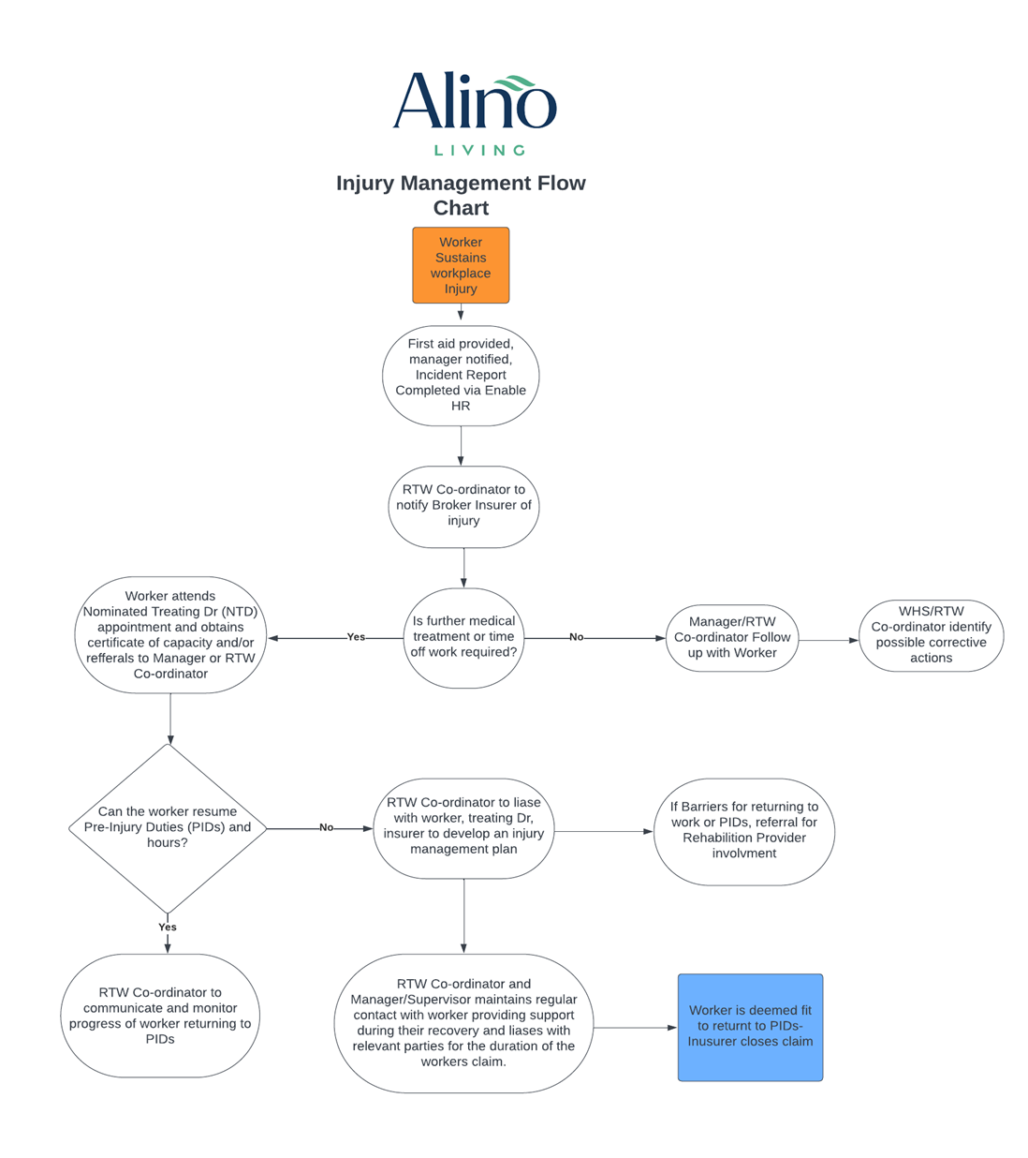

ATTACHMENT 2
Obtain/release Personal information Consent Form

This form provides permission to your employer to collect and disclose your personal and health information relating to your workplace injury management only

Employer Details
Organisation: Alino Living
Contact Name: Jakara Gasson | Position: RTW Co-Ordinator
Phone: 02 4394 2611 | Email: jgasson@alinoliving.com.au

Worker Details
Worker Name:
Claim Number(if provided)
Worker’s declaration
I have discussed this consent form with my employer. I understand that any information collected will be kept in a confidential electronic case file, with access restricted to those who are directly responsible for coordinating and monitoring my recovery at work.
I understand that my employer will:
- only collect personal and health information that is relevant and necessary to manage my recovery at work and facilitate the workers compensation claim
- only use and disclose information for the purpose for which it was collected
- keep any information collected separate from my other personnel records
- take reasonable steps to protect my information by ensuring it is stored securely, kept no longer than necessary and disposed of appropriately
- allow me to access my information without unreasonable delay, unless providing access would be unlawful or pose a serious threat to another person’s life or health.

Considering the above, I authorise (name) and consent to my employer collecting, using and disclosing personal and health information relevant to managing my recovery at work and workers compensation claim with my support team identified below:
Role | Insert Specific names
Nominated Treating Doctor
Workplace Rehabilitation Provider
Broker Insurer
Allied Health Practitioner (Physiotherapist, Psychologist)
Other representative
I understand my consent is voluntary and I may change or withdraw this consent at any time by notifying my employer in writing.

Worker Signature

Date:

Employer representative Signature

Date:

Interpreter Signature (if Required)

Date:

ATTACHMENT 3
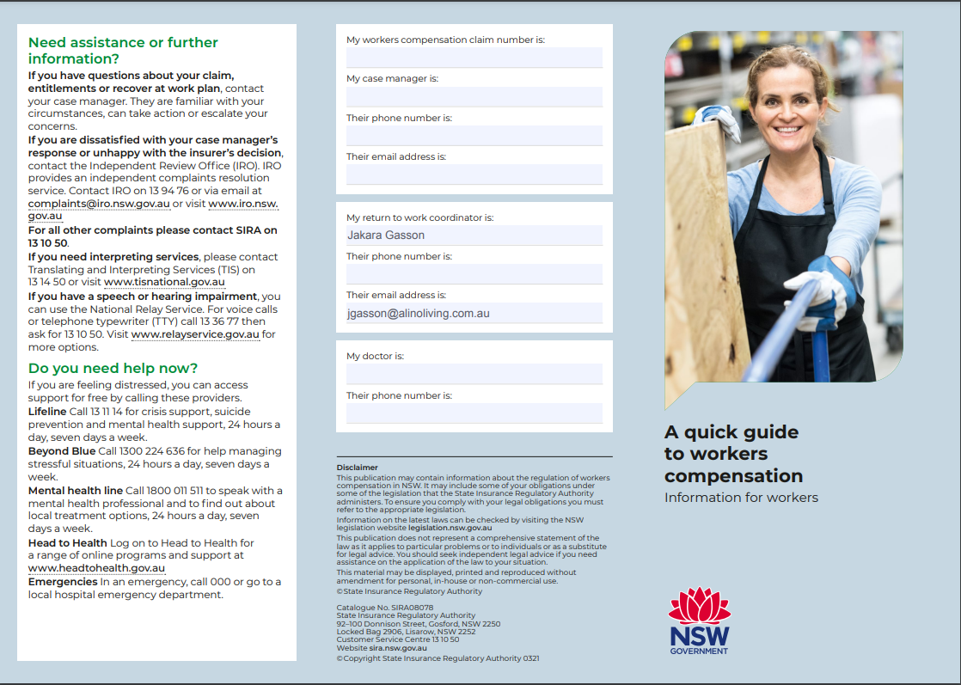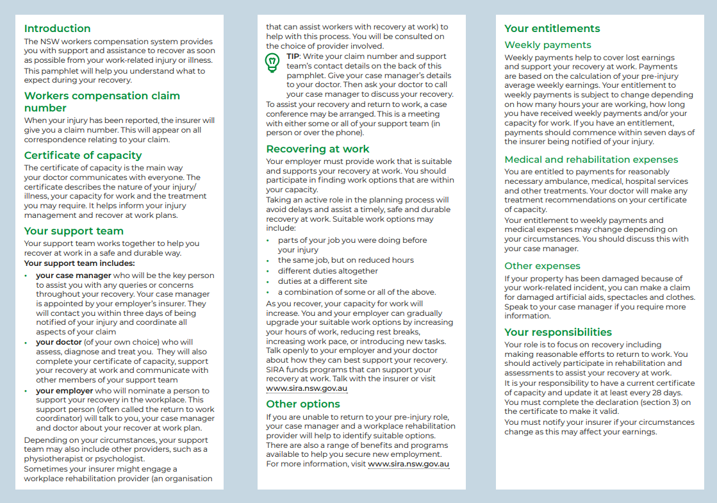

ATTACHMENT 4

How to access the Alino Living Return to work Program
- Log into ACE intranet with your work username and password
https://ace.alinoliving.com.au/login?no_auto=1&no_autologin=1&page=%2F

- Select the workplace drop down and click on policies

- On the left hand side select the work health and Safety Category

4.Select the Return to work Icon – this will provide the full RTW Program for you viewing

