**Canberra Health Services**

**Procedure**

**Mental Health Inpatient Services Ligature Use, Response, Management and Audit Tool Procedure.**

|  |
| --- |
| Contents |

Contents 1

Purpose 2

National Safety and Quality Health Service Standards 3

Procedure Scope 4

Roles and Responsibilities 5

Self Harm by Ligature 6

Responding to a Ligature Incident 8

Management of Ligature Incidents in Mental Health Inpatient Services 9

Post Ligature Incident Management 11

Storing, Checking and Disposal of Ligature Cutters 12

Ligature Risk Auditing Process 13

Applying the Ligature Risks Audit Tool 14

High Risk Ligature Points 16

Designated Zones According to Floor Plan Risk Maps 17

Risk Assessment and Reduction Action Plans 19

Staff Training 20

Evaluation 21

Related Policies, Procedures, Guidelines and Legislation 21

References 22

Definition of Terms 23

Search Terms 25

Attachments 25

Attachment 1 –Self-Harm/Attempted Suicide by Ligature - Response and Management Process 26

Attachment 2- Guide to Using a Ligature Cutter 27

Attachment 3 – *example of a ligature Floor Plan Risk Map* 30

Attachment 6 – Canberra Health Services Risk Reduction Action Plan 33

Attachment 7 - Canberra Health Services Risk Assessment Template & Consequence and Likelihood Tables 34

|  |
| --- |
| Purpose |

Mental Health Inpatient Services within Canberra Health Services (CHS) aims to provide a safe and therapeutic environment for all consumers requiring mental health care and treatment. This includes ensuring that the inpatient environment is as free as possible from ligatures and ligature points. While it is recognised that not all ligature points will be foreseen, this procedure assists mental health inpatient services in CHS to manage the balance between consumer safety, and consumer rights and dignity.

It is important that staff know it is almost impossible to eliminate all potential ligatures to have a completely ligature free clinical environment. A significant proportion of suicides are believed to occur through impulsive acts using the first means to hand and without time for reflection. A judgment therefore has to be made about the likelihood of something being used as a ligature anchor point.

The purpose of this procedure is to provide clinical staff with guidance on how to respond and manage incidents related to ligatures, minimise the risk of injury/death from the use of ligatures, and the process of auditing risk for ligatures within mental health inpatient services CHS. This procedure forms part of our committement to reducing the risk of self-harm and suicide and to provide staff with a systematic approach to the identification and management of ligatures and ligature points within the inpatient environment to ensure a standardised and structured approach to ligature risk management is practiced.

**Note**: All staff must retain a sense of individual clinical judgement not only when completing ligature risk audits, but also as part of their day to day practice. Ligature audits and action plans have the potential to give a false sense of security that all ligatures are either known or being actively managed. Therefore, staff must maintain an active vigilance with regard to the environment and the risks individual patients may present with on a day to day basis.

# National Safety and Quality Health Service Standards

|  |  |  |  |  |
| --- | --- | --- | --- | --- |
|  |  |  |  |  |
|  |  |  |  |  |

**Standard 1 – Clinical Governance**

The clinical governance, and safety and quality systems that are required to maintain and improve the reliability, safety and quality of health care, and improve health outcomes for patients.

**Standard 2 – Partnering with Consumers**

The systems and strategies to create a person-centred health system by including consumers in shared decision making, to ensure that consumers are partners in their own care, and that consumers are involved in the development and design of quality health care.

**Standard 5 – Comprehensive Care**

The integrated screening, assessment and risk identification processes for developing an individualised care plan, to prevent and minimise the risks of harm in identified areas.

**Standard 6 – Communicating for Safety**

The systems and strategies for effective communication between patients, carers and families, multidisciplinary teams and clinicians, and across the health service organisation.

**Standard 8 – Recognising and Responding to Acute Deterioration**

The systems and processes to respond effectively to patients when their physical, mental health or cognitive condition deteriorates.

It is important to remember that reducing the risk of self-harm and suicide is much broader than effectively managing ligature risk. A safe and therapeutic environment, trauma-informed engagement and support, and tailored/individualised treatment, personal safety or suicide prevention plan and therapy create a matrix to reduce the risk of self-harm and suicide. In addition, an approach to these aspects of care based on individual need and cultural needs will identify modified or extra strategies for use. For example, managing the risk of self-harm and suicide for Aboriginal and Torres Strait Islander People may need to incorporate connection to country, access to outdoor space, individual and cultural grief and trauma, language, Elders, traditional healers, and broader definitions of kin and family.

**Content Advice:** This document discusses suicide and self-harm. In discussing suicide and self-harm, there is a shared responsibility for adopting safe and inclusive communication practices, working collaboratively to meet the functions of the procedure. Discussion of workforce health, safety and wellbeing needs are a critical dimension to the advancement of suicide prevention practice. Should you find any of the content in this procedure to be distressing please take a break if needed, reach out to a trusted colleague or contact the employee assistance program (EAP).

*Back to Table of Contents*

|  |
| --- |
| Procedure Scope |

This procedure provides clinical staff with a systematic approach to the identification and management of access to self-harm/suicide ligatures, ligature points and environmental risks within the mental health inpatient environments, including a standardised audit tool to limit the means that consumers of mental health inpatient services may use to self-harm/suicide.

This procedure is applicable to all Clinical Staff working in mental health inpatient services across Canberra Health Service, and applies to all consumers admitted to the following units:

* Adult Mental Health Unit (AHMU) – Building 25, TCH campus
* Adult Mental Health Rehabilitation Unit (AMHRU) - University of Canberra Hospital (UCH) campus
* Mental Health Short Stay Unit (MHSSU) - Level 2, Emergency Department, TCH
* Ward 12B Low Dependency Unit (12B) – Level 2, Building 3, TCH
* Dhulwa Mental Health Unit (DMHU) – Symonston.
* Gawanggal Mental Health Unit (GMHU) - Bruce
* Child and Adolescent Mental Health Unit (CAU)
* Eating Disorders Residential Treatment Centre – Coombs
* North Canberra Hospital
  + Acacia
  + Banksia

CHS mental health inpatient services will carry out an annual clinical environmental audit of areas accessible to consumers. In undertaking such work, due regard will be given to highlighting priority areas, (and prevailing circumstances) which present the highest ligature risks, including fixed equipment, equipment and pipe work in ceiling voids, and all potential risks in unsupervised areas, or where supervision is limited. The outcome of the ligature risk auditing process will result in the management and/or operational solutions (eg: manage locally) or physical solutions (Protect / Replace / Renew / Remove).

*Back to Table of Contents*

# Roles and Responsibilities

Clinical Staff working in CHS mental health inpatient units are responsible to ensure that they have:

* A clear understanding of this procedure
* Be familiar with the emergency response procedure
* Be familiar with ligature incident management including postvention support
* Receive training in the use of a ligature cutter and the post ligature management of a consumer who has attempted self-strangulation or the constriction of blood flow to a body part.

Role specific responsibilities include (this list is not exhaustive):

The Executive Director (MHJHADS) and Executive Director Medical and Mental Health (NCH) are responsible for:

* Ensuring that arrangements are in place so that employees are fully aware of their

statutory, organisational and professional responsibilities and that they are fulfilled

* Ensuring that arrangements in support of this procedure are fully implemented through

Divisional Governance and Program Area performance reviews

* In order to fulfil these responsibilities, operational directors and senior leadership team will have specific delegated responsibilities to support the Executive Director(s) in this process

MHJHADS Program Area Operational Director(s)/Senior Leadership team are responsible for:

* Overseing the operational implementation of this procedure
* Ensursing appropriate assessment and management of risks
* Delegation of responsibilities within their sphere of control
* Ensuring necessary that staff are appropriately skilled and experienced to safely undertake their work

• Necessary reporting procedures are in place

• A framework is in place to monitor compliance with this policy

Service Managers/Team Leaders are responsible for:

* Ensuring that all staff under their management are aware of the procedure regarding the

management of ligature risk

* Ensuring their clinical area receives a ligature risk audit at least annually and to undertake ligature audits elsewhere within the Division when requested
* Monitoring the results of ligature risk audits and ensuring that action plans are developed and implemented
* Present ligature risk audits and action plans at the relevant governance meetings.
* Communicating to ward staff the results of the annual ligature audit and specifically any issues and ligature risks that may be present
* Ensuring that robust processes are in place to support the local management of ligature risks

Individual Staff Members are responsible for:

* Understanding their own responsibilities regarding the procedure and related policies

for the clinical environment where they work

* Completing all relevant documentation in relation to local ligature risk management
* Reporting all incidents involving ligatures or anchor points or near misses

immediately, irrespective of whether injury was sustained

The Nurse in Charge on each shift is responsible for:

* All staff understand their responsibilities regarding the ligature procedure and the processes used locally to manage ligature risk(s) for example, through environmental checks for introduced ligatures
* That all incidents that occur relating to ligature risk are reported without delay and that all relevant documentation is completed in a timely manner within the shift.

|  |
| --- |
| Self Harm by Ligature |

A **ligature** could be defined as any piece of clothing, cordage or any item that can be tied or fastened around the neck, which could be utilised when tied to an object as a tie or noose for the purpose of self-harming by strangulation or hanging.

This *can* include:

* **Clothing accessories** - Belts, braces, laces, stockings, tights, bras.
* **Plastic bags** – carrier bags, rubbish bags, clinical waste bags.
* **Cords** – curtain pull cords, draw cord on bags, venetian blind pull cords or chains.
* **Clothing** – shirts, blouses, t-shirts, ties, trousers (all which can also be torn up into strips). Chains, ropes, hoses, string.
* **Curtains** – window curtains, cubicle curtains.
* **Bedding** - also when torn into strips.
* **Electrical leads** - mobile phone charger leads, head phone leads.
* **Rubber strips** – from fire doors, double glazing, dust strips on cubicle curtain tracking.

A **ligature anchor point**  is anything that could be used to attach (i.e. immobilise at one end) a cord, rope or other material for the purpose of strangulation. The ligature point is used to secure a ligature where the whole, or significant part of the bodies’ weight can be suspended.

Ligature anchor points *can* include:

* **Doors** – trapping a ligature between door and frame, particularly at the top; or from the top edge of an open door (this has been used with wardrobe doors); door self-closing mechanism.
* **Door hinges** – either from the hinges themselves from the part of the hinge that is sticking out from the door; or by trapping a ligature in the door above the hinge; or tying a ligature around the hinge.
* **Handles** – bedroom door handles, en-suite door handles, wardrobe door handles; chest of drawers and cabinets in service users rooms; toilets, shower rooms and bathrooms door handles.
* **Ceiling fittings** – suspended ceiling, lights, air vents and diffusers, smoke detectors, extractor grills.
* **Curtain tracks** – shower curtains, bed cubical tracking, widow curtains.
* **Windows** – trapping a ligature between window and frames; window handles; window opening restrictors, window locks.
* **Pipes** – radiator pipes, hot and cold water pipes, tumble drier ducting.
* **Wall fittings** – fire alarm bells, soap dispensers, paper towel dispensers, shelves, fire alarm call points, coat hooks, pictures and paintings, mirrors, cabinets, fire door electric or magnetic
* ‘hold-back’ / ‘hold-open’ devices, alarm panels, key cabinets, wall mounted TV’s, wall lights, service users alarm / call points, disability rails / grab bars, stair rails.
* **Beds** - bed head / headboard, beds upended or propped up on their end / against the wall, profiling beds from frame or actuating mechanism.
* **Cupboards** - shelving, coat hooks, wire coat hangers, clothes racks, cupboard doors and handles.

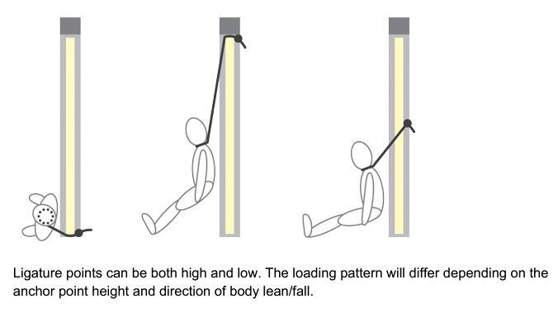

Despite risk assessments and work practices to ensure the safety and wellbeing of consumers admitted to mental health inpatient services for treatment and care, situations may arise where a person attempts serious self-harm or suicide using a ligature.

*Back to Table of Contents*

|  |
| --- |
| Responding to a Ligature Incident |

1. **Raising the Alarm**

Help must be sought immediately when a consumer is discovered with a ligature in situ. Staff should:

* Raise the alarm by calling for help.
* Activate the duress alarm system.
* Instigate an emergency call Code Blue.
* Allocate a staff member to collect the ligature pack and emergency trolley
* In the event of a self-strangulation emergency, staff are to follow the emergency Code Blue procedures

As part of the initial response clinicians **must** assess the situation to ensure their own safety is not at risk before entering a location where a person has applied a ligature for the purposes of self-strangulation. In these situations, the Code Blue procedure is to be followed.

**D**anger

**R**esponse

**S**end for help (2222 or 0,000)

**A**irway

**B**reathing

**C**ardiac Pulmonary Resuscitation (CPR)

**D**efibrillation

1. **Initial Response Risk Assessment Considerations**

Assessment of the situation should include consideration of the following:

* Staff must be familiar with the emergency door release mechanisms in each unit as part of their unit orientation and induction.
* To reduce the level of immediate distress, dignity, privacy, and to avoid further injury to any person, a staff member should, where possible, ensure that other persons in the area such as other consumer, students, visitors and non-essential staff are directed away from the area and out of direct line of sight.

*Back to Table of Contents*

|  |
| --- |
| Management of Ligature Incidents in Mental Health Inpatient Services |

**Managing a Suspended Ligature Incident**

In the event of suspension or partial suspension ligature, it is important to elevate the consumer and to support their body weight if possible, at the earliest opportunity. In doing this it is important staff should adopt and maintain the principles of manual handling to reduce the risk of injury. As soon as the consumer’s body weight is supported (where this is possible), the ligature should be cut at a central point between the consumer and the ligature point so that there is minimal interference with any potential investigation scene. The consumer should then be lowered gently to the floor or another safe flat surface, e.g. bed. When cutting the ligature staff must take care not to pull on it as this may cause further injury. Staff should refer to Section 4 for instruction on using a ligature cutter. If a constrictive ligature remains in place after the consumer has been lowered, it should be removed using the ligature cutter. Staff should make every effort to cut **the ligature at a point that is distant from any knot** that may be present as the ligature and knot can provide forensic evidence in a police investigation.

**Managing an** **Unsuspended Ligature Incident**

When a ligature is unsuspended and there is no tension between the ligature and another object, staff must remove the ligature using the ligature cutter. Staff should make every effort to cut **the ligature at a point that is distant from any knot** that may be present as the ligature and any knot can provide forensic evidence in a police investigation.

**Management Of Aggression During A Ligature Incident**

If a consumer resists staff interventions to remove a ligature without resistance, staff may need to restrain the consumer, taking into account whether the resistive behaviour increases the risks presented by the ligature, or by the use of the ligature cutter. In such situations it is expected that staff will employ appropriate restraint techniques that are sensitive to the needs of the consumer, the safe removal of the ligature, and in line with Occuptional Violence (OV) training. If the person is threatening aggression towards staff members, do not attempt to approach them, and call a Code Black in addition to the Code Blue emergency response.

In situations where the person is resisting intervention, clinicians must use appropriate Occupational Violence (OV) Training approved techniques and ensure the following:

* Not adding weight to the ligature
* Ensure the consumer’s airway needs are monitored
* Remain alert to the possibility of spinal injury.

**Management of Death resulting from a Ligature Incident**

If a consumer is determined to be deceased and the ligature has been released (rather than cut), staff should leave the ligature loosened but in situ if possible. The knot should not be disturbed. Treat the consumer's body with care and respect ensuring privacy at the scene. Ensure that the scene is preserved (minimum of five metres where possible, depending on the environment or situation) and that no entry to the area occurs until the police attend and have cleared the scene. This may mean other consumers need to be moved to another area. Document all events that occur within the perimeter. If removal of objects is unavoidable, for example due to attempted resuscitation, note all objects which have been moved and preserve these separately for the police to examine.

**Removal of a Ligature**

The nature of the type of ligature used and the body part to which it has been applied will inform the means of removal. The appropriateness of the use of a ligature cutter will then need to be determined as these are not designed for use with smaller body parts such as fingers, wrists or toes.

When it is clear that the ligature cannot be removed, or a margin of safety for its removal has not been agreed on and/or the person is unable to attend the nearest Emergency Department using the existing inpatient unit resources then an Emergency Code Blue should be called for inpatient units and ACT Ambulance Service (ACTAS) arranged to safely transport the person to the Emergency Department as per the MEWS escalation pathway procedure.

**Preserving Potential Forensic Evidence**

* Where a ligature is removed the ligature and ligature cutter, or other instruments used, are to be retained in case forensic analysis is required.
* If any remains of the ligature are attached to a ligature point, they should not be removed until appropriate authorisation from the ADON, Operational Director or After-Hours Executive Director on-call.
* In the event of a fatality, the area in which the self-strangulation emergency has occurred is as far as possible, to be removed from operational use and its contents must not be touched or moved.
* The room in which the self-strangulation emergency occurred, for any, and all attempts where serious injury or death has occurred, is to be isolated until such time as the Police have agreed that it can be returned to use.

*Back to Table of Contents*

|  |
| --- |
| Post Ligature Incident Management |

**Documenting and Reporting Requirements**

All incidents of ligature use must be recorded in the consumer’s DHR and in the clinical incident management system (RiskMan) as soon as practicable post incident.

Clinical documentation must include any injuries sustained by the person as a result of a ligature cutter being used, as a result of the act itself and/or through the lowering of the person to the floor.

Check if the person has a Nominated Person, Advance Agreement and/or Advance Consent Direction in place for guidance on who should be notified of the incident. The person’s Nominated Person, Carer, Guardian or people listed in an Advance Agreement and/or Advance Consent Direction, medical staff and the treating Psychiatrist must be notified of the incident.

Any injuries to staff must be documented in a Staff Incident via RiskMan.

Critical incident notifications are to be made by the ADON or by the NIC to ACT Policing and the Operational Director, during after-hours and on Public Holidays notification are to be made to the Executive Director on-call.

|  |
| --- |
| **Note:**  The following documents provide guidance for reporting and notification purposes:   * *Providing Care After Death Procedure* * Canberra Health Services Patient Death Guidelines page on the intranet [Patient death guidelines (sharepoint.com)](https://actgovernment.sharepoint.com/sites/Intranet-CHS/SitePages/Patient-death-guidelines.aspx) |

**Note**: Where restraint has been used, the appropriate notifications and documentation are to be made by clinical staff, including a restrictive practices notification contained within the Digital Health Record (DHR).

**Postvention Support**

All staff involved in a ligature incident must be offered support and the opportunity to discuss the incident as soon as possible. This support must be extended to others in the multidisciplinary team involved in the consumer’s care. The meeting(s) should be organised by the CNC/ADON or relevant senior leader/manager. The decision whether or not to engage with support is the decision of the individual clinician. Ongoing support for staff is available via the Employee Assistance Program (EAP) for additional follow up support and counselling as required. Futher information on support sevcies for staff is via the [Psychological Support for Staff - A Manager’s Guide](https://actgovernment.sharepoint.com/:w:/r/sites/Intranet-CHS/PolicyRegister/_layouts/15/Doc.aspx?sourcedoc=%7B4F4CFB17-2BBA-4ADA-AE62-70DF4603D542%7D&file=Psychological%20Support%20for%20Staff%20-%20A%20Manager%E2%80%99s%20Guide.docx&action=default&mobileredirect=true&DefaultItemOpen=1%3Fweb%3D1).

Other witnesses to the incident such as consumers or visitors must be offered the opportunity to debrief in a culturally safe manner.

**Ligature Risk Audit Tool**

The ADON, Operational Director and DON are to undertake any further actions to prevent a recurrence of the incident, inclusive of a full unit wide ligature risk assessment using the Ligature Risk Audit Tool. Any documented changes are to be made to the unit’s ligature Risk Reduction Action Plan.

*Back to Table of Contents*

|  |
| --- |
| Storing, Checking and Disposal of Ligature Cutters |

**Storage of Ligature Cutters**

Ligature cutters are to be stored on, or immediately adjacent to, the Emergency Trolley. The ligature cutters must not be removed from their designated storage location except in the case of an emergency as they are classified as emergency medical equipment. All staff must be familiar with the location of the ligature cutters.

Additional ligature cutters are to be stored on each unit by the ADON, in a location that is readily accessible and made known to staff but not accessible or visible to consumers who are admitted to the unit.

**Checking of Ligature Cutters**

Ligature cutter checks must occur daily in conjunction with the routine checking of Emergency Trolleys. The check will involve opening the ligature cutter, ensuring that the blade locks in the open position, that the blade is free of rust and that it can be closed again. Any defects observed in the ligature cutter, must be brought to the attention of the CNC and/or the NIC of the unit.

**Disposal of used Ligature Cutters**

The ligature cutter is classed as a single use device. Whenever a ligature cutter has been used the ADON/CNC will replace it from stock. When a used ligature cutter has been returned to the unit by the Police, it must be returned to the ADON/CNC of the unit and disposed of in a sharp’s container.

*Back to Table of Contents*

|  |
| --- |
| Ligature Risk Auditing Process |

The purpose of a ligature audit is to identify, address and/or change practice to manage, potential ligature sources and ligature points in a unit to reduce the risk of self-harm and suicide and improve consumer/carer/family/Kin experiences and outcomes. A ligature audit must include all consumer accessible areas within the footprint of the unit, including internal courtyards. Any areas that are only accessed by consumers in the constant presence of a clinician can be excluded.

Managing risk is neither, a discrete activity or precise science. It is also unlikely that risk can be entirely removed. The most effective approach entails a whole system approach and this audit aims to capture the significant points, and therefore provide managers/team leaders with a tool and process that contributes to making clinical environments as safe as possible.

**Note**: It must be remembered that risk is dynamic, environments change, service users and staff change and the way in which the environment is used changes through each and every day.

The Ligature Risk Audit Tool and Risk Reduction and Action Plan (RRAP) must be completed at a minimum annually and/or following a serious incident involving the use of a ligature or when there has been significant refurbishment in the unit, and must including auditing of all seclusion rooms within relevant units. The ligature risk audit and risk management process comprises of two (2) sections:

* + - 1. **Ligature Risk Audit Tool**: Priority table for identified risk and related timeframes for action.

|  |  |
| --- | --- |
| **High Priority Risk** | Action immediately, cease task/process and/or isolate area |
| **Medium Priority Risk** | Action 2-4 weeks |
| **Low Priority Risk** | Action within 4-8 weeks |

* + - 1. **Risk Reducation and Action Plan**: Reviews the identified ligature points by assigning a risk rating using the [CHS Risk Management Framework](https://actgovernment.sharepoint.com/sites/Intranet-CHS/Shared%20Documents/Forms/AllItems.aspx?id=%2Fsites%2FIntranet%2DCHS%2FShared%20Documents%2FCHS%20Risk%20Management%20Framework%2Epdf&parent=%2Fsites%2FIntranet%2DCHS%2FShared%20Documents) and [CHS Risk Management Policy](https://actgovernment.sharepoint.com/:w:/r/sites/Intranet-CHS/PolicyRegister/_layouts/15/Doc.aspx?sourcedoc=%7BE401C81D-BB64-4A71-9773-E04BD8A24A19%7D&file=Risk%20Management%20Policy%20.docx&wdLOR=c30D724D0-AA08-4AFD-85E7-05AFB30EE297&action=default&mobileredirect=true).

The hierarchy of controls are as follows:

* Eliminate (Protect / Replace / Renew / Remove).
* Control (substitute, isolate the hazard, engineer or by administrative means); or
* Accept/Risk Tolerable

**Arrangements for Establishing and Conducting an Audit of Ligature Risks**

The CHS MHJHADS DON/delegate and NCH Executive Director/delegate will lead the ligature audit process. The composition of the audit team will remain the same during the auditing process of individual services/units to ensure consistency in assessing risk and applying risk mitigation/compensatory factors. The audit should be conducted descretely to avoid bringing potential ligature points to the attention of consumers.

The review team conducting the ligature risk audit will include (at a minimum):

* The Director of Nursing MHJHADS/or delegate
* The Executive Director Medical and Mental Health NCH/or delegate
* An Assistant Director of Nursing from a unit not being audited
* The Clinical Nurse Consultant of the unit being audited
* The Quality and Safety Business Partner
* An independent observer for training purposes i.e. clinical staff member

The activities of the Audit Team include checking the last annual ligature risk audit to ensure that it:

* Was conducted less than 12 months ago or since any alterations were made to the ward/unit (whichever was most recent).
* Identifies any high-risk ligature points observed during the review of the ward/unit area, resulting in a clear plan to reduce the risk posed by the ligature points that were identified (both in terms of clinical care to manage the risk and infrastructure costs).
* Includes tasks in the plan allocated to responsible individuals with a timescale for completion and effective monitoring of the plan to ensure that action is taken.
* Shows how staff have acted on the clinical risk management plan and the Operational Director/Executive Director have acted on identified environmental investment needs.

The Audit Team will be provided with the floor plan of each clinical area, including all areas to which consumers have access, noting which of those areas have full, limited or no supervision. Audit Teams will be expected to survey the entire clinical area (excluding those parts to which consumers do not have access), to identify all potential or actual ligature risks.

All possible ligature points will then be recorded in the audit tool data collection form. The Audit Team will be responsible for noting what actions may be necessary to address the identified hazard(s) (e.g. Remove / Replace / Renew / Manage locally).

In surveying the clinical area, it is expected that where potentially dangerous items are observed, the unit representative will initiate actions to address the matter. These items may include personal effects or items such as plastic bags that must be removed immediately.

When consumer acuity prevents the Audit Team from inspecting a space, such as a bedroom in a High Dependency area, the Audit Team leader or delegate will liaise with the ADON or other responsible person of the unit to arrange a time to return and complete the audit.

*Back to Table of Contents*

|  |
| --- |
| Applying the Ligature Risks Audit Tool |

All CHS units and facilities in scope must undertake an annual ligature risk assessment as a minimum, however, prior to the procurement of any new equipment or furniture a full ligature risk assessment will need to be undertaken. The assessment will be a dynamic assessment which should be reviewed and amended whenever a new ligature risk has been identified or one removed/mitigated.

**Audit Process**

**Step 1: Allocations of roles undertaken**

* **Lead:** the Audit Team Lead will coordinate the process of the audit.
* **Observer :** Visually identify all points that could be used to attach a ligature to which would be likely to sustain the weight of a person (approximately 15kg) to be completed in a systematic manner. Consideration will be given to highlighting priority areas and prevailing circumstances which present the highest ligature risks.
* **Scribe:** To document all possible ligature points in the approved Ligature Risk Audit Tool template, and if necessary the Floor Plan Risk Map. A Workstation on Wheels or laptop is to be provided by the unit undergoing assessment as required.
* **Guide:** A person working on the unit who can clarify the usage and observational requirements for each room / area reviewed. They can also provide local area knowledge when needing to discuss with consumers access required to their bedrooms during the auditing process.

**Step 2: Assign roles**

* All members of the Audit Team are responsible for identification
* Designate a scribe and a tester.

**Step 2: Assemble the ligature point assessment kit**

This is comprised of:

* A device to measure release strain of ligature points.
* In the absence of a bespoke device, fishing scales, luggage scales and or water containers filled to 15litres or less (15 kg) can be used.

**Step 3: Unit/service Floor Plan Risk Map (FPRM)**

The Floor Plan Risk Map zones are a visual representation of the workplace that identifies hazard areas. The Floor Plan Risk Map of the unit will be available to the audit team prior to the inspection walk around. Using the floor plan, review the existing room allocation and determine if all areas are: Unobserved / Partially Observed / Well Observed.

**Step 4: Walk through the unit commences using a structure and systematic approach**

* Identify a starting point in a room
* From the starting point working **left to right, up and down**, identify all actual or potential ligature points that can be seen
* All potential ligature points are to be tested
* It is important to test around any fittings and fixtures as products shrink over time and ligature accessible gaps can appear
* During this phase you need to check for any missing items (for example screws) and any inappropriate fixings (for example, the use of standard screws rather than anti-tamper type)
* Using the Ligature Point Rating Matrix determine the rating of the ligature point. See Attachment 5.

Note: Before the Audit Team leaves each room, a ‘sweep’ needs to occur to ensure no ligature test kit items are left behind.

**Step 5: The audit outcomes will be documented on MS Forms, after which:**

* All high risk points/items identified are followed up by the ADON and Operational Director immediately.
* When required, a follow up meeting / walk around with the services Operational Director/Executive Director(s) is organised to visualise ligature points identified as requiring Removal / Renewal / Repair / Protection with a considerable budgetary requirement or structural change and/or impact.
* Audit outcomes that require further action are to be followed up by the ADON. It is acknowledged that there will be some risks that require further evaluation incorporating specialist knowledge and advice from the engineering department (or specialist contractor). An initial assessment of the risk should still be made on the audit tool data form.
* Present the completed audit to the MHJHADS Governance Committee and relevant NCH committee.

## High Risk Ligature Points

**Note**: Mental health consumer cohort is ***not*** considered a mitigating factor as any person can act impulsively to self strangulation at any time during their care journey.

For MHJHADS mental health inpatient units and residential services for consumers with higher vulnerability to suicide (for example acute mental illness, behaviour that is challenging and/or chaotic, substance misuse, young person, or a person with comorbidies), the following ligature points should be considered high risk and mitigated or eliminated wherever possible:

* Ligature points of **any** height, in any room which consumers spend time in private/ without direct supervision by staff (such as bedroom, toilet, and bathroom)
* The room as a whole and potential for standing on furniture or fittings needs to be considered. Ligature anchor points that are less than 70cm from the floor must be assessed; best practice evidence indicates that death can occur within minutes.
* Ligature points of **any** height (including those at low level) in any area where poor unit design means consumers will be out of sight.

In all other areas of mental health inpatient units/residential services, the risk posed by any ligature point needs to be considered in the context of:

* How easily it can be accessed unobserved; and
* Any benefits that outweigh the risks (for example, gym equipment used only under direct observation, adaptations to assist safer mobility in mental health units for older people).

**Note**: Whilst categorising areas according to their level of risk, nothing is entirely predictable and opportunistic risks arise within any environment. Removing ligatures and anchor points is only ever part of the means by which the risk is managed and a whole systems approach must also consider the level of engagement and knowledge of individual service users’ illness and risk they present. Managers/Team Leaders should also consider the use of the environment for the risk that service users present and any management issues such as staffing levels and staff skills

## Designated Zones According to Floor Plan Risk Maps

* **Designated Red Zone** (shown as **RED** on the Floor Plan Risk Map – where most consumers spend time, in private, without direct supervision by staff.
* **Designated Amber Zone** (shown as **AMBER** on the Floor Plan Risk Map) – where most consumers spend minimal time under direct supervision by staff and are usually in the company of peers, visitors or workers.
* **Designated Green Zone C** (shown as **GREEN** on the Floor Plan Risk Map) – where consumers spend time in areas that can only be swipe accessed by staff and will be supervised at all times.

|  |  |  |
| --- | --- | --- |
| **Areas where most people receiving treatment and care spend long periods of time, in private, without direct supervision of staff or in the company of their peers.** | **Areas where people spend periods of time with minimal direct supervision from staff and are usually in the company of peers, visitors or workers.** | **Where consumers spend time in areas that can only be swipe accessed by staff and will be supervised at all times.** |
| All bedrooms | Common Lounge Areas | Access to controlled areas/locked rooms |
| Ensuite toilet/shower areas | Dining rooms/areas |  |
| Toilets in general ward areas | Therapy, recreation, gym and spiritual spaces where staff are not in constant attendance |  |
| Isolated rooms without good line of sight such as unisex toilets | Sitting rooms without good line of sight |  |
| Unlocked Laundry areas where staff are not in constant attendance | Recreation Areas |  |
| Isolated external areas adjacent to or near the unit | Seclusion Rooms (12B) |  |
| Seclusion Rooms (HDU/MHSSU/Dhulwa) |  |  |

**Note**: While areas can be rated according to the level of risk, unpredictable and opportunistic risks will arise within any clinical environment and vigilance is required particularly at night in areas Designated amber and green zones.

Whilst this audit tool supports a standardised approach to completing the audit, auditors must never ignore their clinical judgement and knowledge of the clinical area to help ensure the accurate assessment of perceived risks.

*Back to Table of Contents*

**Compensatory Factors**

Compensation Factors include elements and situations, which would cause an identified ligature point to remain as a high or low risk, providing certain physical or operational criteria were sustained. In this regard, a Compensating Factor must be common practice, or relate to the design of the room and must be permanent. For example, a consumer on continuous observations whilst in their bedroom at the time of the audit will not count as a Compensatory Factor because this is a temporary clinical management stragetgy and not a permanent or consistent element.

When considering the context of observation through design, staffing/skills mix, safety culture, and training and support, compensatory factors can influence the effectiveness of the system of care and safety. For example:

* Consistant staffing levels and skills mix – supports adequate, constant and thorough observation and therapeutic engagment.
* Robust safety culture –strong organisational committement to safety with clear policies and procedures; regular safety audits and prompt addressing of any identified risks; service directors and managers prioritise safety in decision-making and resource allocation.
* Comprehensive training and support – regular mandatory training sessions on recognising, responding and managing ligature risks; availability of mentalhealth support for staff to manage stress and prevent psychological harm.

**Recommended Course of Action**

Once all ligature risks are identified, the ligature audit team are to assign a recommended course of action for all identified ligature risks in accordance with the descriptions given below.

|  |  |
| --- | --- |
| **Recommended Course of Action** | **Description/Definition** |
| **Remove (Eliminate)**  (Extreme) | The risk is deemed to be of such a nature that to leave it would put the consumers at risk. The ligature point needs to be removed and the surface finishes repaired, as the item is no longer needed, or there is no suitable alternative. |
| **Remove & Replace (Substitute)**  (High) | The risk is deemed to be of such a nature that to leave it would put the consumers at risk. The ligature point needs to be removed and replaced with a “purpose-designed” similar anti-ligature  piece of equipment (or materials). |
| **Remove & Renew (Substitute)**  (High) | The risk is deemed to be of such a nature that to leave it would put the consumers at risk. The ligature point need to be removed and new alternative equipment or materials need to be installed. |
| **Protect (Isolate)**  (Medium) | A technical solution to the problem identified is required to hide the potential ligature point. For example installing anti-ligature fixtures and fittings in bedrooms and common areas. |
| **Managed Locally (Administrative control)**  (Low) | The ligature point is of a nature that the Audit Team, supported by the Operational Director/Executive Director assessment that it is unnecessary to remove it OR  There is no technical solution to the problem, for example, door hinges OR  There is a need to acknowledge (and retain) the risk because the risk of another potential injury is greater if it is removed, than that associated with a ligature risk, for example, hand rails within an elderly consumer’s toilet/bathroom. |

*Back to Table of Contents*

|  |
| --- |
| Risk Assessment and Reduction Action Plans |

Any ligatures and ligature points identified during the Ligature Risks Audit Tool (LRAT) and rated as high by the audit team are to undergo a risk analysis which is to be documented on the LRAT included on Attachment 4.

Based on an analysis of identified individual and grouped risks, appropriate risk control and mitigation measures are to be included. The ADON and Operational Director will ensure that once the audit is completed, all agreed high risks are documented and addressed through development of a RRAP included on Attachment 6.

These plans are developed for identified risks and used to track the completion of the risk reduction strategies adopted within agreed timeframes at unit level. ADONs must escalate any identified risks that are unable to be adequately mitigated and managed on the unit to the respective Operational Director and as circumstances require, to the Clinical Director and Executive Director, to ensure that the risk is managed and appropriate preventative action is taken, monitored and reviewed.

Where structural alterations to the environment have been made since the last audit or changes to the clinical environment have occurred, the Ligature Risk Assessment Tool audit criteria can be revised and the necessary changes made to the Floor Plan Risk Map and Environmental Safety Checks.

When completed, the Risk Reduction and Action Plan and the measures to be implemented are to be communicated to all staff (not just clinical staff) working at the unit during staff meetings and clinical handovers. Information communicated to staff should include progress on meeting necessary risk reduction requirements, and be tabled at the local service/unit’s Work Health & Safety meeting.

It is important to note that while all risks cannot be completely eliminated, appropriate steps can be taken through the Risk Reduction and Action Plan to reduce the impact of the risks identified in the clinical environment, to the point that the risk can be made safer by collaboration between all those involved in a person’s treatment and care. The following approach to clinical risk is to be adopted in the development of Risk Reduction and Action Plan.

*Back to Table of Contents*

|  |
| --- |
| Staff Training |

Clinical staff will be provided with the following training:

* Staff are trained aligned to the procedure for the removal of ligatures to ensure there is an effective emergency response capability, readily available, including the availability of ligature cutters and staff competence to use them effectively.
* Use of ligature cutters and the implementation of a Code Blue Emergency response under this procedure as part of each mental health inpatient unit/residential service Code Blue Emergency response process.
* Ligature risk management system: including the use of Floor Plan Risk Map, the completion of the At Risk Category/Clinical Risk Assessment, Environmental Safety Checks, Searching of a Consumer’s Person or Property and the use of the Ligature Risk Audit Tool.

Training for use of ligature cutter and ligature risk management system will be facilitated through the CNC/Clinical Nurse Educator (CNE)/Clinical Development Nurse (CDN) in each unit and training records maintained through HRIMs. Basic Life Support (BLS) training must to include Ligature Cutter training.

*Back to Table of Contents*

|  |
| --- |
| Evaluation |

**Outcomes**

The outcome of the audit will result in management and/or operational solutions, or physical solutions which may need to be funded. The subsequent inspection with executive directors is aimed to assist in supporting managers in actioning/prioritising/authorising works where funding is required. A Risk Reduction and Action Plan will then be developed and the plan will be monitored and endorsed by the MHJHADS Governance Committee or NCH Governance committee.

**Measures**

* % Completion of risk assessments and audits
* % Completion of action plans from assessments
* Annual review of each mental health inpatient unit or residential facility using the Ligature Risk Audit Tool
* Monitoring of ligature reduction programme
* Monitoring of adverse incident data
* Audits of suicides in in-patient facilities
* Compliance completion rates and action plans are monitored through relevant Governance Committees to Canberra Hospital and NCH
* Annual review of staff training records to ensure all staff have been trained to use ligature cutter and post ligature management of a person.

*Back to Table of Contents*

|  |
| --- |
| Related Policies, Procedures, Guidelines and Legislation |

**Policies**

* [Risk Management](https://actgovernment.sharepoint.com/:w:/r/sites/Intranet-CHS/PolicyRegister/_layouts/15/Doc.aspx?sourcedoc=%7Be401c81d-bb64-4a71-9773-e04bd8a24a19%7D&action=view&wdAccPdf=0&wdparaid=BBE0FEE)
* [Incident Management (Clinical)](https://riskman.internal.health.act.gov.au/)

* [Searching of a Consumer’s Person or Property](https://actgovernment.sharepoint.com/:w:/r/sites/Intranet-CHS/PolicyRegister/_layouts/15/Doc.aspx?sourcedoc=%7B4711F375-9FED-45EC-B6EC-76B35035D16D%7D&file=Searching%20of%20a%20Consumer%E2%80%99s%20Person%20or%20Property.docx&action=default&mobileredirect=true&DefaultItemOpen=1)
* [Work Health and Safety](https://actgovernment.sharepoint.com/:w:/r/sites/Intranet-CHS/PolicyRegister/_layouts/15/Doc.aspx?sourcedoc=%7BC079E9A0-37B9-44ED-A8DE-D8F2B5191ED8%7D&file=Work%20Health%20and%20Safety.docx&action=default&mobileredirect=true&DefaultItemOpen=1)
* [CHS Work Health Safety Management System](https://actgovernment.sharepoint.com/:w:/r/sites/Intranet-CHS/_layouts/15/Doc.aspx?sourcedoc=%7B87599f38-e963-44a0-9187-a7aeb514081d%7D&action=view&wdAccPdf=0&wdparaid=64787B9E)
* [ACT Government Risk Management Policy 2021](Q://MH/Director%20of%20Nursing%20MHJHADS/9.%20Projects%202024/Ligature%20Audit%20Procedure/Literature/ACT%20Government%20Risk%20Management%20Policy%202021%20Final.pdf)

**Procedures**

* [Infection Prevention and Control Healthcare Associated Infections Clinical](https://actgovernment.sharepoint.com/:w:/r/sites/Intranet-CHS/PolicyRegister/_layouts/15/Doc.aspx?sourcedoc=%7BF775630B-7D84-4743-AED2-30FB2CF295B9%7D&file=Infection%20Prevention%20and%20Control%20Procedure.docx&action=default&mobileredirect=true&DefaultItemOpen=1)
* [Providing Care After Death](https://actgovernment.sharepoint.com/:w:/r/sites/Intranet-CHS/PolicyRegister/_layouts/15/Doc.aspx?sourcedoc=%7B76541F4A-DF66-47CD-A67F-88A46660A0A6%7D&file=Providing%20care%20after%20Death.docx&action=default&mobileredirect=true&DefaultItemOpen=1)
* [Initial Management, Assessment and Intervention for People Vulnerable to Suicide](https://actgovernment.sharepoint.com/:w:/r/sites/Intranet-CHS/PolicyRegister/_layouts/15/Doc.aspx?sourcedoc=%7B147B92AA-31DD-4DBC-90B3-FF0260EE1C6E%7D&file=Initial%20Management%2C%20Assessment%20and%20Intervention%20for%20People%20Vulnerable%20to%20Suicide%20.docx&action=default&mobileredirect=true&DefaultItemOpen=1)
* [CHS Emergency Management Plans – Code Blue](https://actgovernment.sharepoint.com/:w:/r/sites/Intranet-CHS/PolicyRegister/_layouts/15/Doc.aspx?sourcedoc=%7BE8E6E911-F84F-4BDA-881A-DDEAC7FDDCAF%7D&file=CHS%20Emergency%20Management%20Plans%20-%20Code%20Blue.docx&action=default&mobileredirect=true&DefaultItemOpen=1)
* [CHS Vital Signss & Early Warning Scores – The Canberra Hospital](https://actgovernment.sharepoint.com/:w:/r/sites/Intranet-CHS/PolicyRegister/_layouts/15/Doc.aspx?sourcedoc=%7BE8292AE0-F840-4FBB-A194-8276F8BAA14F%7D&file=Vital%20Signs%20%26%20Early%20Warning%20Scores%20%E2%80%93%20The%20Canberra%20Hospital%20Inpatients.docx&action=default&mobileredirect=true&DefaultItemOpen=1)
* [Spinal Injury Management of the Adult](https://actgovernment.sharepoint.com/:w:/r/sites/Intranet-CHS/PolicyRegister/_layouts/15/Doc.aspx?sourcedoc=%7BB71C48C8-2E4C-4903-90F3-AD0E2F53B4C7%7D&file=Spinal%20Injury%20Management%20of%20the%20Adult%20Patient.docx&action=default&mobileredirect=true&DefaultItemOpen=1)
* [Psychological Support for Staff – A Manager’s Guide](https://actgovernment.sharepoint.com/:w:/r/sites/Intranet-CHS/PolicyRegister/_layouts/15/Doc.aspx?sourcedoc=%7B4F4CFB17-2BBA-4ADA-AE62-70DF4603D542%7D&file=Psychological%20Support%20for%20Staff%20-%20A%20Manager%E2%80%99s%20Guide.docx&action=default&mobileredirect=true&DefaultItemOpen=1)

**Framework**

* [Risk Management Framework](https://actgovernment.sharepoint.com/sites/Intranet-CHS/SitePages/Risk-management.aspx#risk-management-framework-and-policy)

**National Documents**

* [Australian Commission on Safety and Quality in Health Care Standards](https://www.safetyandquality.gov.au/standards/nsqhs-standards)

**Legislation**

* Health Records (Privacy and Access) Act 1997
* Human Rights Act 2004
* Work Health and Safety Act 2011
* *Carers Recognition Act 2021*
* *Children and Young People Act 2008*
* *Guardian and Management of Property Act 1991*
* *Information Privacy Act 2014*
* *Mental Health Act 2015*
* *Mental Health (Secure Facilities) Act 2016*
* *Public Advocate Act 2005*

*Back to Table of Contents*

|  |
| --- |
| References |

Brief Guide: Ligature anchor points, ligatures and other means of self-harm using fixtures

and furniture, 2022, Care Quality Commission (CQC)

Hunt, Isabelle, Windfuhr, Kirsten, Shaw, Jenny, Appleby, Louis & Kapur, Nav. 2012. Ligature Points and Ligature Types Used by Psychiatric Inpatients Who Die by Hanging: A National Study. *Crisis: Journal of Crisis Intervention & Suicide*, ***33***, 87-94. <https://doi.org/10.1027/0227-5910/a000117>

Quinlivan, L, Cooper, J, Davies, L, Hawton, K, Gunnell, D, Kapur, N. Which are the most useful scales for predicting repeat self-harm? A systematic review evaluating risk scales using measures of diagnostic accuracy. BMJ Open 2016; 6: e009297

Carter G, Milner A, McGill K, Pirkis J, Kapur N, Spittal MJ. Predicting suicidal behaviours using clinical instruments: Systematic review and meta-analysis of positive predictive values for risk scales. *British Journal of Psychiatry*. 2017;210(6):387-395. doi:10.1192/bjp.bp.116.182717

Madsen T, Erlangsen A, Nordentoft M. Risk Estimates and Risk Factors Related to Psychiatric Inpatient Suicide—An Overview. *International Journal of Environmental Research and Public Health*. 2017; 14(3):253. <https://doi.org/10.3390/ijerph14030253>

[The built environment: Reducing harm by ligature in practice - Care Quality Commission (cqc.org.uk)](https://www.cqc.org.uk/guidance-providers/mhforum-ligature-guidance/built-environment)

Bendigo Health, 2021, Mental Health Services inaptient units ligature risk audit protocol. Bendigo Health Mental Health Services

Tasmanian Health Service, 2022, Statewide Mental Health Services Inpatient Environmental Ligature Risk Audit. Protocol. Tasmanian Health Service

National Health Service (NHS), 2023, Ligature Risk Assessment and Management Policy. Mental Health and Learning Disabilities Ligature Risk Assessment Policy, Version 2.0. Isle of Wight. NHS Trust

Mental Health Drug and Alcohol, 2023, Ligature Risk Identification and Management in Mental Health Drug & Alcohol Inpatient Units. Procedure. Northern Sydney Local Health District

*Back to Table of Contents*

|  |
| --- |
| Definition of Terms |

|  |  |
| --- | --- |
| Anti-Ligature Fitting | An anti-ligature fitting is any fitting that is designed in such a way  as to prevent a ligature being attached to it. An anti-ligature fitting  should:   * Cause the ligature to slip off. * Cause the fitting to break away from its mount (at 15Kg or less) when placed under pressure of weight. |
| Audit | The systematic examination of an area to identify anything that may pose a ligature risk |
| Detention Series Hardware | Anti-ligature, free of hanging points, no sharp edges or corners to minimise injuries from impact and complies with Australian Standards for strength, durability and fire rating. |
| Fixed Anti Ligature | These items are generally items that are required to bear weight or strain such as a hand rail, or a door handle. As it is not an option for these products to release under an abnormal load, the ligature risk is eliminated by designing it in such a way that it is not possible for a cordlike object to be looped or tied around it. |
| Grab rails with Infill plates | Continuous full length grab rail with infill plate to reduce the potential risk of ligature. Grab rails has rounded edges. |
| Latching Hardware | A latch typically engages another piece of hardware on the other mounting surface. |
| Ligature | An object or device which can be used to cause harm by restricting breathing and/or blood flow. These may be used for self harm including asphyxiation with or without other objects, including ligature points. Ligatures can be made from any material, and 80% of deaths are from a material less than 1 cm width. Ligatures can include:   * Cords, ties, gymnastic bands, electric wire or ropes * Belts, shoe laces, scarves neck ties * Plastic bags, craft supplies, tape or cable ties * Material or clothing torn/damaged for the purpose of creating a ligature. |
| Ligature Point or Anchor Point | A ligature point is any fixture or fitting which is load bearing either entirely or partially that can be used to tie or secure a cord, sheet or other tether that can then be used as a means of self-harm through self-strangulation and in extreme circumstances resulting in death by suicide. Ligature points can include:   * The gaps between a window or door and its frame * Windows, cupboards or door handles * Coat and towel hooks * Window curtain, bed curtain and shower rails * Shower heads and shower controls * Sink taps, plug and waste * Window, door or cupboard edges and frames * Door hinges, pivots and self-closers * Ventilation grills, ceiling vents and ducts |
| Ligature cutter | A tool that is used to release a ligature by cutting. A ligature cutter is purpose specific and a single use item for cutting ligatures during an emergency. They must not be used for any other purpose |
| Ligature incident | Any incident pertaining to the use of a ligature, including self-harm and actual or attempted suicide. |
| Load Release Anti Ligature | A product which is attached to a surface by a method which allows the products to be released from the surface when the load reaches a threshold value, below which the product performs a specific function. |
| Postvention | Postvention is an intervention conducted after a suicide, largely taking the form of support for those impacted and bereaved (family, friends, professionals and peers), but includes preparedness, planning, response and recovery from a death by suicide. Organised support for those impacted and bereaved, including consumers, carers, family and staff, recognising that those affected may be at an increased risk of suicide following a suicide death. Support is usually offered in the form of counselling. A workplace postvention response is an ongoing procedure increasing preparedness and planning for a death by suicide, and inclusive of a trauma support and intervention response, followed by review for recovery and learning. |
| Suspended ligature | A ligature that is attached to a fixed point so that a person’s bodyweight is supported by the ligature, in this situation the person’s weight acts as the constricting force. |
| Unsuspended ligature | A ligature that is secured tightly around a part of the body, e.g. throat, to restrict breathing or blood-flow, in this situation harm can result from strangulation. |

*Back to Table of Contents*

|  |
| --- |
| Search Terms |

Ligature, ligature audit, ligature management, ligature points, self-harm, self-strangulation, suicide, hanging

*Back to Table of Contents*

|  |
| --- |
| Attachments |

**Disclaimer**: *This document has been developed by Canberra Health Services specifically for its own use. Use of this document and any reliance on the information contained therein by any third party is at his or her own risk and Canberra Health Services assumes no responsibility whatsoever.*

*Policy Team ONLY to complete the following:*

|  |  |  |  |
| --- | --- | --- | --- |
| *Date Amended* | *Section Amended* | *Divisional Approval* | *Final Approval* |
| *18/03/2022* | *Full review* | *ED, MHJHADS* | *CHS Policy Committee* |
| *15/02/2024* | *Updated to include NCH* | *Deborah Plant, ED of NCH Medical and Mental Health* | *CHS Policy Team* |

*This document supersedes the following:*

|  |  |
| --- | --- |
| *Document Number* | *Document Name* |
| *CHS20/056* | *Ligature Risk Management for MHJHADS Inpatient Mental Health Units* |
| *CHS20/055* | *Ligature Use in inpatient mental health units response management* |

## Attachment 1 –Self-Harm/Attempted Suicide by Ligature - Response and Management Process

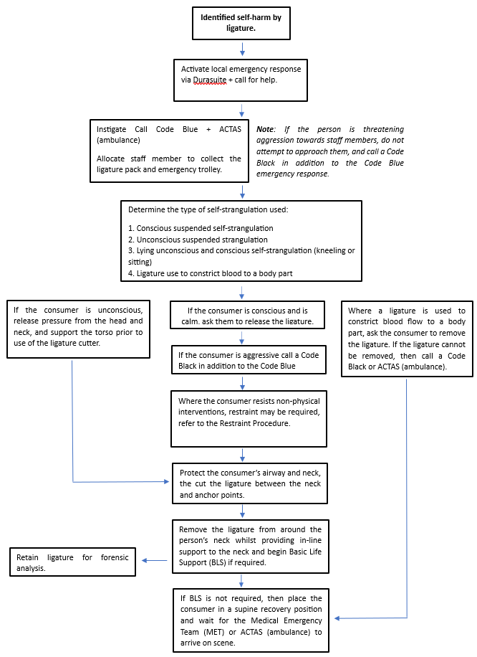

## Attachment 2- Guide to Using a Ligature Cutter

The ligature cutter is most effective when used to cut softer materials that are not too thick e.g. shoe laces, string, linen, or thin electrical cables such as the wire used for headphones and mobile phone chargers. Ligature cutters are designed to provide an effective and safe method of cutting a ligature when used correctly.

Note: Staff should not use the ligature cutter for purposes other than releasing a ligature.

The ligature cutters used within mental health inpatient services have a metal hook, which folds into a plastic handle. When the metal hook is unfolded it ‘locks’ into position for use. The hook is designed with blunt outer edges and a sharp inner edge to ensure the hook can be safely inserted under the ligature while minimising the risk of laceration or soft tissue injury to the consumer or staff. The ligature cutter can be closed by depressing the button on the side of the plastic casing and pushing the hook back into the enclosure, taking care to ensure no body parts are between the blade and the case.

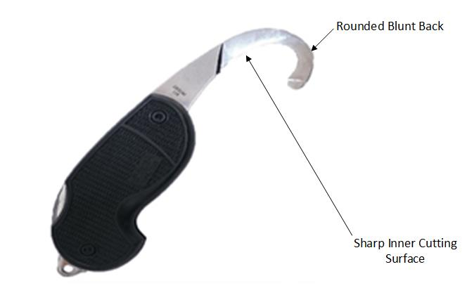

**Figure 1: Ligature cutter used in MHJHADS (not to scale)**

**Overview of Method of Use**

The ligature cutter must be opened and handled in accordance with the Manufacturer’s Instructions. To safely release a ligature the blunt round end should be firmly paced against the consumer’s skin so that it can slide under the ligature as illustrated in Figure 1. Once it has been safely placed between the consumer and the ligature, the ligature cutter should be turned so that the blade faces the ligature, i.e. away from the person, as illustrated in Figure 2.

Staff should use a sawing or twisting motion in the direction away from the consumer until the ligature is released. Staff should take care not to pull, as this may cause further injury to the consumer. Staff must retain the ligature in order to preserve evidence in the event of a police investigation.

**Figure 1 – Inserting the Ligature Cutter**

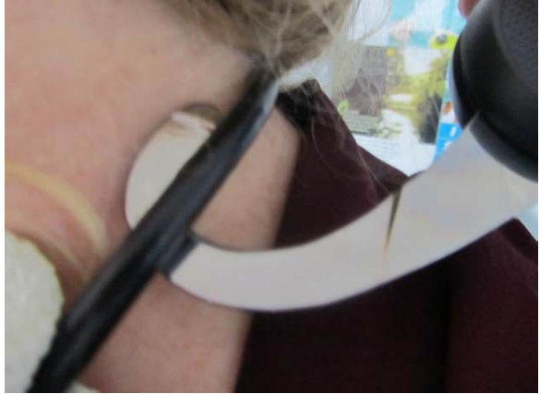

**Figure 2 – Position of a Ligature Cutter for Releasing the Ligature**

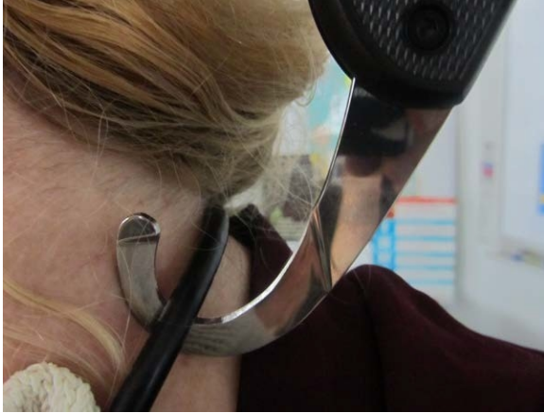

Where possible avoid cutting through the knot itself as this will make removal more difficult and the knot may also be required for forensic investigation. Once the ligature has been cut, support the person’s head and neck as much as possible while maintaining manual in-line stabilisation of the head and neck as the person is lowered to the ground in a supine position to prevent any additional spinal damage that may have occurred.

An open ligature cutter is treated as a sharp, as it is a cutting tool. Once used, the ligature cutter should be closed if the situation allows the responder time to do this. If there is no time to close the ligature cutter immediately following its use, allow another responder to do this and retain it in a safe location.

Once a ligature cutter has been used it must be immediately replaced with a new one, requested from the NIC/CNC, and stored on either the emergency trolley or, in a designated location that is readily known and accessible to clinical staff.

## Attachment 3 – *example of a ligature Floor Plan Risk Map*

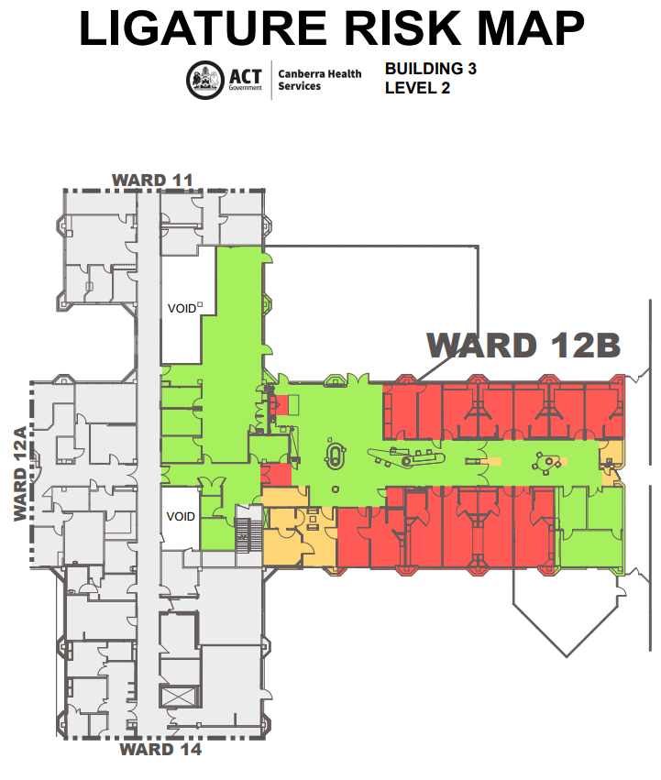

Low Risk 

Medium Risk 

High Risk 

**Attachment 4 - Ligature Risk Audit Tool (MS Forms)**

|  |  |  |  |  |  |  |  |  |
| --- | --- | --- | --- | --- | --- | --- | --- | --- |
|  | | **Service Area:** | | | | | | |
|  | | **Audit Team Members:** | | | | | | |
|  | | **Date of Audit:** | | | | | | |
|  | | **Ligature Risk Audit Tool** *(template only)* | | | | | | |
| **Ward Location** | **Room** | **Ligature Point Identified** | **Ligature Point(s) total** | **Room Rating** | **Compensatory Factors** | **Total** | Risk Mitigation Actions | |
| *Example* | *Bedroom 1A* | *Door hinge*  Window covering  Hooks |  |  |  |  | **Remove/Replace** | **Protect/Manage Locally** |
| *1* | *3* | 2 | *6* |  |  |
| *1* | *3* | 2 | 6 |  |  |
| *3* | *3* | 3 | 9 |  |  |
| Example | *TV Room* | Draw handles | *2* | *2* | 2 | 6 |  |  |

**Attachment 5 - Ligature Point Rating Matrix**

|  |  |  |  |  |  |
| --- | --- | --- | --- | --- | --- |
| **Room Designation Rating** | **Rating** | | **High** | **Medium** | **Low** |
| **Description** | | Areas where most people receiving treatment and care spend long periods of time, in private, without direct supervision of staff or in the company of their peers. | Areas where people spend periods of time with minimal direct supervision from staff and are usually in the company of peers, visitors or workers. | Where consumers spend time in areas that can only be accessed by staff and will be supervised at all times. |
| **Compensatory Factors** | **Rating** | | **High** | **Medium** | **Low** |
| **Description** | **Observation** | Limited **observation** due to poor design. | Limited observation through poor design. | Limited observation due  to poor design. |
| **Staffing** | Limited **staffing** ratios and skills mix staff. | Good staffing ratios/skills mix. | Good staffing ratios/skill mix. |
| **Culture of risk management amongst staff team** | Poor **culture** of risk  management amongst staff/team. | Poor culture of risk  management amongst  staff/team. | Reasonable culture of risk  management amongst  staff/team. |
| **Commitment to staff training and support in managing risk** | Low level of **commitment** to staff training and support in managing risk. | Commitment to staff training but low staffing levels conflict with its delivery. | Commitment to staff training and support in managing risk. |

## Attachment 6 – Canberra Health Services Risk Reduction Action Plan

**Risk Reduction and Action Plan (RRAP) – *example only***

|  |  |  |  |  |  |  |  |
| --- | --- | --- | --- | --- | --- | --- | --- |
| **Ward/Unit** | **Risk No.** | **Plan Developed from Ligature & Ligature Risk Assessment completed on: / /** | | | **Image** | | |
| **Name** | | **Designation / Signature** | | |  | | |
| **ADON** |  |  | | |
| **CNC** |  |  | | |
| **Risk**  **Location** | **Risk**  **Rating** | **Description of Risk** | **Action/s required**  **(state if action requires immediate OD escalation)** | | **Action**  **Officer** | **By**  **When** | **Status** |
|  |  |  |  | |  |  |  |
| Have risks requiring Operational Director escalation been escalated:  YES / NO | | | | Have risks requiring Facilities Management escalation been escalated:  YES / NO | | | |
| If YES, date of notification: / / | | | | If YES, date of notification: / / | | | |

|  |
| --- |
| **Assistant Director of Nursing Confirmation**  I can confirm that that a Ligature and Ligature PointRiskAssessment Audit has been completed by the Assessment Team and finalised with the Operational Director. The Risk Reduction Action Plan has identified appropriate actions arising from the completed Ligature and Ligature Point Risk Assessment and that these risks have been included on the Unit Risk Register. Risks have also been recorded on Clinical incident management system . The Unit HSR and Unit staff have been advised of the risk reduction strategies by the CNC and responsibilities assigned within the Risk Reduction Action Plan to manage and reduce the risk identified. Where further follow-up action or immediate escalation is required these items have been referred separately to the Operational Director. |

|  |  |  |  |
| --- | --- | --- | --- |
| **Submitted:** | **/ /** | **Received** | **/ /** |
| **ADON** |  | **Operational Director** |  |
| **Signed** |  | **Signed** |  |
| **Date** |  | **Date** |  |

## Attachment 7 - [Canberra Health Services Risk Assessment Template & Consequence and Likelihood Tables](https://actgovernment.sharepoint.com/:w:/r/sites/Intranet-CHS/_layouts/15/Doc.aspx?sourcedoc=%7BEFAF2092-170B-45B0-80B1-801DE7F1BAC0%7D&file=Risk%20assessment%20template.docx&action=default&mobileredirect=true&DefaultItemOpen=1)

|  |  |  |
| --- | --- | --- |
| **The risk of:** | | |
| **COMPLETE RISK ASSESSMENT DETAILS** | | |
| Group, Division, Branch, Work area/unit, physical location: | | |
| ***Completed by****:* | | |
| Name: | Signature: | Date: |

|  |  |  |  |
| --- | --- | --- | --- |
| **Risk Category** | | | |
| CLINICAL | PEOPLE INJURIES | BUSINESS OPERATIONS | PROPERTY AND SERVICE DELIVERY |
| FINANCIAL | REPUTATION | INFORMATION AND RECORDS MANAGEMENT | COMPLIANCE/ REGULATION |
| CULTURAL AND HERITAGE | NATURAL ENVIRONMENT | EMERGENCY/DISASTER MANAGEMENT (SOCIAL IMPACT) | EMERGENCY/DISASTER MANAGEMENT (COMMUNITY/PEOPLE IMPACT) |

|  |
| --- |
| **STEP 1. ESTABLISH THE CONTEXT** |
| **Context** *(What are the circumstances in which you are operating? You should consider the background, the objective of your team/unit/division, the resources available, the information/data available, the political climate, who your stakeholders are):* |
|  |

|  |
| --- |
| **STEP 2. IDENTIFY THE RISK** |
| **The risk of:** |
| **Cause** *(Why is it a risk?)* |
| **Consequence** *(What will happen if this risk eventuates?)* |

***Note:*** *The ‘risk description’ is a succinct summary of the risk, causes and consequences*

*i.e. The risk of…caused by…resulting in….*

|  |  |  |  |
| --- | --- | --- | --- |
| **STEP 3. ANALYSE THE RISK** | | | |
| **Current controls**  *What is in place NOW to control the risk?*  *(Consider policy and procedures, education programs, data analysis)* | **Are these controls effective in reducing the risk?** | | |
|  | ADEQUATE | NEEDS IMPROVEMENT | INADEQUATE |
|  | ADEQUATE | NEEDS IMPROVEMENT | INADEQUATE |
|  | ADEQUATE | NEEDS IMPROVEMENT | INADEQUATE |
|  | ADEQUATE | NEEDS IMPROVEMENT | INADEQUATE |
|  | ADEQUATE | NEEDS IMPROVEMENT | INADEQUATE |
|  | ADEQUATE | NEEDS IMPROVEMENT | INADEQUATE |
|  | **Consequence**  *Most likely/ common form, not worst case* | **Likelihood** | **Risk Rating** |
| **Current level of risk** *(Consider all existing/current controls)* |  |  |  |

*Refer to the CHS Consequence and Likelihood rating tables on p3-5 of this document. For full resolution versions, refer to the* [*Healthhub*](https://actgovernment.sharepoint.com/sites/Intranet-CHS/SitePages/Risk-management.aspx)

|  |
| --- |
| **STEP 4. EVALUATE THE RISK** |
| *A totally risk free environment is unrealistic. Risk evaluation should recognise that it is not usually possible to eliminate all risk and question whether the current level of risk is tolerable.* |
| **This risk is:**  **ACCEPTABLE**  **INTOLERABLE** |

*Refer to the Priority for action table on p6 of this document.*

|  |  |  |  |  |  |
| --- | --- | --- | --- | --- | --- |
| **STEP 5. TREAT THE RISK** | | | | | |
| **RISK TREATMENT ACTION PLAN**  *What* ***needs to be done*** *to better control the risk? eg actions to strengthen existing controls, new initiatives to control the risk.* | | | | | |
| **Possible Risk Treatment Actions/Strategies** | **Advantages** | **Disadvantages** | **Action/**  **Strategy accepted (Yes/No)** | **Action Owner**  *(Position responsible for completing the action)* | **Estimated completion date** |
|  |  |  |  |  |  |
|  |  |  |  |  |  |
|  |  |  |  |  |  |
|  |  |  |  |  |  |

|  |  |  |  |
| --- | --- | --- | --- |
|  | **Consequence** | **Likelihood** | **Risk Rating** |
| **Target level of risk**  *(Level of risk that is aspired to following implementation of risk treatment action plan)* |  |  |  |

