**Canberra Health Services**

**Guideline**

**Clozapine Therapy**

|  |
| --- |
| Contents |

Contents 1

Guideline Statement 4

Background 4

Key Objective 5

Scope 6

Roles and Responsibilities 6

Section 1 – Legislation and Regulation 8

1.1 Medicines, Poisons and Therapeutic Goods Regulation (2008) 8

1.2 Pharmaceutical Benefits Scheme and Highly Specialised Drugs (HSD) Program 9

1.3 First 18 weeks of Treatment (Titration) 9

1.4 After 18 weeks (Maintenance) 10

1.5 Accessing Clozapine in the Community 10

1.6 Supply of Clozapine for Patients in Financial Hardship 11

1.7 Therapeutic Goods Administration (TGA) mandatory haematological monitoring 11

Section 2 – Clozapine Centre in the ACT 12

2.1 Clozapine Coordinator 12

2.2 MHJHADS Community Clozapine Assistants (clozapine nurses) 13

Section 3 – Commencing a Patient on Clozapine 13

3.1 Physical health and psychiatric assessment pre-commencement of clozapine 13

3.2 Pre-Commencement Tests and Baseline Monitoring Measurements 14

3.3 Pre and Post-Commencement Pharmacy Review 15

Section 4 – Consent to Treatment 15

Section 5 – Preparation for Clozapine Initiation 16

5.1 Pre-Initiation Education 16

5.2 Linkages and Feedback to General Practitioners (GP) 16

5.3 Physical Health in Care Plan 17

5.4 Clozapine Blood Results Monitoring 17

5.5 Prescribing 18

5.6 Clozapine Titration Guide 19

5.7 Inpatient Medication Orders 19

5.8 Special Prescribing Considerations 20

5.9 High Risk Groups and Special Populations 20

5.10 Maximum Dose 21

Section 6 – Clozapine Initiation Sites 21

6.1 Adult Mental Health Day Service (AMHDS) clozapine initiation 21

6.1.1 Inclusion Criteria for Community Initiation 22

6.1.2 Exclusion Criteria for Community Initiation 22

6.2 North Canberra Hospital Clozapine Initiation 24

6.3 Hospital Inpatient and AMHDS Administration and Monitoring Procedure: 24

6.3.1 Initial Dose administration & Vital Signs Monitoring: 24

6.3.2 Second Dose administration & Vital Signs Monitoring: 25

6.4 Non-Adherence to Clozapine Therapy in Community Patients 26

6.5 Transfer of Care from AMHDS Post Initiation 26

6.6 Ongoing Monitoring Requirements 27

Section 7 – Community Recovery Service Nurse-led Clinics 29

7.1 The Clozapine Assistant 29

7.2 Screening for side effects 30

7.3 Early warning signs of deteriorating patient and Code Blue in community setting 31

7.4 Clinic equipment requirements 31

Section 8 – Management of People in Amber and Red Ranges and Medical Emergencies 32

8.1 AMBER Range 32

8.2 RED Range 32

8.3 Other Serum Blood Results Flagging Potential Clozapine Discontinuation 33

8.4 Patient and carer education – Clozapine patient care card 33

8.5 Emergency Department Presentations 33

Section 9 – Interactions with Other Medicines and Substances 34

9.1 Clozapine and smoking – tobacco and cannabis 35

9.2 Clozapine and Caffeine 35

9.3 Clozapine and Other Drug Interactions 36

*Potential to increase clozapine levels* 36

Section 10 – Potential Side Effects of Clozapine 37

Section 11 – Maintenance therapy Medical Review, Monitoring, Blood Screening and Pathology 45

11.1 Pathology 45

Section 12 – Clozapine Supply and Prescribing Limitations 46

Section 13 –Restarting Clozapine Therapy After Interruption and Inpatient Admissions 47

Section 14 – Discontinuing Clozapine: Dose Reduction and Monitoring 48

Section 15 – Managing People Transferring within Australia and Overseas 48

Section 16 – Special Dispensation of Clozapine 49

Section 17 – Managing Complications and Adverse Events 49

Section 18 – Important Contacts 50

Evaluation 51

Related Policies, Procedures, Guidelines and Legislation 52

References 54

Definition of Terms 56

Search Terms 56

Attachments 57

Attachment A: Haematological monitoring to initiate a patient on clozapine 58

Attachment B: Minimum monitoring as per CPMSTM, 2023 59

Attachment C: Lester Tool 60

Attachment D: Potential drug interactions with clozapine (Metro South Health Service District, Mental Health Services Shared Care Protocol,Health, 2016). 62

Attachment E: Porirua Protocol - adapted 63

Attachment F : Clozapine pre-commencement checklist 64

Attachment G: AMHDS temperature monitoring at home agreement – print approved form agreement from forms register 65

Attachment H: GP clozapine initiation letter 66

Attachment I: Nurse-led clinic workflow 67

Attachment J: Recommended AMHDS care pathway for weeks 1 to 4: 68

Attachment K: Physical health in care plan (clozapine therapy) 71

Attachment L: Inpatient unit clozapine initiation flowchart 74

Attachment M: Minimum recommended monitoring and test schedule 9 75

Attachment N: Clozapine patient care card 76

Attachment O: Charter of Health Care Rights 77

|  |
| --- |
| Guideline Statement |

Canberra Health Services (CHS) Network, through the Division of Mental Health, Justice Health and Alcohol and Drug Services (MHJHADS), has a responsibility to ensure the safe and effective use of clozapine, including:

* ensuring patient meets criterion for use.
* registration with a clozapine patient monitoring system (Clozaril® Patient Monitoring System [CPMSTM] or ClopineCentral™)
* pre-treatment haematological and metabolic screening
* ongoing haematological and metabolic monitoring.

CHS Network includes the inpatient facilities at Canberra Hospital, Clare Holland House, North Canberra Hospital, and University of Canberra and community-based services.

This Guideline provides recommendations regarding best practice for the safe and effective prescription, initiation, commencement and monitoring of the use of clozapine therapy to support decision making, minimise the risk of people experiencing an adverse drug event and to standardise evidence-based practice for clozapine treatment in the management of people with schizophrenia.

This Guideline is to be read in conjunction with the appropriate drug brand protocol being either CPMSTM Protocol, 2023 + with Covid-19 update in CPMS (or later version) or ClopineCentral™, 2021 amended version (or later version). It supports the National Safety and Quality Health Service Standards, Standard 4 - Medication Safety, which aims to ensure competent clinicians safely prescribe, dispense, and administer appropriate medicines to people who are informed about their medicines.

## Background

Clozapine, trade named Clozaril® or Clopine®, is a medication regulated by the Therapeutic Goods Administration (TGA), subsidised under the Pharmaceutical Benefits Scheme – Highly Specialised Drugs Program (PBS S100).

Clozapine is an atypical antipsychotic of the dibenzodiazepine class indicated for use in the management of schizophrenia, for patients who have had inadequate responses to other antipsychotic medication.

Treatment-resistant Schizophrenia is defined as moderate or greater impairment in functioning which fails to respond to an adequate trial (six weeks with >80% adherence) of two or more antipsychotic drugs at a dose equivalent to at least 300 mg chlorpromazine daily 29.

Clozapine is the most effective antipsychotic for reducing positive symptoms and hospitalisations among people with treatment-resistant schizophrenia. Clozapine therapy must be used in partnership with the patient and is enhanced when used in combination with psychosocial therapies such as cognitive behavioural therapy (CBT) for psychosis, illness self-management training, family support and education. Patients and families/carers are to be provided with educational information to support their understanding of this medication and potential side-effects.

Clozapine is the most effective antipsychotic in terms of symptom reduction but is reserved for third line use as it has more risks and monitoring requirements when compared to other antipsychotic medications. Clozapine has a high adverse event burden due to potential life-threatening haematological and cardiac effects. Serious adverse effects include neutropenia, agranulocytosis, and myocarditis. Participants may only be prescribed clozapine when mandatory blood testing and other monitoring requirements can be met. Monitoring reduces the incidence of fatal outcomes related to adverse effects of clozapine.

National and local legislation, regulation, standards, and policies govern the use of clozapine to ensure that it is safely and effectively prescribed, supplied, initiated, administered, and monitored in both hospital and community-based settings.

CHS has a responsibility to ensure the safe use of clozapine with adherence to the Australian Government Department of Health Pharmaceutical Benefits Scheme Guidelines, the national Clozaril® Patient Monitoring System (CPMS) Protocol TM as well as local Service Standards. The two clozapine monitoring systems used within Australia can be accessed at <https://www.ecpms.com.au/> (for Clozaril®) or <https://www.clopine.com.au/> (for Clopine®).

The safe management of clozapine is the responsibility of all staff involved in clozapine therapy.

## Key Objective

The key objective of this document is to provide an evidence based and contemporary clinical guideline consistent with the CPMSTM protocol for the safe, quality and consistent use of clozapine therapy, and to assist in and provide transparency on decision-making and communication pathways related to the safe and quality use of clozapine prescribing practices of CHS staff.

This guideline has been developed inclusive of the CPMSTM Protocol June 2023. The protocol, or any amended or newer versions, should always be referred to. Exceptions to the use of Clozaril® brand from Mylan Pharmaceuticals, must be notified to the Clozapine Coordinator to ensure adherence to the Pfizer ClopineCentral Protocol TM.

*Back to Table of Contents*

|  |
| --- |
| Scope |

This guideline applies to CHS Network staff (permanent, temporary and casual) and all organisations and individuals acting as their agents (including Visiting medical officers and other partners, contractors, consultants and volunteers), involved in the prescription, initiation, maintenance and monitoring of clozapine use, including private psychiatrists working with CHS Network public patients, general practitioners (GP), registered nurses and hospital and community pharmacists working in partnership with CHS Network.

For the purposes of this document, the term clozapine therapy refers to the prescription, initiation, maintenance, and monitoring of the use of clozapine in both in-patient and community settings across CHS Network. CHS Network includes the inpatient facilities at Canberra Hospital, Clare Holland House, North Canberra Hospital, and University of Canberra and community-based services.

Note that Deakin Private Mental Health Hospital, Hyson Green and private practice centres are not covered by this guideline.

*Back to Table of Contents*

|  |
| --- |
| Roles and Responsibilities |

The MHJHADS Director of Clinical Services, or equivalent at NCH, is responsible for the implementation, monitoring, and evaluation of clozapine guidelines.

**Clinical Directors**

The Director of Clinical Services is responsible for ensuring that staff involved in clozapine patient care and treatment are aware of and understand the responsibilities and requirements outlined in this guideline.

Medical officers prescribing clozapine must know the indications, contraindications, potential adverse effects and treatment options, and reporting requirements. Medical officers are also responsible for ensuring the screening and monitoring tests are ordered at appropriate intervals and reviewed in a timely manner, that CPMS™ or ClopineCentral™ relevant documentation and forms are completed and that prescriptions meet the Therapeutic Goods Administration (TGA) and Pharmaceutical Benefits Scheme (PBS) Section 100 standards.

Nursing officers involved in the support of the treating psychiatrist must be adequately prepared to function in this role, including receiving orientation to the role of clozapine assistant and in completing the endorsed clozapine training.

**Director of Pharmacy**

The Director of Pharmacy at each site is responsible for facilitating the smooth running of CPMSTM registered hospital pharmacies and ensuring all pharmacy staff comply with appropriate clozapine protocols. Pharmacists must be aware of the PBS Highly Specialised Drugs (Section 100) rules, CPMSTM protocol and this Guideline.

**Clozapine Coordinator**

The Clozapine Coordinator for CHS is central to ensuring compliance by all registered personnel with the CPMSTM protocol, thereby ensuring patient safety, and monitoring weekday email alerts. All participants, health professionals, medical officers, pharmacists, pharmacies, clozapine assistants and the Clozapine Coordinator must be registered with the relevant clozapine patient monitoring system.

All clinicians are responsible for notifying the treating team and the Clozapine Coordinator, by phone and by the generic Clozapine Coordinator email, of any adverse events or deviations from the protocol, such as failure to have blood tests. The first clinician to become aware of an incident, such as a refusal to have a blood test or an adverse reaction, should complete a Riskman with ‘Clozapine’ in the description of the incident. The Clozapine Coordinator will confirm by phone and email the treating doctor has been made aware of the incident and will make a notification on the electronic medical records system Digital Health Record (DHR).

**Clozapine Assistants (local centre contact)**

Registered Nurses assigned as the Clinical Recovery Service (CRS) team clozapine assistant are responsible for managing nurse-led clozapine clinics. This involves, but is not limited to, reviewing and assessing participants as per the CPMSTM protocol, notifying medical officer if complications are observed or there are potential adverse drug interactions, reporting on a regular basis against blood monitoring protocols, updating the ‘Clozapine Caseload report’ and updating the patient monitoring service database (refer to Attachment I). In bed-based areas, the CNC or staff who are delegated to perform in that role support the treating medical team as required.

**Clinical Managers**

Clinical Managers work closely with people taking clozapine, the Clozapine Coordinator and clozapine assistants to follow up on adherence to monitoring protocols, particularly blood tests. When the patient is not clinically managed, the CRS Team Leader will work with the clozapine assistant to ensure adequate resources are available to meet monitoring requirements.

**The patient and their carer**

People receiving clozapine therapy are referred to as patients in this document to align with the use of the term patient in the CPMSTM Protocoland Clozapine Patient Number (CPN). Carers are important in supporting the patient on clozapine and often provide support for the patient to attend appointments, clinic reviews, blood tests and pick up medication. The views and needs of carers should be considered, along with the views and needs of the patient, when decisions are made that impact carers and the role of carers.

*Back to Table of Contents*

|  |
| --- |
| Section 1 – Legislation and Regulation |

The initiation, ongoing administration, supervision and monitoring, education, and other supports for people on clozapine therapy is informed by National, State and Territory legislation, regulations, standards, policies, and procedures. A summary of the key legislative and regulatory components of this framework, including the clozapine system in the ACT, is provided in Sections 1.1 to 1.4.

## 1.1 Medicines, Poisons and Therapeutic Goods Regulation (2008)

Clozapine is classed as a restricted Schedule 4 medicine under the Medicines, Poisons and Therapeutic Goods Regulation (2008) and due to potential hazards with its use, the prescribing of clozapine is also restricted.

Clozapine may only be prescribed by someone who has received an authorisation to do so and this reflects the need to ensure that medical officers prescribing clozapine are properly qualified and aware of monitoring practices to minimise the adverse event risk for people prescribed this medication. In the initial treatment phase, this requirement limits prescriber approval to specialists practising in the specialist area of mental health or a doctor employed by the Territory and working under supervision of the Chief Psychiatrist under the *Mental Health Act* 2015 (ACT).

**Medical Officer Registration on CPMSTM**

Medical officers ***must*** therefore meet the following criteria before they commence any prescribing of clozapine and initiation of treatment:

* have standing approval to be a prescriber under the Medicines, Poisons and Therapeutic Goods Regulation (2008); **and**
* be familiar with the CPMSTM protocol which is available from the Clozapine Coordinator (senior nurse) or clozapine assistants; **and**
* be a prescriber on the CPMSTM database registered to Canberra Hospital (including CHS and UCH) or to North Canberra Hospital (NCH) (depending on where the patient is), which can be facilitated by the Clozapine Coordinator.

Pharmacists may only dispense prescriptions for clozapine written by an approved prescriber. It is the responsibility of the prescriber and the dispenser to ensure that they are operating within their legislative and governance boundaries.

**MHJHADS Registered Prescribers**

The CPMSTM registered MHJHADS prescribers register will be maintained by the Clozapine Coordinator and available to all community clozapine clinics for reference.

## 1.2 Pharmaceutical Benefits Scheme and Highly Specialised Drugs (HSD) Program

For the purposes of initiation of treatment, clozapine is classified as a ‘highly specialised drug’ (section 100 HSD) under the PBS 3. HSDs are medications for the treatment of chronic conditions which, because of their clinical use or other special features, are restricted to supply through public and private hospitals having access to appropriate specialist facilities.

Patients **stabilised** on clozapine may access their medicine through community pharmacies (via the S100 HSD Community Access Scheme) as well as through the public hospital system. CHS Network patients in the community utilise the private community pharmacy system unless there are special circumstances.

The PBS has a number of other administrative requirements that must also be met in relation to the prescribing and dispensing of clozapine.

For the purposes of **‘Initial Treatment’** of people with clozapine, the following clinical and treatment criteria must be met:

* the patient must be non-responsive to other neuroleptic agents OR
* the patient must be intolerant of other neuroleptic agents AND
* the patient must be treated by a psychiatrist or in consultation with a psychiatrist affiliated with the hospital or specialised unit managing the patient.

## 1.3 First 18 weeks of Treatment (Titration)

**For CHS Network sites:** For the first 18 weeks, outpatient supply of clozapine treatment the patient will be required to access supply through Canberra Hospital Pharmacy under the **initiation streamline code 5015.**

If treatment is initiated as an inpatient, the clozapine will be supplied from the pharmacy department of the NCH Network site the patient is admitted to up until the patient is discharged back to the community setting.

Patients must complete a minimum of 18 weeks of initial treatment under this restriction before being able to qualify for treatment under the continuing restriction. The name of the consulting psychiatrist should be included in the DHR. Titration must be done under the guidance of a consultant psychiatrist.

## 1.4 After 18 weeks (Maintenance)

**For CHS Network sites:** After completing the initial 18 weeks, and when the patient is considered stable by the treating psychiatrist, prescribers and patients have the choice as to which community pharmacy dispenses their clozapine. The requirements to be able to access clozapine via the S100 HSD Community Access Scheme can be found on the Pharmaceutical Benefits Scheme (PBS) website. **The maintenance streamline code is 4998.**

For the purposes of the PBS subsidy for clozapine “continuing/maintenance therapy”, eligible prescribers in the community are able to prescribe clozapine without the need to demonstrate an association with a hospital but must follow the authority approval process for prescribing clozapine and can only prescribe clozapine for maintenance therapy under the guidance of the patient’s treating specialist.

## 1.5 Accessing Clozapine in the Community

To access medication in the community, prescriptions will need to be ordered on the Digital Health Record, or a PBS Authority Script. Community authority prescription will also need each individual strength of medication written as separate prescriptions (i.e. a dose of 425mg would require 2 prescriptions, one for 100mg supply and another for 25mg supply).

The community pharmacy and pharmacist will need to be registered with the CPMSTM system database. There is also the requirement of clozapine dispensing that the pharmacy is provided with a copy of the current blood count results verified by a medical officer.

Please note the following important points:

1. Ensure that the prescriptions written are compliant with PBS requirements:
   1. The streamlined authority code needs to be written next to each item.
2. The streamline code for initiation therapy is 5015
3. The streamline code for maintenance therapy is 4998
   1. Medicare and concession details need to be annotated on each prescription
   2. Different strengths need to be written on
4. Hospital scripts supply - two separate lines
5. Community scripts supply - two separate prescriptions

(please note Clozaril® only available in 25mg and 100mg)

* 1. Prescriber number and name needs to be written on each prescription in addition to the prescriber signature.
  2. Quantities are to be written in number of tablets
* For patients who require >200 tablets of either strength, a phone authority is required, and the prescription should be written on a blue PBS authority script.
* The Canberra Hospital (TCH) Pharmacy Department needs at least 24 hours’ notice for dispensing (i.e. the scripts should be faxed or entered into electronic medical records system (DHR) at least 24 hours before desired collection time).
* Canberra Hospital stocks Clozaril® brand of clozapine as the preferred formulary brand.

1. Patients should be maintained on a single brand of clozapine throughout therapy wherever possible, and prescriptions should be specified for Clozaril® brand for dispensing accessed through the S100 HSD Community Access Scheme. Prescribers are advised to endorse their scripts, to prevent brand substitution from occurring and to ensure compliance with the recent introduction of active ingredient prescribing. A small stock of Clopine® is also kept in imprest by the Canberra Hospital Pharmacy for continuity of therapy if required.

## 1.6 Supply of Clozapine for Patients in Financial Hardship

MHJHADS patients who encounter financial hardship, post titration period, may in some circumstances be able to obtain their clozapine supply from the Canberra Hospital pharmacy. A co-contribution is required by the PBS for each script. Such arrangements should be discussed with the Team Leader of the relevant mental health team and the Director of Pharmacy for the payment of this co-contribution.

The payment of the co-contribution will be at the discretion of the Mental Health Team Leader/Manager, based on discussion between the treating team and patient where financial hardship is demonstrated. This also allows the manager to work with clinicians on what other supports can be put into place for the patient to strengthen their financial independence.

The service will generally only pay for those people who can demonstrate financial hardship. The patient may be required to provide documentation to support their request and complete the *CHS Patient Debt Write-Off*.

The patient and/or carer/guardian will be informed in writing if this arrangement is approved by the treating mental health team, and that it is a temporary arrangement and subject to review.

## 1.7 Therapeutic Goods Administration (TGA) mandatory haematological monitoring

The TGA has implemented mandatory haematological monitoring standards in Australia to promptly identify and minimise the risk of clozapine side effects.

All authorised clozapine prescribers must comply with the following mandatory monitoring standards:

* pre-treatment parameters including baseline haematological, metabolic, and cardiac screening
* periodic haematological, metabolic, and cardiac testing once treatment has commenced and/or following cessation of treatment.

*Back to Table of Contents*

|  |
| --- |
| Section 2 – Clozapine Centre in the ACT |

People receiving clozapine therapy are listed as ‘belonging’ to a specific centre through their registration with the centre.

Each centre has one nominated centre coordinator (Registered Nurse) who is responsible for overseeing and facilitating successful adherence to the Clozaril® Patient Monitoring System (CPMS) Protocol TM and/or ClopineCentral™ protocol and relevant guidelines. This person is known as the Clozapine Coordinator.

The *Canberra Hospital* centre provides clozapine treatment to the Adult Mental Health Unit (AMHU) at the Canberra Hospital, MHJHADS ‘outlier’ inpatients within CHS - the Alexander Maconochie Centre (AMC), Adult Mental Health Rehab Unit (AMHRU) at the University of Canberra Hospital (UCH), Bimberi Youth Justice Centre,Dhulwa Mental Health Unit (DMHU) and the Gawanggal Mental Health Unit (GMHU). Canberra hospital centre also includes the MHJHADS Community teams such as Assertive Community Outreach Service (ACOS), Community Recovery Service Teams,Older Persons Mental Health Community Team (OPMHCT), and the Child and Adolescent Mental Health Service’s (CAMHS) - Specialist Youth Mental Health Outreach Team (SYMHO).

**Note**:

The *North Canberra Hospital* centre provides clozapine to NCH Mental Health Unit **inpatients only** and the *North Canberra Hospital* centre registration is for NCH clinicians working at NCH.

*Canberra Hospital* centre registration is for CHS Network clinicians working within their role in CHS Network sites listed above. Clinicians who move from CHS Network to other jurisdictions, or move to CHS Network from other jurisdictions, need to register with the appropriate centre.

## 2.1 Clozapine Coordinator

The Clozapine Coordinator is a senior MHJHADS Registered Nurse whose primary duties include overall management of the clozapine system, and whose role includes:

* overarching supervisory and management guidance over the five CRS clinics, ACOS and OPMHCT
* facilitating completion of new patient registrations
* communicating registrations, discontinuations, transfers, and information about people from the centre to the CPMSTM (or ClopineCentral™) office
* ensuring that all teams comply with the CPMSTM (or ClopineCentral™) protocols
* facilitating approval of personnel registrations including those for medical officers, pharmacists, and clozapine assistants (nurses)
* providing education, assistance and training for staff involved in the care of people receiving clozapine therapy
* provide training for clozapine clinic staff on complexities of patients on clozapine and other issues such as AOD / physical health/ side effects/medication interactions
* liaison with inpatient teams and support for processes
* follow up of abnormal results and CPMSTM notifications of missed bloods, late dispensing, discontinuation of medication
* conducting file audits
* facilitating regular clozapine assistant orientation and induction training
* facilitating Complex Clozapine Multidisciplinary Team Meetings (CCMDT) across all the clinics in the ACT region with all nurse practitioners, doctors and clozapine assistants involved in these clinics, with the aim of discussing complex patients, review of procedures and policies and ensuring there is standardisation across all the clinics.

## 2.2 MHJHADS Community Clozapine Assistants (clozapine nurses)

Registered Nurses working in the community CRS teams are assigned to manage nurse-led clozapine clinics as their primary role (refer to section 7). All clozapine assistants are required to undergo orientation and induction training overseen by the Clozapine Coordinator prior to commencing these duties.

For **inpatients** of NCH, a clozapine assistant (a senior mental health nurse) is available to assist with monitoring and coordination of clozapine therapy for NCH inpatients

*Back to Table of Contents*

|  |
| --- |
| Section 3 – Commencing a Patient on Clozapine |

People can be commenced on clozapine through admission to an appropriate public inpatient facility e.g. AMHU, AMHRU, NCH Mental Health Ward, DMHU or GMHU. Clozapine can also be commenced as a day patient at the AMHDS, within the AMC and Bimberi Youth Justice Centre, if clinically appropriate and operationally feasible. Clozapine may be initiated in a community team with the approval of the program area’s clinical director, who has the authority to decide if the treatment is clinically appropriate and operationally feasible. Refer to community inclusion and exclusion criteria in section 6.1

In the case of a patient commencing clozapine as a day patient, the medical work-up and the registration and allocation of a clozapine patient number (CPN) for the patient receiving treatment, must be completed by the primary team prior to admission. Refer to Attachment F for pre-commencement checklist.

## 3.1 Physical health and psychiatric assessment pre-commencement of clozapine

Where clozapine is being considered a comprehensive physical and psychiatric assessment of the patient must be undertaken including, where relevant, information from the patient’s previous treating psychiatrist/ team/ carer(s).

A full medical examination is required and the list below provides an overview of key assessments to be undertaken pre-commencement (with acknowledgement to the State of Queensland [Queensland Health] - Safe and quality use of clozapine therapy in mental health services, 2016):

* history of medication and other past treatments – including whether clozapine has been used before and if the patient was previously discontinued from any brand of clozapine due to neutropenia or agranulocytosis
* assessment of current smoking status
* height, weight, and waist measurements
* any possible history of drug-induced neutropenia or bone marrow disorders, or any other factors that might increase the risk of neutropenia or agranulocytosis while on clozapine.
* relevant family history including ethnic background of Afro-Caribbean or African ancestry that infers a risk of benign ethnic neutropenia (BEN) with naturally low neutrophil counts
* any history or family history of cardiac related disorders that could increase the risk of cardiac related side effects while on clozapine e.g. hypertension
* any history or family history of diabetes mellitus, dyslipidaemia, or other metabolic disorders
* any history or family history of epileptic activity
* any history or family history of thromboembolism
* pregnancy status
* breast feeding status—the benefits of clozapine therapy must be carefully considered as clozapine is excreted in breast milk
* current bowel habits
* allergies and adverse drug reactions.

## 3.2 Pre-Commencement Tests and Baseline Monitoring Measurements

Prior to commencement baseline measurements are to include:

* blood group and full blood count, white blood cell count and neutrophil count
* beta human chorionic gonadotropin - female (Beta HCG) - pregnancy check
* urea / electrolytes
* prolactin and thyroid function
* fasting glucose and lipids
* liver function tests
* cardiac enzymes-including Troponin T and I and creatine kinase
* C - reactive protein (CRP) - inflammatory marker
* electrocardiogram (ECG)
* echocardiogram (ECHO).

**Note:**

Under some circumstances it may not be possible to get a transthoracic echocardiogram prior to the commencement of clozapine. The decision to commence clozapine without a transthoracic echocardiogram should be based on an individual risk assessment and the rationale documented in the electronic medical records system (DHR).

Pre-treatment / baseline white blood cell and neutrophil counts must be reviewed and provided in accordance with the CPMS Protocol TM (refer to Attachment A).

## 3.3 Pre and Post-Commencement Pharmacy Review

Prior to commencement a pharmacist review of current medications, prescribed, over the counter and lifestyle substances should be conducted. Interactions should be noted, and strategies developed to manage potential unwanted interactions. This may include packing medications in Dose Administration Aids so that medications with interactions such as some anti-depressants are taken in the morning and the clozapine dose in the evening, minimising inappropriate dosing by the patient.

During post commencement reviews any new medication prescribed by the GP should be assessed for interactions (refer to Attachment D).

*Back to Table of Contents*

|  |
| --- |
| Section 4 – Consent to Treatment |

Clozapine treatment is actioned after informed consent has been obtained. The initiation process should be explained to the patient and their family/carers by the treating medical officer. The patient and, where applicable, their identified carer/family member/guardian must be made aware of the following as part of informed consent:

A *patient health information storage consent* *form* can be obtained from the relevant Clozapine Coordinator or CPMSTM website and **must** be signed by the patient or their guardian, or prescriber on the patient’s behalf, and forwarded to CPMSTM before registration can occur and clozapine can be prescribed. A copy of this completed form must be uploaded into the patients DHR.

Note: The protocol for ClopineCentral™ states that the consent form must not be sent to Pfizer but added to the patient clinical record.

*Back to Table of Contents*

|  |
| --- |
| Section 5 – Preparation for Clozapine Initiation |

The authorising consultant psychiatrist must determine if the patient is suitable for treatment by clozapine therapy. Where a patient is identified as suitable for treatment, the medical officer must inform the Clozapine Coordinator (refer to contact details) of their intention to commence the patient on clozapine.

Clozapine potentially causes life threatening haematological and/or cardiac side effects. To ensure these risks are managed in a systematic way:

* all patients on clozapine should have a FYI flag recorded in the electronic medical records system (DHR), indicating they are on clozapine
* All patients prescribed clozapine should be enrolled to the Clozapine Treatment service under DHR’s Programme Management. Note: The Adult Mental Health Service, Child and Adolescent Mental Health Services (CAMHS) status must be Open – Active to enrol the Clozapine Service. Note: The Clozapine Team is not the primary team
* all adverse events, abnormal blood results and/or cardiac complications must be communicated to the Clozapine Coordinator and treating doctor immediately. They must be recorded in the patient’s DHR and a Riskman incident report completed.

## 5.1 Pre-Initiation Education

Education should be provided both verbally and in writing to families and/or carers and support persons who undertake to support the patient receiving clozapine. Provision of the education must be documented in the patient’s DHR. It is the responsibility of the initiating prescriber to acknowledge their responsibility to manage and provide education on the physical health-related side effects of this medication (e.g. metabolic syndrome, cardiac complications). The *Australian Charter of Health Care Rights* should be provided at this time (refer to Attachment O). The charter reflects an increased focus on person-centred care and consumer empowerment. The charter includes a right to partnership, information and provide feedback.

Information must also be provided about the monitoring requirements for clozapine therapy:

* post – initiation, people receiving clozapine must attend weekly haematological screening (FBC), and medical reviews during the 18-week initiation and titration period, and
* clozapine clinic four (4) weekly thereafter, and
* six monthly medical review, or as clinically indicated, for the remaining period they are receiving clozapine.

## 5.2 Linkages and Feedback to General Practitioners (GP)

The prescribing doctor should ensure that all members of the team are clear about who is responsible for monitoring the patient. Good communication, including between specialists, GPs and pharmacists is essential for the safe use of clozapine.

The prescribing medical officer is responsible for ensuring the diagnosis and medications recorded in the patient’s clinical record are accurate and up to date. The CRS clozapine assistant, or other program area assigned nurse, is responsible for maintaining an accurate record of the patient’s current GP. As part of the physical health assessment prior to commencement of clozapine, the treating team should enquire about the patient’s current GP and barriers or hindrances to accessing the GP.

Should the patient not have a GP, the matter should be escalated to the team leader.   
(Refer to the *CHS Providing Physical Health Care across Mental Health, Justice Health and Alcohol & Drug Services Guideline* for more information.)

The GP is part of the treating team. Prior to initiation on clozapine the prescribing medical officer (or delegate) should inform the patient’s GP of the initiation on clozapine, to ensure the GP is aware of ongoing clozapine prescription and titrating weekly and then maintenance four (4) weekly FBC monitoring requirements and provide an emergency contact number for the treating team/ACCESS team (refer to Attachment H).

Specialists are encouraged to send a regular report or communication to the GP to keep them informed of any changes to presentation and/or doses and request ongoing physical health monitoring or treatment such as management of metabolic syndrome. It is recommended that, at a minimum, the prescriber communicates with the GP at each six-month review.

During post-commencement reviews and clinics any new medication prescribed by the GP should be assessed for drug interactions (refer to Attachment D).

## 5.3 Physical Health in Care Plan

An entry should be made in the patient’s Mental Health Care Plan in the DHR to detail roles and responsibilities involved in the ongoing physical health care and monitoring relating to clozapine therapy. This should be entered as soon as practicable. In addition to psychoeducation and the provision of the c*lozapine patient care card*, this forms part of the therapeutic and safety partnership with the patient and their carer/guardian and GP. Refer to Attachments K and N.

## 5.4 Clozapine Blood Results Monitoring

Information required for CPMSTM registration and the provision of a CPN includesbaseline/pre-treatment results-blood results which can be **no older than 10 days old** to be valid for registration. A patient’s white blood cell count and neutrophil blood count are required to be registered with the clozapine patient monitoring service (CPMSTM or ClopineCentral™) **prior** to commencement of clozapine. Refer to Attachment L for an inpatient initiation process flow chart.

**Table 1: CPMS Clozapine blood results monitoring system** 5. **\* B.E.N. = Benign Ethnic Neutropenia.**

|  |  |  |
| --- | --- | --- |
| **White Blood Cell and Neutrophil count results** | | **Recommended Action** |
| **GREEN RANGE** | **WBC** >3.5 x 10^9/L  **Neutrophils** >2.0 x 10^9/L  **B.E.N.* [see below]**  **WBC** >3.0 x 10^9/L  **Neutrophils** >1.5 x 10^9/L | Clozapine therapy may be commenced subject to assessment by the treating Consultant Psychiatrist and successful registration. |
| **AMBER RANGE** | **WBC** 3.0 -- 3.5 X 10^9/L  **Neutrophils** 1.5 -2.0x 10^9L  **B.E.N.* [see below]**  **WBC** 2.5-3.0 x 10^9/L  **Neutrophils** 1.0-1.5x10^9/L | Repeat blood count after one week. If still within the same range, Clozapine therapy may commence subject to assessment by the treating Consultant Psychiatrist and successful registration.  Increase monitoring to twice weekly |
| **RED RANGE** | **WBC** <3.0 X 10^9/L  **Neutrophils** <1.5 x 10^9/L  **B.E.N.* [see below]**  **WBC <** 2.5 x 10^9/L  **Neutrophils** < 1.0 x10^9/L | **STOP**  The patient cannot receive further clozapine  Repeat test in 24 hours  **CLOZAPINE THERAPY MUST NEVER BE STARTED**  Within 24 hours, forward the red result to the CPMS office, and perform a second blood count. Call CPMS haematologist 0404 451 327 on receipt of first red result.  If result remains red range repeat until amber range, than twice weekly until in the green range. |

Total white blood cell (WBC) and neutrophil count (NC) results determine the commencement of clozapine therapy.

## 5.5 Prescribing

Patients cannot be prescribed clozapine until successful registration with the CPMSTM system. CPMSTM will notify the registering doctor and Clozapine Coordinator of the registration and Clozapine Patient Number (CPN).

Dosage changes may **only** occur under the guidance of the treating Consultant Psychiatrist (CPMS, 2023, 2.4.2). The prescription of clozapine, either for titrating patients or maintenance patients, must not occur until a satisfactory WBC and NC has been reviewed by the medical officer.

Active Ingredient Prescribing is part of a Commonwealth Government initiative to ensure consistent and standardised medicines information to support safe and appropriate use of medicines. With the change to Active Ingredient Prescribing from 1/2/2021, patients may be asked at a community pharmacy, if they prefer a generic brand. It is good practice to educate patients that no clozapine brand substitution is permitted and that the brand has been indicated on the prescription as this is clinically necessary.

**Note:**

Prescribers please specify the specific brand of clozapine on all clozapine prescriptions and indicate no brand substitution is permitted.

## 5.6 Clozapine Titration Guide

* The rate of clozapine titration will depend on symptom response, tolerability, gender, BMI and serum clozapine levels.
* Clozapine should be ordered in DHR using the ‘Clozapine initiation and monitoring’ order set which has the dose titration pre-set.
* This is a **guide only;** prescribers can refer to *The Clozapine Quick Reference Guide* 6 which also provides a recommended clozapine initiation dosing schedule for reference.

## 5.7 Inpatient Medication Orders

Dose initiation or titration:

* The titration schedule from the National Inpatient Medication Chart (NIMC) – Clozapine titration Guide has been entered into the DHR clinical record used in all CHS inpatient units. Prescribers can utilise this to initiate clozapine.
* Prescribers can contact the relevant pharmacy (for the inpatient site) for advice on ceasing and restarting the titration schedule.

**Alert:**

Should a dose be “withheld” in the DHR , for any reason, the chart will default to the next dose on the titration guideline. For example, should the initiation dose of 12.5 mg be withheld due to medication not being delivered to the unit, the next scheduled dose will be 25 mg.

Having said that EPIC DHR will reshuffle starting dates if the duration of a step is update by a prescriber. For example, if the prescriber said the patient should be charted for 25 mg on Day 2 and Day 3 (by either increasing the number of doses or duration of that step), the 50 mg originally scheduled to start on Day 3 would be pushed back to start on Day 4.

**Clozapine Prescribing for Inpatients of NCH**

* The NCH Clozapine Assistant must notify the allocated community team of clozapine commencement in hospital and notify of discharge plans in order to assist smooth transition to the community
* On discharge, the patient should be provided with sufficient medication to last until their allocated clozapine review in the dispensing community centre. If they are still in the initiation phase, this cannot exceed 7 days’ supply. Pathology forms should also be provided to enable the patient to attend scheduled blood tests 24 hours before the review with the psychiatrist and dispensing of a new prescription
* The Clozapine Coordinator should transfer care of patient to the accepting clozapine monitoring centre on CPMS.

**Clozapine Supply for Inpatients of NCH**

* NCH Pharmacy will individually dispense Clozapine according to the medication orders in DHR.
* Individually dispensed Clozapine must only be administered to the patient the clozapine has been labelled for.
* The After Hours Cupboard at NCH holds an emergency supply of clozapine sufficient for one dose in the event that a patient is admitted after hours or has an insufficient supply of clozapine for overnight when the Pharmacy is closed

## 5.8 Special Prescribing Considerations

Delaying clozapine initiation beyond three years after illness onset significantly reduces the likelihood of response. 28 Older age and longer duration of illness are associated with lower response rates 28.

It is recommended that clozapine not be used in combination with other antipsychotics, unless approved by a specialist psychiatrist with appropriate consent and adequate clinical justification, and consideration should be given to ECGs to monitor for prolonged QTc. Cross tapering is sometimes necessary when initiating clozapine therapy (when discontinuing the preceding antipsychotic preparation is not realistic) but this must be done with caution. Appropriate monitoring of over-sedation, blood pressure changes and the possibility of aspiration due to hypersalivation should be put in place, especially during the titration phase 4.

Timely tapering of concurrent medications whose adverse effects overlap with that of clozapine is necessary to minimise adverse effects of clozapine and may improve adherence 28. Benzodiazepines and anti-cholinergic agents should be tapered off prior to commencement of clozapine, or titration schedules should be modified, to avoid over-sedation, delirium or risk for constipation or paralytic ileus 28.

In underweight patients or those with renal, hepatic, or cardiovascular disorders, cerebrovascular insufficiency, or cerebral sclerosis, in those aged over 60, those with a history of sensitivity to psychotropic medications, the initial dose should be low, and any dose increases should be slow. Clozapine is only recommended in pregnancy when the benefits of treatment outweigh the risk that inadequately controlled psychiatric illness pose to both the mother and unborn child 6.

The Canberra Hospital Pharmacy maintains a supply of Clopine® brand liquid clozapine formulation for patients with swallowing difficulties or issues with medication diversion. If needed for a NCH inpatient, please contact the NCH pharmacy to coordinate access.

## 5.9 High Risk Groups and Special Populations

Prescribers should check current prescribing and monitoring guidelines for people in high-risk groups. These special populations include:

* patients under age 18
* older patients (60+)
* patients with a history of seizures
* patients with cardiovascular, renal or hepatic disorders (severe hepatic, renal or cardiovascular disorders, including active liver disease associated with nausea, anorexia or jaundice, progressive liver disease and hepatic failure are contraindications)
* patients with sleep apnoea 30.

Dosage should be adjusted individually, and for each patient the lowest effective dose should be used.

## 5.10 Maximum Dose

For most patients the usual recommended maximum dose is 600 mg/day. However, in exceptional cases some people may require larger doses to obtain maximum therapeutic benefit, in which case judicious increments of not more than 100mg are permissible up to, but not exceeding 900 mg/day 2.

In patients who are not responding to clozapine it is also important to determine if any pharmacotherapeutic issues exist (e.g. smoking; excess caffeine intake; poor adherence; drug interactions etc.) that may affect the ability to achieve a therapeutic level and to address these factors to the greatest extent possible 8.

*Back to Table of Contents*

|  |
| --- |
| Section 6 – Clozapine Initiation Sites |

Within the CHS Network, people can be commenced on clozapine on **any** inpatient unit with the support of a psychiatrist (refer to Attachment L).

In the case of a patient commencing clozapine as a day patient at Adult Mental Health Day Service (AMHDS), or in the case of a planned inpatient admission for clozapine initiation, the medical work-up and patient monitoring registration must be completed by the relevant community team prior to admission.

The treating psychiatrist will liaise with the AMHDS to arrange community initiation and titration. If there is no capacity at the AMHDS for commencement, or the AMHDS determines that the patient is not suitable for community commencement, arrangements will need to be made by the referring team for elective planned inpatient admission for clozapine initiation.

## 6.1 Adult Mental Health Day Service (AMHDS) clozapine initiation

Community initiation can take place in the AMHDS for patients who have suitable supports in place to facilitate the requirements for observation and monitoring. A referral to AMHDS in DHR is required.

For community clozapine initiation, the initiating consultant psychiatrist, or delegated medical officer, will inform the relevant community team clozapine assistant and the Clozapine Coordinator of their intention to commence the patient on clozapine. The treating community team should agree with the treatment plan and have resources to adequately ensure compliance with the medication, monitoring and test regimen.

### **6.1.1 Inclusion Criteria for Community Initiation**

(with acknowledgement of Cheshire and Wirral Partnership, NHS, 2018):

(All the answers should be YES)

* is the patient likely to be adherent with oral medication and to monitoring requirements?
* has the patient understood the need for regular physical monitoring and blood tests?
* has the patient understood the possible side effects and what to do about them?
* is it possible for the patient to be seen every day during the community titration schedule?
* is the patient able to attend clozapine clinic and collect medication every week?
* is the patient likely to be able to seek help out-of-hours if they experience potentially serious side-effects?
* does the patient have a supportive family/carer network with someone available to stay overnight and at weekends during the first four weeks of the titration period? Information will be provided to them about clozapine particularly recognition of adverse effects and what to do if they occur.

### **6.1.2 Exclusion Criteria for Community Initiation**

(with acknowledgement of Cheshire and Wirral Partnership, NHS, 2018):

(All the answers should be NO)

* history of seizures, severe renal or cardiac disorders (myocarditis), unstable diabetes, paralytic ileus, blood dyscrasia, neuroleptic malignant syndrome (NMS) or other disorder that increases the risk of serious side effects (initiation with close monitoring in hospital may still be possible)
* unreliable or chaotic lifestyle that may affect adherence to the medication or the monitoring regimen
* significant abuse of alcohol or other drugs likely to increase the risk of side effects
* patients considered high-risk or special populations, such as patients over the age of 60 or under the age of 18 years
* patients whose medicine regimen will require complex cross titration due to polypharmacy or interacting medicines. Discuss and check with the TCH mental health pharmacy team for further advice and guidance
* patients who live alone with no overnight family or carer support during the titration
* any other medical condition that warrants close monitoring during titration.

A referral to the AMHDS for clozapine initiation will be discussed at the Multi-Disciplinary Team (MDT) meeting and either accepted or declined based on the response to inclusion and exclusion criteria, clinical reasoning and the capacity for the AMHDS to provide resources for the initiation. The referring team will be notified of the referral decision via the DHR. A patient may be re-referred at any time.

Community initiation will be considered on an individual basis and take into consideration the capacity of the AMHDS to facilitate the supervision and monitoring required. The participant must be able to commit to review and monitoring on the day of initiation and subsequent days (refer to Attachment J).

After acceptance for initiation a contingency plan must be developed by the primary team in case the patient defaults from visits or becomes non-adherent.

### 6.1.3 Community Initiation in AMHDS

The patient needs to be informed that when initiating in AMHDS (or other approved community setting):

* they will be in the AMHDS (or other approved community setting) for a minimum of 6 hours on the day of initiation
* they will not be able to leave the UCH AMHDS during the clinic hours on day 1 & 2 and should be provided with nicotine replacement therapy (NRT) from the community primary team if needed
* AMHDS admissions occur for a minimum of 4 weeks. Actual length of attendance is subject to medical review and overall tolerance to clozapine titration
* admission commences on a Tuesday (Day 1) of a week with no public holidays
* daily assessments will be conducted for weekdays from Monday through to Friday for the first week
* heart rate, temperature and BP and respirations should be performed at least twice during each attendance
* people can access information regarding nutrition, fitness, side effect management from the day hospital
* people who experience adverse effects such as marked sedation, hypotension, marked tachycardia etc may be transferred to the inpatient unit
* weekly bloods will need to be taken on days 7, 14, 21 and 28 (Mondays or Tuesdays if Monday is a Public Holiday)
* all patients MUST be accompanied home either by a carer/relative or healthcare worker
* reviews with the Psychiatrist will occur weekly at a minimum for the next three weeks for the purpose of assessing progress, identifying, and managing side effects, adjusting the titration rate, and managing antipsychotic medication cross titration
* daily temperatures need to be taken every day at the same time, including non-clinic days, for the first 28 days and phoned through to the AMHDS clinic nurse during business hours, Monday - Friday and to through to the AMHRU nurse in charge (NiC) on weekends (refer to Attachment G).

The AMHDS nurse, or AMHRU NiC after hours, will provide instructions to the patient to present to the Emergency Department if their temperature reading is above 38 degrees. The temperature will be recorded in the DHR flowsheet. The prescriber, or Psychiatric Registrar on Call, will be contacted in order to phone the Emergency Department, speaking with the treating team, ahead of the patient’s arrival to ensure appropriate neutropenic precautions are taken immediately.

## 6.2 North Canberra Hospital Clozapine Initiation

The decision to initiate clozapine may be made by the inpatient psychiatrist or the patient is referred for commencement by the treating outpatient psychiatrist. In the event that a community psychiatrist has recommended clozapine commencement, they should first consult with the treating inpatient psychiatrist to agree that clozapine is the most appropriate treatment option for the patient.

Consideration should be given as to whether clozapine is able to be started in a community setting via the ACT Health Mental Health Day Service or whether a hospital admission is required. In the event that admission to hospital is considered the most appropriate setting for commencement, it is requested that the necessary blood tests and echocardiogram are obtained prior to admission to North Canberra Hospital.

The Medical Officer shall prescribe the clozapine in the DHR using the Clozapine Titration order set, and the Pharmacy Department notified of the patient’s CPN number. The pharmacists reviewing the order, monitoring the blood test results and dispensing the clozapine must be registered with CPMS.

Pharmacy will dispense up to one week’s initial supply as charted and will also check the baseline blood test results before dispensing the clozapine in the individual patient’s name. Clozapine dispensed to an individual inpatient must not be used for any other patient.

## 6.3 Hospital Inpatient and AMHDS Administration and Monitoring Procedure:

Initiation monitoring (day 1 and 2) mustbecarried out by a Registered Nurse.Monitoring must be carried out prior to administration of the initial clozapine dose.

### **6.3.1 Initial Dose administration & Vital Signs Monitoring:**

* No more than 60 minutes before the first dose monitoring of vital signs (BP, temperature, heart rate, oxygen saturation and respiration)
* After the first dose is administered, monitoring of vital signs (BP, temperature, heart rate, oxygen saturation and respiration) and neurological signs must take place
* Half-hourly for the first two hours, standing BP, temperature, heart rate and respiration
* Hourly for the next four hours standing BP, temperature, heart rate and respiration or as determined by the prescriber.
* If there are any changes in vital signs, i.e. blood pressure drop of twenty (20) mmHg systolic, increase in heart rate above 120 beats per minute (bpm) or heart rate irregularity, chest pain, shortness of breath, syncope or altered consciousness state, the participant should be transported to the nearest emergency department for medical review and /or a Medical Emergency team (MET/Code Blue / HERO call. The medical officer responsible for commencement of the medication is to be notified
* Potential tachycardia:
* Post-initiation, some people experience chronic tachycardia (refer to potential adverse effects).
* On an inpatient unit, the treating medical officer may decide to adjust the Medical Early Warning signs (MEWs) parameters in the clinical record DHR to reflect this. However, MEWS should only be adjusted if needed (i.e. if the patient is not tachycardic from clozapine it should be left as is).
* If heart rate is adjusted in the clinical record, it should be done as below:
* 50-109 MEWS = 0
* 110-120 MEWS = 1
* 121–139 MEWS = 3
* 140+ MEWS = 4.

**Note:**

As a high-risk medication, clozapine should be included in each clinical handover for all patients on clozapine therapy.

All patients initiated on clozapine should be kept under close supervision for approximately **six hours** in an environment with appropriate resuscitation facilities, to monitor for any adverse effects after the first clozapine dose. The patient should not have leave off the unit during this 6-hour initiation observation period. The prescribing medical officer (or a covering doctor) must be available and *able to attend in person.*

The initiating nurse must:

Record observations in the flowsheets tab of the DHR and in the body of the file notes in the clinical record noting “initial clozapine dose”.

### **6.3.2 Second Dose administration & Vital Signs Monitoring:**

* The administering nurse should look for any alerts in the clinical record DHR **prior** to administration of the second dose
* Monitor vital signs (BP, temperature, heart rate, oxygen saturation and respiration) no more than 60 minutes before administering the second dose
* After the second dose is administered, monitoring of vital signs (BP, temperature, heart rate and respiration)must take place 4-6 hours post dose, for days 1-5, or as determined by the prescriber
* For community commencement the initiating medical officer (or delegate) should be contactable during the reviews and monitoring times.
* The administering nurse should record observations in the flowsheets tab in the clinical record DHR and in the body of the file notes in the clinical record noting “second clozapine dose”

## 6.4 Non-Adherence to Clozapine Therapy in Community Patients

In the case of participant non-attendance at clozapine clinics, the clinic nurse will:

* inform the Prescriber as soon as practicable
* inform the Clinical Manager / Team Leader of the referring primary team that the patient did not attend the clinic
* the responsibility for the blood monitoring for the patient is then the responsibility of the Clinical Manager / Team Leader of the **referring primary team**
* document non-attendance in the clinical record
* complete a Riskman incident report.

## 6.5 Transfer of Care from AMHDS Post Initiation

Arrangements will be made for transfer of care back to the appropriate primary community team after a minimum of 4 weeks of community initiation in AMHDS, for continuation of the titration period of 18 weeks (minimum) including weekly reviews by a medical officer and monitoring for signs and symptoms of infections or potential adverse side effects.

A patient will be discharged from the AMHDS if they are managing self-administration and are not experiencing adverse effects which require further investigation and management. The patient should attend a medical officer appointment at the receiving community team approximately one week after discharge from AMHDS and is to attend clozapine clinics as per routine community clozapine management.

Transfer of care from an inpatient unit should be planned and co-ordinated with the clozapine clinic and prescriber of the receiving primary community team in order to ensure safe transfer:

* an ISBAR handover should be provided including current dose and week of titration
* the patient should be registered to the “Clozapine Treatment Service” and have the team’s Clozapine pool/Clozapine assistant marked as responsible staff in DHR. DHR
* Clozapine alerts should be visible on the patient DHR profile. This alert is either found as sticky notes or the flag.
* the patient and carer/guardian must be provided with details of their next medical appointment and clinic date, be provided with pathology forms and emergency contact details before discharge
* the CNC or their delegate of the inpatient unit will ensure a verbal ISBAR handover(ISBAR and/or ISOAP) format written handover is provided to the receiving team which includes full details of clozapine status, workup and dates of Echocardiograms and ECGs and other tests, and dates of future booked tests
* the CNC of the inpatient unit should provide handover to the primary team clozapine assistant details of post discontinuation blood tests required for patients discharged after an unsuccessful initiation on clozapine or discontinued on clozapine while an inpatient.

## 6.6 Ongoing Monitoring Requirements

People receiving clozapine ***must*** attend the clozapine clinic for weekly haematological screening (FBC) for the first 18 weeks of initiation and then four (4) weekly for the remaining period (maintenance) they are receiving clozapine (refer to Attachment B).

As a minimum, monitoring requirements must comply with the CPMSTM protocol, this including monitoring of temperature for the first 28 days at the same time each day 2. Special populations or individuals may require a more frequent monitoring regimen.

**Table 2 Summary of Observation and Monitoring Pathway**

|  |  |  |
| --- | --- | --- |
|  | **Monitoring requirements** | |
| **Week 1**  **Days 1-2**  **Days 3-7** | **Inpatient setting** | **Community setting** |
| **First dose administration and vital signs monitoring**  No more than 60 minutes before the first dose monitoring of vital signs (BP, temperature, heart rate, oxygen saturation and respiration).  After the first dose is administered, monitoring of vital signs (BP, temperature, heart rate, oxygen saturation and respiration) **and neurological signs** must take place  **Half-hourly for the first two hours**, standing BP, temperature, heart rate, oxygen saturation and respiration  **Hourly for the next four hours** standing BP, temperature, heart rate and respiration or as determined by the prescriber**.**  The patient must be observable for 6 hours post initiation.  **Second dose administration and vital signs monitoring**:  The administering nurse should look for any alerts in the clinical record **prior** to administration of the second dose.  Monitor vital signs (BP, temperature, heart rate, oxygen saturation and respiration) no more than 60 minutes before administering the second dose  After the second dose is administered, monitor vital signs (BP, temperature, heart rate, oxygen saturation and respiration)4-6 hours post dose, for days 1-5, or as determined by the prescriber. | As per inpatient unit.  The patient must be observable for 6 hours post initiation.  The patient must be accompanied home by a prearranged care person.  The patient must not drive.  The patient and carer must be provided with emergency contact details.  As per inpatient unit.  Monitor vital signs b.d. on subsequent dose.  The patient must be accompanied home by prearranged care person.  The patient must not drive.  The patient and carer must be provided with emergency contact details. |
| Monitor vital signs twice daily, or more frequently if clinically required.  Temperature **must** be taken at same time each day for first 28 days (CPMS, 2023). | Monitor vital signs as per AMHDS care pathway.  Temperature **must** be taken at same time each day for first 28 days (CPMS, 2023). |
| **Weeks**  **2-4** | Monitor vital signs daily if inpatient.Temperature to be taken at same time each day for first 28 days. | Monitor bi-weekly (minimum) if community based/outpatient (WA Health, 2020).  Temperature **must** be taken at same time each day for first 28 days (CPMS, 2023). |
| **Refer to Table 1: Clozapine blood results monitoring system** | | |
| **Weeks**  **5-18** | **Inpatient setting**  Monitor vital signs - temperature, respirations, heart rate, oxygen saturations and blood pressure **to be conducted weekly, or as clinically indicated.**  Include Troponin T and I and C-reactive protein **weekly** for the first month on **days 7, 14, 21** and **28**.  **Community setting**  Monitor vital signs-temperature, respirations, heart rate, oxygen saturation and blood pressure **weekly.**  Include Troponin T or I and C-reactive protein **weekly** for the first month on **days 7, 14, 21** and **28**. | |
| **Weeks 5-18 - Continue haematological monitoring (FBC) and weekly medical review. Consider extended titration period if clinically appropriate.** | | |
| **Ongoing monitoring post 18 weeks** | | |
| * Update patient’s Care Plan to include ongoing clozapine updates and physical health needs and co-morbidities * Discuss at MDT * Enter all results and communications in the patient’s health records * Ensure GP is aware of ongoing clozapine prescription and four weekly FBC requirements * **Check for side effects of clozapine use at every review.** | | |

*Back to Table of Contents*

|  |
| --- |
| Section 7 – Community Recovery Service Nurse-led Clinics |

Each CRS team has a dedicated clozapine assistant who is a Registered Nurse. However, it is expected that all RN2/3 staff will be trained up and supported in co-ordinating team clozapine activities at some stage in their employment within a CRS team. These nurses manage clinics in co-ordination with the treating team. Refer to Attachment I: Nurse-led Clinic Workflow for an overview of the clinic process.

Other program areas should ensure they have Registered Nurses, of RN2 level or above, trained to support the medical team to manage clozapine therapy.

**Note:**

All communication with CPMSTM or ClopineCentral™ must include the Clozapine Coordinator (cc coordinator into all emails or contact Clozapine Coordinator before phoning).

## 7.1 The Clozapine Assistant

The clozapine assistant is responsible for reviewing and assessing participants as per the CPMSTM protocol and this guideline, notifying medical staff if complications are observed, reporting on a regular basis against blood monitoring protocols, organising orders for pathology and scripts to pharmacies and updating the patient monitoring service database. Refer to *CHS Information and Communication Technology Resources: Acceptable Use Procedure*, regarding the use of email for clinical information.

Each community clozapine clinic will update the ‘Clozapine Case Load Report’ on DHR which

Details information about each clozapine patient registered, and which team they are under.

Clozapine assistants are to complete face to face clinic assessments (refer also *to CHS Providing Physical Health Care Across Mental Health, Justice Health and Alcohol & Drug Services Guideline*):

* assess mental state and medication compliance, check number of tablets remaining
* assess change to smoking status – discuss concerns and changes with Psychiatrist
* review changes to other prescribed or over the counter medications – discuss with Psychiatrist regarding potential interactions
* assess substance use that may affect clozapine levels including caffeine consumption
* physical health assessment check for signs of infection, temperature, oxygen saturation, BP, waist measurement, weight, BMI and non-fasting BGL (when recommended by prescribing doctor)
* cardiovascular dysfunction – chest pain, shortness of breath on exercise, shortness of breath at rest, diaphoresis, manual heart rate, oxygen saturation and BP
* seizure activity/myoclonus
* side effects - extra pyramidal side effects, constipation, hypersalivation, sedation or as described by patient and utilising a standardised screening tool (refer to section 7.2)
* it is preferable that blood results have been sighted before the patient attends the clinic. Note: the patient must be assessed for signs or symptoms of infection in the “48-hour period” (CPMS, 2023)
* check white blood cell count and neutrophil are within correct green range –

White Blood Cell count - >3.5 x 109/L and Neutrophil count – >2.0 x 109/L -

* for bloods results that are not in this range alert the prescribing medical officer immediately
* check the prescribing medical officer has reviewed all results and is aware of any medication interactions or lifestyle changes which may affect clozapine levels
* additional tests, if clinically indicated or requested by the treating psychiatrist, are to be performed by recalling the patient.

The clozapine assistant will record this information as a minimum in DHR using the Clozapine Review Form and record the clozapine monitoring observations on documentation tab or flowsheets in the patient’s clinical record.

If the clozapine assistant has significant concerns, a medical officer **must** be contacted to discuss the review and assess the patient if required. If the clozapine assistant feels the clozapine clinic is unable to meet the requirements of the CPMSTM protocol (or ClopineCentral™) protocol, or this guideline, this should be raised through local management structures.

## 7.2 Screening for side effects

People are unlikely to adhere to their prescribed antipsychotic medication when the side effects are intolerable. It is important to form a partnership with patients in managing their side effects, providing education and information about side effects and the actions and options available to manage these with the patient and their family/carer(s) 14.

Partnering with patients can be enhanced by utilising the *Clozapine Patient Questionnaire* now available in DHR Flowsheets. The questionnaire obtains information regarding symptoms, side effects from medication and lifestyle changes at each clinic assessment. It is an easy to use patient self-reporting questionnaire, which can be filled in by the patient or clinician, aimed at identifying the potential side effects of clozapine:

* drowsiness and sedation
* postural hypotension
* tachycardia
* myoclonus
* hypersalivation
* anti-cholinergic side effects
* constipation
* nocturnal enuresis
* weight gain
* diabetes mellitus
* sexual dysfunction.

It is good clinical practice to give the *Clozapine Patient Questionnaire* to patients before the clinic appointment to regularly review side effects. The form can be The form can be completed by the patient or completed in DHR flowsheets by the clinician. Side effects should be communicated to the prescribing medical officer before a script is written.

## 7.3 Early warning signs of deteriorating patient and Code Blue in community setting

People presenting for a nurse-led assessment may at times have physical health issues which require medical review. The clozapine assistant is to inform the prescriber of any physical deterioration and evaluate this in reference to MEWS early warning score rating (as per the *CHS* *Vital Signs & Early Warning Scores* policy and procedure; and NCH Vital Signs procedure).

Code Blue relates to a medical condition that has the potential to be life threatening and/or cannot be managed with the available resources at hand. If the clozapine assistant identifies that a patient has a medical emergency, they should follow the Code Blue procedure as outlined in *CHS Emergency Management Plans – Code Blue.* An ISBAR handover should be given to ACT Ambulance Service (ACTAS). A Riskman incident report should be completed as soon as practicable on the day of the incident. The prescriber should be notified as soon as practicable.

## 7.4 Clinic equipment requirements

All service delivery sites will have the necessary equipment to enable staff to carry out appropriate physical examinations, assessments and/or screening, as required. All staff should adhere to the *CHS* *Active Management of Larger (Bariatric) Adult Patients Procedure* for service users who report a weight greater than 120kg or a BMI of greater than 40. Refer to the *CHS Providing Physical Health Care Across Mental Health, Justice Health and Alcohol & Drug Services Guideline*.

Each clozapine clinic should have a dedicated clinic room for the specified clinic days. A minimum time of 30 minutes should be allocated for each clinic assessment.

The minimum equipment required for assessments should be made available:

* personal protective equipment (PPE)
* hand sanitizer
* glucometer including consumables
* tape measure
* BP monitoring equipment – manual and electronic,
* examination plinth
* access to a computer to document in the clinical record
* access to Bristol Stool Chart
* thermometer
* bariatric suitable body weight scales and height measurement device to enable BMI.
* DHR Rover device

*Back to Table of Contents*

|  |
| --- |
| Section 8 – Management of People in Amber and Red Ranges and Medical Emergencies |

**Note:**

Always refer to CPMSTM Protocol, 2023 or latest version, or ClopineCentral™ if applicable, to determine blood test results range and actions required.

## 8.1 AMBER Range

People within the AMBER range can continue clozapine treatment with the following:

* clinical and haematological reviews to occur twice weekly until results return to the GREEN range
* no more than 3-4 days of medication can be dispensed when patients have blood result in the amber range.

People can then return to weekly or monthly monitoring dependent on their commencement date.

## 8.2 RED Range

**RED - Clozapine should be stopped immediately if blood results fall in the RED range.**

The Clozapine Coordinator is to be notified of a **red** blood result immediately and if the Clozapine Coordinator is unavailable, the CPMSTM Office should be notified on 1800 501 768 by the medical officer.

A second full blood count is required within 24 hours of receipt of the RED result, and results are to be provided to the Clozapine Coordinator (or CPMSTM). If the second set of results are also in the **red** range, full blood counts must be performed daily, and the patient closely monitored for symptoms of infection (***transfer to hospital may be indicated at this time).*** Medication orders should be ceased in the clinical record and details added into notes and to the FYI flag in DHR.

If the WBC or Neutrophil levels continue to fall despite clozapine cessation, **management must be guided by the CPMS Haematologist, and protective isolation may be indicated.**

A patient who has had a red result with clozapine or agranulocytosis may be considered for re-challenge by the CPMS Consultant Haematologist and the CPMS Quality Assurance Committee (QAC) providing the neutropenia/agranulocytosis can be attributed to a cause other than clozapine therapy. If it is likely that the patient has had a red result due to clozapine, they cannot be recommenced on clozapine.

Once results have returned to the **amber range**, refer to section 13 of the CPMSTM Protocol 2.

## 8.3 Other Serum Blood Results Flagging Potential Clozapine Discontinuation

If the eosinophil count is greater than 3.0 x 109/L, it is recommended by CPMSTM 2 that clozapine therapy should be discontinued until level falls to less than 1.0 x 109/L. In the event of thrombocytopenia with platelet levels of less than 50 x 109/L, it is recommended by CPMSTM 2 that clozapine therapy should be discontinued.

Note: the sparse literature on the topic of mild blood dyscrasias in clozapine treatment, would seem to recommend a nuanced approach rather than an absolute one, considering the broader clinical situation and risks of stopping effective medicine.

## 8.4 Patient and carer education – Clozapine patient care card

For all patients on clozapine therapy, information must be provided to the patient / carer about what action must be taken if there is an abnormal temperature reading or symptoms of a medical emergency.

The Clozapine patient care card should be offered to, and discussed with, all patients, and if applicable, their carers (refer to Attachment N). It is important that they are aware of the signs and symptoms of potential adverse effects as outlined on the card and that these may occur at any time and be advised to seek medical attention promptly if any of these occur.

## 8.5 Emergency Department Presentations

When a patient prescribed clozapine presents to either of the CHS Network Emergency Departments or is admitted to an inpatient unit via the Emergency Department, the Emergency Department treating medical officer must contact the Mental Health Consultation Liaison Team (MHCL)

* At Canberra Hospital via 0466 372 195 (as requested on the reverse of the Clozapine care card) for advice on the patient’s current clozapine treatment and recommended care. Clozapine is a high-risk medication and must be assertively managed. There is no requirement to raise a referral to MHCL.
* At NCH via switchboard to inform MHCL of admission and place a MHCL “referral” in DHR

The MHCL teams can provide advice on recommended investigations and protocols for ceasing or re-commencing clozapine. The recommended investigation for myocarditis, cardiomyopathy, neutropenia, and neuroleptic malignant syndrome are:

* Electrocardiogram ECG
* full blood count
* C- reactive protein
* troponin T and I
* creatine kinase
* Transthorasic echocardiogram.

Consider **clozapine toxicity** if symptoms include excessive sedation, confusion, delirium, hypersalivation or myoclonus. Inflammation and infection inhibit CYP enzymes 21. During hospitalisation for severe infections clozapine levels may be raised due to a combination of inflammation, smoking cessation, and antibiotic interactions (e.g. ciprofloxacin [CYP1A2], erythromycin [CYP3A4]).

Clozapine toxicity can occur when levels are high and when there are sudden and large increases in clozapine levels.

Clozapine toxicity can be secondary to a number of factors:

* intentional or accidental overdose
* concurrent prescription of interacting medications
* changes in tobacco smoking
* changes in doses
* concurrent infection or inflammation.

Clozapine levels should be measured on admission to hospital or when non-compliance is suspected, in addition to regular monitoring schedules.

*Back to Table of Contents*

|  |
| --- |
| Section 9 – Interactions with Other Medicines and Substances |

Clozapine’s metabolism is complex and there are significant inter and intra-individual variations in clozapine serum levels for a given dose. Additionally, there are many clinically significant interactions between clozapine and other substances which may result in unwanted pharmacodynamics or pharmacokinetic interactions. Prior to commencing clozapine, it is best practice to complete a medication review.

Clozapine appears to be involved in pharmacokinetic and pharmacodynamic interactions when prescribed concurrently with most major classes of therapeutic agents. In general, the addition of other medications with similar pharmacological effects or side-effects to clozapine may enhance these effects in an additive or possibly synergistic manner 16.

A full medication management plan must be completed that considers effects of concurrent use of substances and certain medications, including:

* potential interactions, including any enzyme inducing or inhibiting effects
* potential effects on clozapine levels
* adverse effects and efficacy.

This includes assessment of current smoking and caffeine use and discussion with the participant about the effect of changing habits. Where available, pharmacists can assist with this review. Inaddition, clinicians may refer to the Smoking Cessation Clinical Pathway under page 4 Section 3 of the Managing Nicotine Dependence Procedure. Referral of the patient to Quitline, Smoking Cessation Clinic by email.

## 9.1 Clozapine and smoking – tobacco and cannabis

Starting or stopping smoking can cause dramatic changes in clozapine blood levels. Any change in the patient’s smoking status should be documented and clearly communicated to the treating team. Abrupt cessation of smoking may lead to clozapine toxicity through a rise in serum clozapine levels.

Prescribers should be aware of a possible similar effect on clozapine levels with a cessation of cannabis smoking. Smoking cannabis has the same effect on clozapine serum levels as smoking tobacco14. Regular assessment of cannabis use should be undertaken, use monitored, and patients should be offered support to decrease and manage cannabis use.

Smoking 7 – 12 cigarettes per day is probably sufficient to induce clozapine metabolism14. Care must be taken to monitor patients closely after they cease smoking during clozapine treatment, as plasma levels may increase by up to 50%, leading to increased adverse effects, notably seizures 13. The clinical team should provide ongoing support and advice to the patient and care giver, regarding the possible impacts that may emerge with smoking cessation or reduction.

A conversation should take place with the patient before leave or discharge from an inpatient unit to try to establish whether they intend to continue abstaining or to smoke once they have left the ward. If the intention is to smoke, a plan for the clozapine dose should be formulated and documented. In the case of discharge, this should be clearly communicated to the community consultant and clozapine assistant 14.

**Note:** It is the polyaromatic-hydrocarbons within the tar of cigarettes which affects clozapine metabolism and levels, not the nicotine. NRT does **not** affect clozapine levels 3.

Smoking cessation and dose reduction

* Cessation of smoking should be done under supervision and in a tapered manner and needs to be accompanied by a review of the clozapine dose.
* Prescription medications used for smoking cessation have been associated with destabilisation of mental state in some patients.
* For potential drug interactions with clozapine - refer to attachment D 15. Consider a strategic approach in consultation with the psychiatrist.
* Should a patient prescribed clozapine abruptly cease smoking, the clozapine dose should be reduced by ⅓ to ½ and a clozapine serum level taken after a week.

## **9.2 Clozapine and Caffeine**

(With acknowledgement to the State of Queensland [Queensland Health] – Safe and quality use of clozapine therapy in mental health services, 2016).

Caffeine is an inhibitor of CYP1A2 and may increase clozapine concentrations. Caffeine may significantly inhibit the metabolism of clozapine. Changes in caffeine intake (e.g. tea, coffee, cola, and energy drinks) can lead to clinically significant changes in serum clozapine levels. Concurrent use of caffeine in moderate to high quantities, above 3-4 cups per day, with clozapine may result in an increased risk of clozapine toxicity. Clinicians should ensure that caffeine consumption levels are regularly assessed and monitored.

## 9.3 Clozapine and Other Drug Interactions

*Potential to increase clozapine levels* **15:**

* Selective Serotonin Reuptake Inhibitors (SSRI) e.g. fluvoxamine (very large effect), fluoxetine, paroxetine, sertraline (large doses)
* Fluvoxamine is a potent inhibitor of CYP1A2 and has been shown to increase clozapine concentrations up to 10-fold in several studies and case reports. Other SSRIs such as paroxetine, sertraline, fluoxetine appear to cause a modest increase in clozapine concentrations, possibly through inhibition of CYP2D6. Citalopram appears less likely to interact with clozapine.
* Ciprofloxacin
* Cimetidine
* Some macrolide antibiotics e.g. erythromycin, clarithromycin, azithromycin
* Carbamazepine
* Rifampicin
* St John’s Wort
* Omeprazole
* Phenytoin
* Phenobarbitone.

*Potential to depress bone marrow:*

* Carbamazepine
* Trimethoprim/sulfamethoxazole
* Nitrofurantoin
* Cytotoxic medication
* Immunosuppressant medication.

*Potential to depress respiration:*

* Benzodiazepines (esp. large parenteral doses or at start of therapy).

*Potential for anticholinergic side effects:* (e.g. constipation, urinary retention, delirium):

* Anticholinergic TCAs e.g. amitriptyline, dothiepin
* Anticholinergic antipsychotics e.g. chlorpromazine, periciazine, quetiapine
* EPSE medication e.g. benzhexol, benztropine, biperiden
* Sedating antihistamines e.g. diphenhydramine, cyproheptadine, promethazine, trimipramine
* Gastrointestinal antispasmodics e.g. atropine, hyoscine - potential for hypotension
* Antihypertensives
* Some antipsychotics e.g. chlorpromazine, periciazine, trifluoperazine, risperidone (initially), quetiapine (initially).

*Potential for toxicity:* Naturopathic or herbal medications may cause clozapine toxicity.

**Table 3**: **Quick reference drug- interactions**

|  |  |
| --- | --- |
| **Important clozapine – drug interactions** 6 | |
| Increased clozapine levels with: | Decreased clozapine levels with: |
| Cimetidine | Carbamazepine (avoid due to increased neutropenia) |
| Erythromycin | Phenytoin |
| S.S.R.I. | Rifampicin |
| Venlafaxine | Omeprazole |
| Antifungals | Cigarette smoking |
| Protease inhibitors |  |

*Back to Table of Contents*

|  |
| --- |
| Section 10 – Potential Side Effects of Clozapine |

Clozapine treatment has well documented side effects, **some of which are life threatening**. These should be discussed with people being prescribed clozapine and their family/carers along with actions to minimise or reduce these side effects (refer to section 7.2). They should be advised to act immediately if any life-threatening symptoms develop and provided with the Clozapine patient care card (refer to Attachment N).

For pharmacological options and actions, the treating team should contact the Canberra Hospital MHJHADS Pharmacist or the NCH Pharmacy depending on the location of the patient (refer to section 18).

Given the potential success of clozapine, every opportunity for the continuation of clozapine should be taken provided it can occur safely 4. Aggressive management of early adverse side effects is important to maximise the likelihood of successful adherence with clozapine therapy 28.

Table 4 below summarises the more common and significant potential side effects related to clozapine, some of which are life threatening. Signs and symptoms should be carefully monitored.

**Table 4: Management of Potential Side Effects Associated with Clozapine Therapy**

| **Side effect/ signs and symptoms** | **Recommended action** |
| --- | --- |
| **Haematological effects** | |
| **Benign and transient fever** (temperature > 38 degrees)  Within first 3 weeks can occur in up to 20% initiated on clozapine which is generally self-limiting within 3 days of onset. | Physical examination for signs of infection.  Check FBC, WBC, Troponin I and T and CRP.  Consider ECG and ECHO.  Present to Emergency department if the treating doctor is unable to attend.  If the patient has **a raised temperature, sore throat or other symptoms of infection**, this may be a sign of low white cell count caused by clozapine. See agranulocytosis below. |
| **Neutropenia**  This is relatively common with first 18 weeks but may uncommonly occur after this maximal risk period 1.  **WBC less than** 3.0 X 109/L and/or  **Neutrophils less than** 1.5 x 109L  Flu-like symptoms such as sore throat and fever. | **Contact prescribing doctor.**  **Stop clozapine**  **Repeat test in 24 hours**  Contact haematologist at CPMSTM if further information required.  Please also refer to CPMSTM protocol for further management and recommendations.  Reintroduction of clozapine should only occur with haematological support. |
| **Agranulocytosis**  **WBC less than** 3.0 X 109/L and/or  **Neutrophils less than** 1.5 x 109L  Flu-like symptoms such as sore throat and fever. This is relatively common with first 18 weeks but may occur at any time 2. | **Contact prescribing doctor**  **Stop clozapine**  Contact haematologist at CPMSTM if further information required.  Please also refer to CPMSTM protocol for further management and recommendations.  Reintroduction of clozapine should only occur with haematological support. |
| **Benign ethnic neutropenia (BEN)2** | The presence of benign ethnic neutropenia should not prevent clozapine treatment however a haematologist review, prior to commencing clozapine, may lead to an adjustment of the white blood cell count re. the green, amber and red ranges.  Please refer to CPMSTM protocol for BEN ranges. |
| **Cardiac effects** | |
| **Tachycardia**  Most likely to occur in first four weeks after commencing clozapine.  Benign tachycardia can occur in up to 25% of people.  Tachycardia will often settle and resolve within the first two months, or as tolerance develops 4. | **Contact prescribing doctor.**  Heart rate should be monitored at the clozapine clinic.  Check FBC, WBC, ECG, ECHO.  Refer to cardiac monitoring and management section of CPMSTM.  If a patient presents with tachycardia along with other symptoms such as chest pain or heart failure, close attention must be paid to the possibility of additional pathology. A full history must be taken, a clinical examination conducted, vital signs reviewed, and an ECG performed.  Do not stop clozapine therapy due to tachycardia 28.  Consider Atenolol after eliminating other possible causes.  Consider the use of The Lester (tool) adaptation of the cardiometabolic health resource 27 to make assessments of cardiac and metabolic health (refer to Attachment C). |
| **Deep vein or venous thromboembolism/ pulmonary embolus** | Avoid immobilisation.  Contact the medical officer immediately for a medical review.  Present to Emergency Department if the treating doctor is unable to attend. |
| **Myocarditis**  If myocarditis occurs, it is usually within 1-6 weeks of commencement 4.  Tachycardia at rest with rapid breathing, dyspnoea, hypotension, raised jugular venous pressure, fatigue, flu-like symptoms, chest pain or fever. | **Contact prescribing doctor.**  **Withhold clozapine.**  **Treating team and Clozapine Coordinator will alert CPMS.**  **Refer to cardiologist.**  Check Troponin and C-reactive protein (CRP) levels; withhold clozapine.  Repeat ECG and Echocardiogram (ECHO).  If myocarditis confirmed contact cardiologist at Clozapine monitoring centre.  If an Adverse Event (AE) is identified during interactions between the CPMS team and medical officers, pharmacists, Clozapine Coordinator or clozapine assistants or any other personnel, the AE will be reported to Mylan Drug Safety by the CPMS team. **Medical officer to notify TGA.** |
| **Eosinophilic myocarditis**  May be transient and benign eosinophilia.  The incidence of eosinophilia associated with clozapine has been reported from 0.2 to 62% 17.  No classical symptoms- may have common cold like symptom, symptoms of asthma, rhinitis, urticaria or other allergic disorders before cardiac symptoms detected. Shortness of breath, chest pain, fatigue/weakness.  There does not appear to be a dose dependent risk increase 22. | **Contact prescribing doctor.**  **Refer to haematologist and Cardiologist.**  **Alert** CPMSTM  **Withhold clozapine**  Treat with high level of caution 18.  Check Troponin I and T and CRP levels.  Repeat ECG and ECHO.  If myocarditis confirmed contact cardiologist at Clozapine monitoring centre.  Provide copies of latest pathology results as well as ECG and Echo results. |
| **Cardiomyopathy**  May occur at any time.  The possibility of cardiomyopathy must always be considered if there is clinical evidence of heart failure, including resting tachycardia, tachypnoea, and shortness of breath or hypotension. | **Contact doctor and treating team.**  **Refer to cardiologist and alert CPMS**  **Withhold clozapine**  Check Troponin I and T and CRP levels.  Repeat ECG and Echocardiogram.  If cardiomyopathy confirmed contact cardiologist at Clozapine monitoring centre.  If an Adverse Event (AE) is identified during interactions between the CPMSTM team and medical officers, pharmacists, Clozapine Coordinator or any other personnel, the AE must be reported to Mylan Drug Safety by the CPMSTM team.  **Medical officer to notify TGA.** |
| **Orthostatic hypotension**  Tachycardia and postural hypotension, with or without syncope, may occur, especially in the initial weeks of treatment and may represent a continuing risk in some people.  Such events are more likely to occur during initial dose titration in association with rapid dose escalation. | Best managed with slow titration of clozapine.  People must be provided with advice on managing postural dizziness (take time to stand up) and the modification of dietary salt and fluid intake.  Specialist support may be needed if this symptom persists. Treatments to address hypotension (including anti-hypotensive) are available but must only be used under specialist support.  **Note:** Some people may develop hypertension on clozapine. |
| **Central Nervous System (CNS) effects** | |
| **Neuroleptic Malignant Syndrome (NMS)**  Symptoms include fever, severe muscle rigidity, with two or more of: diaphoresis, dysphagia, tremor, incontinence, tachycardia, altered BP, altered level of consciousness, raised Creatine Kinase level. | **Potentially Life threatening**  **Withhold clozapine**  If NMS is suspected, clozapine should be stopped immediately.  The patient must be transferred to the Emergency Department for treatment.  If an inpatient, staff should call a CODE BLUE - Medical Emergency Team (MET) or at UCH a HERO call. |
| **Sedation –** common side effect  Commonly occurs in the first four weeks-most common side effect of clozapine.  This may occur in 45% of people commencing clozapine.  This may persist but generally improves. | Consider adjusting the dose, for example, smaller dose in the morning and a higher dose taken at bedtime.  Some patients can only tolerate night-time dosing.  Consider plasma level monitoring and avoid other sedating agents.  The patient should be advised not to drive if affected, or not at all during initial titration. |
| **Seizures**  This dose dependent risk increases with:  higher plasma levels, especially dosages greater than 600mg/day  rapid dose titration  concurrent use of drugs that lower seizure threshold.  pre-existing seizure disorder and illness.  **Note: seizures may occur at any time** | **Contact prescribing medical officer**  Consider reduction in dose. Clozapine may need to be discontinued.  Check with pharmacist for pharmacological anticonvulsant options.  Valproic Acid is commonly used and can be rapidly titrated.  Monitor serum clozapine levels regularly. |
| **Headache** | Review by medical officer to determine cause of headache.  Simple analgesia such as paracetamol may be used for symptomatic relief. |
| **Myoclonus-** Uncommon side effect. | **Contact prescribing medical officer**  May be precursor to seizures and may require anti-convulsant. |

|  |  |
| --- | --- |
| **Gastrointestinal (GI) effects** | |
| **Constipation/ hypomotility -** common side effect.  Can affect up to 60% of patients.  Clozapine may reduce GI motility throughout the gut, resulting in complication higher in the GI tract 19.  Can range from mild constipation to fatal bowel obstruction and /or ischemia.  Fatalities reported are **higher** than those related to agranulocytosis 20. | **May be under-reported by people receiving clozapine however if untreated can lead to paralytic ileus and should be** **considered a serious adverse effect.**  Bowel movements should be monitored, use stool chart.  Screen for less frequent bowel motions, hard stools, abdominal bloating, cramping or pain, decreased appetite, or fatigue.  Aperients should be considered pre-emptively for all patients on clozapine.  Consider use of Porirua Protocol 20.  Review other medications that may cause constipation.  Avoid psyllium and other bulk-forming laxatives due to markedly longer transit time 28.  Refer suspected severe constipation to gastroenterologist. |
| **Nausea** | Consider an anti-emetic use.  Consider potential anticholinergic effect |
| **Metabolic effects** |  |
| **Metabolic syndrome / hyperglycaemia**  May occur at any time and may progress to diabetes type II  **Hyperlipidaemia -** Common side effect. Affects approx. 50% of people. | Psychoeducation on diet and exercise. Regular weighing at clozapine clinic.  Liaison with GP referral and dietician or endocrinologist may be indicated. Perform fasting plasma glucose at baseline (for non-diabetics) or HbA1c (for diabetics), then at one month, then six months annually.  Regularly screen for raised lipids and use lipid lowering agents. |
| **Weight gain -** Common side effect.  Associated with poorer quality of life and barriers to social engagement. Weight gain was the most distressing side-effect reported by callers to mental health helplines 24. Weight gain can lead to reduced adherence to treatment, which can lead to relapse and poor mental health outcomes. | Provide dietary counselling prior to commencing clozapine.  Psychoeducation on diet and exercise at initiation is vital.  Regular weighing at clozapine clinics.  Liaison with GP and referral to dietitian may be indicated.  Consider Metformin if eGFR is over 30ml/min 28. |

|  |  |
| --- | --- |
| **Other** |  |
| **Dry mouth** | Sugar free chewing gum or low joule drinks may help.  Artificial mouth sprays are also available.  Consider referring to dental therapist. |
| **Parotid swelling-** Rare side effect.  Painful swelling of parotid gland associated with hypersalivation. | Cessation of clozapine or use minimal effective dose.  A combination of benztropine and terazosin may be considered 4. |
| **Hyper salivation (sialorrhoea) -** Common side effect | Off label use Atropine drops 1% - one drop in water and gargle before bed. Consider Atropine in tablet form (Kwells) due to risk of toxicity by overuse or misuse 10.  Augmentation with diphenhydramine or benzamide antipsychotics (e.g. amisulpride) can ameliorate sialorrhoea 21.  Consider Ipratropium 0.06% spray intraorally starting at bedtime (1-3 sprays) and increasing to a maximum dose of 3 sprays t.i.d. 28. |
| **Nocturnal enuresis** – Common side effect which may affect up to 30% of people.  Loss of bladder control, especially at night (may occur at any time). | Avoid high fluid intake in the evening.  Consider splitting dose.  Consider careful addition of anticholinergic medication such as tricyclic antidepressants.  Consider monitoring for anti-cholinergic side effects. |
| **Obsessive compulsive behaviour**  Symptoms may be transient but can follow a persistent and chronic course. | Dose reduction may lead to symptom improvement.  Cognitive behavioural therapy and/or serotonin- specific reuptake inhibitors (anti-depressants). |
| **Acute renal failure -** Rare side effect  Advanced age does not appear to be a risk factor for the development of clozapine-associated renal insufficiency as the majority of cases occur in patients under 60 years of age. | **Withhold clozapine**  Consider role of concomitant sodium valproate or lithium on the risks for clozapine associated renal insufficiency 28.  Refer to Nephrology for review. |

|  |  |
| --- | --- |
| **Pneumonia –** increased risk of aspirational pneumonia due to hypersalivation 10.  Due to elevated clozapine levels during infection patients treated with clozapine may be sedated and confused and therefore present late for treatment with worse prognosis. | Seek medical review ASAP.  Check potentially elevated serum levels due to infection.  Respiratory infection should be considered in patients with high white cells 13.  Due to clozapine's effect on the immune system pneumonia may not present with elevated WCC or classic signs or symptoms 13.  Urgent antibiotic treatment may prevent further deterioration and risk of mortality 13.  Pharmacy review for interaction of clozapine and antibiotics 12 |
| **Obstructive Sleep Apnoea**  Patients at risk with weight gain induced by clozapine | Consider using the STOP- Bang Questionnaire at baseline and 6 monthly reviews 25  Refer to sleep clinic at TCH if risk identified. |

**Note:**

All adverse events or abnormal blood results must be communicated to the

Clozapine Coordinator and prescribing medical officer immediately for further action. A Riskman incident report should be completed.

*Back to Table of Contents*

|  |
| --- |
| Section 11 – Maintenance therapy Medical Review, Monitoring, Blood Screening and Pathology |

Patients on clozapine maintenance therapy must be reviewed, at a minimum, every 6 months by the treating Consultant Psychiatrist2.

A review of monitoring requirements should be undertaken by the prescribing medical officer. Issues with obtaining outstanding tests should be escalated to MDT where a plan will be made to ensure the completion of these tests and review of the results as soon as practicable (refer to Attachment M).

## 11.1 Pathology

In both inpatient and community treatment settings, to comply with the CPMSTM Protocol a review of blood results and review for signs and symptoms of infection must be done within a **48-hour period** commencing on the morning of when the blood sample is due, before a prescription is written 2.

In community treatment, people may choose from one of ACT Pathology, Capital Pathology or Laverty Pathology to attend their bloods. It is preferable for the patient to attend the same laboratory (e.g. Capital/ACT Health/Laverty) rather than changing laboratories.

All request forms for FBC only should be endorsed “Rule 3 Exemption” (written on the form); this request is then valid for six (6) months or six (6) episodes, whichever occurs first, allowing the patient to attend blood testing six times on the one request form. Note: This can be requested on DHR by requesting the FBC and differential test on +ADD ORDER, and selecting “Yes” for is this order Rule 3 exempt? / manually completed on Pathology form.

It is preferable that patients attend to blood testing early in the week, so results are available prior to the clozapine clinic. Blood results are entered onto the CPMSTM database by the clozapine assistants in CRS nurse-led clinics.

Bloods should be done so that trough clozapine levels (mg/L) are obtained, 12 hours after the last administration of medication, i.e. if medication taken at 20:00 then bloods should be obtained no earlier than 8:00 the next morning **prior** to taking the morning dose of medication. Norclozapine is one of the main metabolites of clozapine. It has a longer half-life than clozapine so less effected by daily fluctuations and not dependent on a trough sampling time.

**Alert:**

Any concerns about blood test results should be discussed with the patient / carer, prior to any further issue of a script, or if Clozapine treatment needs to be ceased.

**Table 5: Mean clozapine to norclozapine levels and ratios 28**

|  |  |  |
| --- | --- | --- |
| Clozapine level | Median clozapine to norclozapine ratio | Norclozapine level |
| <350mcg/L | 1.25 | <280mcg/L |
| 350-600mcg/L | 1.55 | 280-387mcg/L |
| 601-1000mcg/L | 1.78 | 343-562mcg/L |
| **>1000mcg/L** | **2.08** | **>481mcg/L** |

*Back to Table of Contents*

|  |
| --- |
| Section 12 – Clozapine Supply and Prescribing Limitations |

People subject to weekly monitoring can receive no more than 7 days’ supply of clozapine, and people subject to four weekly monitoring can receive a maximum of 28 days’ supply of clozapine.

Medical officers must review the patient’s blood results and confirm that they are in the **GREEN**or **AMBER**range before providing a new script (CPMS p.10). A review of blood results and writing a clozapine script must be within a **48-hour period** commencing the morning of when the blood sample is due 2.

*Back to Table of Contents*

|  |
| --- |
| Section 13 –Restarting Clozapine Therapy After Interruption and Inpatient Admissions |

People miss doses of clozapine for several reasons. Taking a full dose of clozapine after a period of greater than 48 hours since the last dose poses a significant risk of potentially life-threatening seizures.

MHJHADS endorses the CPMSTM Protocol therapy interruption re-titration guide below (always refer to the latest version of the protocol):

**Table 6: Restarting clozapine therapy after interruption 2**

|  |  |
| --- | --- |
| **Period of interruption (time since last dose was due)** | **Dosage and monitoring requirements** |
| Less < 48 hours | No change to dosage or monitoring |
| Greater > 48 hours & equal to or less < 72 hours | Start on 12.5mg and titrate up  No additional monitoring requirements |
| Greater > 72 hours & equal to or less < 28 days | Start on 12.5mg and titrate up  For **4 weekly patients**: weekly monitoring for 6 weeks. If no abnormalities, resume monthly monitoring  For patients on **weekly** monitoring: monitoring for 6 weeks and as long as needed to reach 18 weeks/126 days (whichever is greatest) |
| Greater > 28 days | Restart patient with new patient registration form.  New pre-treatment blood results and monitoring same as new commencement (18 weeks)  Start on 12.5mg and titrate up  No initial 6-hour vital sign monitoring is required |

Where a patient has been admitted to a non-mental health ward the treating team should always consult with the Clozapine Coordinator or the Mental Health Consultation Liaison Team before continuing clozapine treatment (refer to section 18).

To avoid adverse events related to recommencement at full dose after a period of nonadherence, concerns regarding adherence should be discussed with the treating medical officer / consultant psychiatrist prior to administering treatment.

*Back to Table of Contents*

|  |
| --- |
| Section 14 – Discontinuing Clozapine: Dose Reduction and Monitoring |

In the instance of discontinuation of clozapine, the Clozapine Coordinator or prescribing medical officer will formally complete the CPMSTM or ClopineCentral™ discontinuation documentation to “cease” the patient on the appropriate database. Discontinuation must occur under the guidance of a consultant psychiatrist.

If clozapine therapy needs to be ceased, it is recommended that the dose be gradually reduced over a period of one to two weeks wherever possible. A reduction of 25mg per day is recommended.

The patient should be closely observed for an intense rebound of psychotic symptoms and cholinergic rebound. The patient should be observed for symptoms such as headache, nausea, vomiting and diarrhoea. An anticholinergic agent can be used to minimise the occurrence of these symptoms.

Additional considerations for Clozapine cessation:

* Leukopenia and/or neutropenia
* Worsening of assessment scores or of clinical condition over four successive weeks
* No change in assessment scores within 18 weeks of treatment
* Other major clinical/medical complications

Refer to the CPMSTM (or ClopineCentral™) Protocol for mandatory discontinuation monitoring regimen.

*Back to Table of Contents*

|  |
| --- |
| Section 15 – Managing People Transferring within Australia and Overseas |

The Clozapine Coordinator will attend to transfers for people on clozapine therapy who are transferring into or out of the ACT.

Many areas within Australia use an alternate brand of clozapinehowever **brand substitution is not allowed**, as each brand comes with its own monitoring service (Clozapine Patient Monitoring System [CPMS] for Clozaril® or ClopineCentral™ for Clopine®).

For people transferring from another jurisdiction into the ACT, at least three business days is needed in order to register people onto the CPMSTM and transcribe over their previous blood history. For people travelling overseas, the Clozapine Coordinator requires a minimum of three weeks’ notice to arrange clozapine dispensation.

*Back to Table of Contents*

|  |
| --- |
| Section 16 – Special Dispensation of Clozapine |

Under special circumstances, CPMSTM may approve an extension of the blood test period and allow a dispensation of additional clozapine.

Weekly patients (titrating) can be approved for up to two days of medication and four weekly people up to two weeks. Patients on maintenance can have up to 2 weeks additional medication.

Requests for special dispensation should be communicated to the Clozapine Coordinator. Refer to ClopineCentral™ for the procedure for Clopine®.

*Back to Table of Contents*

|  |
| --- |
| Section 17 – Managing Complications and Adverse Events |

Analysing adverse incidents and critical events informs process improvements to enhance the safe and quality use of medications. Patient safety incident monitoring is a mandatory requirement of National Safety and Quality Health Service Standards, as it is under *CHS Incident Management – Clinical Policy*.

Should an adverse event occur as a result of clozapine therapy (which could include cardiac complications, haematological or serious metabolic complications or any other side effects), the adverse incident must be reported as follows:

* in the patient’s clinical record
* on the Adverse Drug Reaction form in the DHR which is submitted to the ACT Adverse Drug Reaction reporting Committee and then onto the Therapeutic Goods Administration (TGA)
* on the CPMSTM system within 24 hours of the event taking place or being first noted
* in Riskman – please use “Clozapine” in the description and/or title of the Riskman incident report.

*Back to Table of Contents*

|  |
| --- |
| Section 18 – Important Contacts |

|  |  |
| --- | --- |
| ACT Wide Clozapine Coordinator: | Mobile: 0418 288 614  Email: CHS.Clozapine.Coordinator@act.gov.au |
| NCH Clozapine Assistant | CNC Acacia ward at NCH  Phone: 62017265 |
| MHJHADS Pharmacist: | Phone: 0466 921 834 |
| NCH Pharmacy | Phone: 62016265 |
| Mental Health Consultation Liaison Team (MHCL) | CHS Network (sites other than NCH) CL team: 0466 372 195 or via Canberra Hospital switchboard  NCH CL Team: via NCH switchboard |
| Therapeutic Goods Administration reporting | <https://www.tga.gov.au/report-side-effect-medicine> |
| CPMS Office  (Office hours are 9am to 5pm, Monday to Friday) | Phone: 1800 501 768  Fax: 1800 550 150  Email: [cpms@cpharm.com.au](mailto:cpms@cpharm.com.au) |
| To discuss haematological problems related to Clozaril or report **red** patients  CPMS Consultant Haematologist (24 hour): | Phone: 0404 451 327 |
| Adverse reaction reporting  (Mylan Drug Safety) | Phone: 1800 931 383  Fax: 02 9298 3992 |
| CPMS Office After Hours | Phone: 1800 501 768 |
| **ClopineCentral** | Phone: 1800 656 403  Fax: 1800 657 454  Email: [ClopineCENTRAL@pfizer.com](mailto:ClopineCENTRAL@pfizer.com) |
| Adverse reaction reporting | Email: [AUS.AEReporting@pfizer.com](mailto:AUS.AEReporting@pfizer.com) |

*Back to Table of Contents*

|  |
| --- |
| Evaluation |

The impact of the document will be assessed by:

* regular reporting on divisional clozapine operations will be prepared by the Clozapine Coordinator and tabled at the MHJHADS Medicines Safety & Therapeutics Group Committee
* quarterly clozapine assistant forums will be facilitated by the Clozapine Coordinator to support the staff development program, focusing on the safety and quality of care provided to clozapine patients
* mandatory and essential clozapine assistant education will be recorded on HRIMS and will be regularly reviewed by the Clozapine Coordinator
* the Clozapine Coordinator will work with medical colleagues to ensure that a suitable level of training is provided to psychiatric registrars.

**Outcome**

These will be demonstrated in the following outcomes:

* a clear governance structure will exist, with clozapine operations being reported on to the relevant committee
* clozapine will be prescribed and managed by psychiatrists according to the CPMSTM Protocol
* all staff involved in treatment and care of clozapine patients will receive training that is appropriate to their role

**Measures**

* clozapine reporting will be noted as being tabled at the relevant committee
* staff development records will be maintained on HRIMS
* patient feedback will be sought and documented in clinical notes.

*Back to Table of Contents*

|  |
| --- |
| Related Policies, Procedures, Guidelines and Legislation |

**Policies**

* CHS Welcome booklet consumer care representative
* CHS Patient Debt Write-Off Policy
* CHS Medication Handling Policy
* CHS Informed Consent – Clinical Policy
* CHS High Risk Medicines Policy
* CHS Incident Management - Clinical Policy
* CHS Information and Communication Technology Resources: Acceptable Use Policy
* CHS Emergency Management Plans – Code Blue.

**Procedures**

* CHS Incident Management – Clinical Procedure
* CHS Clinical Handover Procedure
* CHS Vital Signs and Early Warning Scores Procedure
* CHS Providing Physical Health Care Across mental health, Justice Health and Alcohol & Drug Services (MHJHADS)
* CHS Active Management of larger (Bariatric) Adult Patient Procedure
* CHS Adult Community Mental Health Services (ACHMS) Community Recovery Services (CRS)
* CHS Care of Persons Subject to Psychiatric Treatment Orders (PTOs) with or without a Restriction Order Procedure
* NCH Medication Handling
* NCH High Risk Medicines Management
* NCH Vital Signs

**Guidelines**

* CHS Providing Physical Health Care Across Mental Health, Justice Health and Alcohol & Drug Services Guideline

**Standards**

* National Safety and Quality in Health Service Standards, second edition, 2017
* Standard 1 Governance
* Standard 2 Partnering with Consumers
* Standard 4 Medication Safety
* National Standards for Mental Health Services 2010

**Legislation**

* Carer Recognition Act (Commonwealth) 2010
* Health Records (Privacy and Access) Act 1997
* Human Rights Act 2004
* Health Practitioner Regulation National Law (ACT) 2010
* Medicines, Poisons and Therapeutic Goods Act (ACT) 2008
* Medicines, Poisons and Therapeutic Goods Regulation (ACT) 2008
* Mental Health Act 2015
* Secure Mental Health Facilities Act (ACT) 2016

**Other**

* Charter of Health Care Rights
* Australian Commission on Safety and Quality in Health Care (2013) National Adult Clozapine Titration Chart User Guide, ACSQHC, Sydney.
* Royal Australian and New Zealand College of Psychiatrists (RANZCP) Clinical Practice Guidelines for the management of schizophrenia and related disorders (First published in Australian and New Zealand Journal of Psychiatry 2016, Vol. 50(5) 1-117).
* Australian Commission on Safety and Quality in Health Care - National Recommendations for Terminology, Abbreviations and Symbols to be used in the Prescribing and Administering of Medicines.
* National Adult Clozapine Titration Chart User Guide, Australian Commission on Safety and Quality in Health Care 2012.
* Australian Commission on Safety and Quality in Health Care website, including High Risk Medicines information: [www.safetyandquality.gov.au/our-work/medication-safety/high-risk-medicines](http://www.safetyandquality.gov.au/our-work/medication-safety/high-risk-medicines)
* Clinical Excellence Commission, High Risk Medicines: [www.cec.health.nsw.gov.au/programs/high-risk-medicines](http://www.cec.health.nsw.gov.au/programs/high-risk-medicines)
* South Australia Health, High risk medicines: <https://www.sahealth.sa.gov.au/wps/wcm/connect/public+content/sa+health+internet/clinical+resources/clinical+topics/medicines+and+drugs/high+risk+medicines>
* Western Australia, Department of Health. High risk medicines: <https://ww2.health.wa.gov.au/Articles/F_I/High-risk-medications>
* Victoria Department of Health, High risk medicines: <https://www2.health.vic.gov.au/hospitals-and-health-services/quality-safety-service/quality-use-of-medicines/high-risk-medicines>

*Back to Table of Contents*

|  |
| --- |
| References |

1. Galletly, C, Castle, D, Dark, F., Humberstone, V, Jablensky, A, Killackey, E, Kulkarni, J., McGorry, P, Nielssen, O, & Tran, N (2016). Royal Australian and New Zealand College of Psychiatrists clinical practice guidelines for the management of schizophrenia and related disorders. *The Australian and New Zealand journal of psychiatry*, *50*(5), 410–472. https://doi.org/10.1177/0004867416641195
2. Clozaril Patient Monitoring System Protocol (CPMS), 2023, published by Mylan Pharmaceuticals Australia Pty Ltd.
3. Pharmaceutical Benefits Scheme-Section 100 Highly Specialised Drugs (HSD) Program, 2020.
4. Queensland Health, 2021. Safe and quality use of clozapine therapy in mental health services, Published by the State of Queensland.
5. Australian Commission on Safety and Quality in Health Care, 2023. NIMC (clozapine titration) User Guide, ACSQHC, Sydney, Version 1.2 2013. https://www.safetyandquality.gov.au/publications-and-resources/resource-library/national-inpatient-medication-chart-nimc-clozapine-titration-guide.
6. Ally, B and Stallman HM, 2016. Evaluation of a clozapine decision support tool in a mental health facility. Journal of Pharmacy Practice and Research, Volume 46, Issue 2 (June), pp. 137-138.
7. Royal Women’s Hospital Victoria, 2016. Pregnancy and Breastfeeding Medications.
8. NPS Medicine wise, 2020, https://www.nps.org.au/medicine-finder/clopine-tablets
9. NHS, Clozapine Prescribing and Monitoring Guidelines, Cheshire, and Wirral Partnership, 2020. NHS Foundation Trust, Issue 6.3, https://www.cwp.nhs.uk/media/5308/mp5-issue-63-clozapine-prescribing-and-monitoring-guideline.pdf
10. Government of Western Australia, 2020. Guidelines for the Safe and Quality Use of Clozapine Therapy in the WA health system, Published by Government of Western Australia, Department of Health (May 2020).
11. NHS, Clozapine Guidelines, Version 4, Southern Health, NHS Foundation Trust, 2018. https://www.southernhealth.nhs.uk/EasysiteWeb/getresource.axd?AssetID=77706&type=full&servicetype=Inline
12. Waddell L and Taylor M, 2008, Glasgow Antipsychotic Side effect Scale (GASS), Journal of Psychopharmacology, Vol. 22, pp. 238-243.
13. SA Health, May 2020. Interactions between Clozapine and other drugs, Government of South Australia https://www.sahealth.sa.gov.au/wps/wcm/connect/public+content/sa+health+internet/clinical+resources/clinical+programs+and+practice+guidelines/medicines+and+drugs/clozapine
14. Waddell L. and Taylor M, 2008. A new self-rating scale for detecting atypical or second-generation antipsychotic side effects. Journal of Psychopharmacology*,* Volume 22, Issue 3, pp. 238-243. https://jop.sagepub.com/content/22/3/238.abstract
15. Northumberland, Tyne, and Wear NHS Foundation Trust, 2019. Appendix 18 – Clozapine and smoking – V03-Apr 19 Part of PPT-PGN-05 – Safe Prescribing of Clozapine – (NTW(C) 38 - Policy on Pharmacological Therapies).
16. Metro South Health Service District, Mental Health Services Shared Care Protocol, Qld Health, 2016.
17. Edge et al, 1997 cited in Candace S Brown, John S Markowitz, Thea R Moore, Nicole G Parker, Atypical Antipsychotics: Part II Adverse Effects, Drug Interactions, and Costs, Annals of Pharmacotherapy, 10.1345/aph.17216, 33, 2, (210-217), (2016).
18. Marchel, D, Hart, AL, Keefer, P et al, 2017*.* Multiorgan eosinophilic infiltration after initiation of clozapine therapy: a case report. *BMC Res Notes* Vol. 10, Issue316. <https://doi.org/10.1186/s13104-017-2662-1>
19. Nielsen J, Correll CU, Manu P, et al. 2013. Termination of clozapine treatment due to medical reasons: when is it warranted and how can it be avoided? *The Journal of Clinical Psychiatry* 74: 603–613
20. Medsafe. 2011. Clozapine: impacts on the colon. *Prescriber Update* 32(2): 14–15. URL: www.medsafe.govt.nz/profs/PUArticles/ClozapineJune2011.htm
21. Leung, j, Nelson, S, Takala, c & Goren, j, 2014. Infection and Inflammation Leading to Clozapine Toxicity and Intensive Care: A Case Series, The Annals of Pharmacotherapy. 48.
22. Every-Palmer S, Ellis PM, Nowitz M, et al., 2017. The Porirua Protocol in the Treatment of Clozapine-Induced Gastrointestinal Hypomotility and Constipation: A Pre- and Post-Treatment Study. CNS Drugs Vo. 31, pp.75–85. doi:10.1007/s40263016-0391-y
23. Davis, E & Kelly, D, 2019. Clozapine associated renal failure: A case report and literature review, Mental Health Clinician, Vol. 9, issue 3, pp. 124-127.
24. The Lancet Psychiatry Commission, 2019, http://dx.doi.org/10.1016/s2215-0366(19)30132-4
25. STOP- BANG 2012. Toronto Western Hospital, University Health Network,   
    University of Toronto. http://www.stopbang.ca/osa/screening.php
26. Sackey BK, Moore TA, Cupples NL, Gutierrez CA, 2018. Clozapine-induced myocarditis: Two case reports and review of clinical presentation and recognition. *Ment Health Clin*. Volume, 8, Issue 6, pp. 303-308. doi:10.9740/mhc.2018.11.303
27. Shiers DE, Rafi I, Cooper SJ, Holt RIG, 2014. Update (with acknowledgement to the late Helen Lester for her contribution to the original 2012 version) Positive Cardiometabolic Health Resource: an intervention framework for patients with psychosis and schizophrenia. Royal College of Psychiatrists, London.
28. Bleakley S, Taylor D. 2014. The Clozapine Handbook. UK: Lloyd-Reinhold Communications.
29. Meyer, JM and Stahl, SM, 2019. The Clozapine Handbook. Cambridge University Press, Cambridge.
30. MiMS, 2021, <https://www.mims.com.au/>
31. CHS Guideline Managing Nicotine Dependence

*Back to Table of Contents*

|  |
| --- |
| Definition of Terms |

**ACTAS:** ACT Ambulance Service

**Clinical Record:** includes all forms of clinical record documentation, most commonly in the Digital Health Record

**Clozapine Therapy**: The prescribing, administering and schedule of monitoring of haematological blood results and monitoring for side effects required for initiation and maintenance on clozapine

**Clozaril Patient Monitoring Service (CPSM):** System devised to monitor patients while taking Clozaril

**ClopineCentral**: System devised to monitor patients while taking Clopine

**Consumer**: In this document the term ‘consumer’ refers to any person using Health Directorate Services and is interchangeable with the terms ‘patients’ and ‘clients’

**CRS:** Community Recovery Service

**High-Risk Medicines:** Are those medicines that have a high risk of causing significant patient harm or death when used in error. Although errors may or may not be more common than with other medicines, the consequences of errors with these medicines can be more devastating

**MHJHADS:** Refers to Mental Health Justice Health Alcohol and Drug Services

**NCH:** North Canberra Hospital

**Neutrophil count (NC):** Measurement of the number of neutrophils in a blood sample

**Neutropoenia:** Decrease in the blood neutrophil count to below 1.5 x 109/L  
**Patients**: Refers to any patient of CHS, including both inpatients and outpatients

**Thrombocytopenia:** Decrease in the platelet count below 150 x 109/L

**Total white cell count (WBC):** measurement of a concentration of white cells in a blood sample

*Back to Table of Contents*

|  |
| --- |
| Search Terms |

Clozapine, Approved prescriber, Cardiac, Clozaril Patient Monitoring Service, CPMS, Drug interactions, Haematological Monitoring, Side Effects.

*Back to Table of Contents*

|  |
| --- |
| Attachments |

Attachment A: Haematological monitoring to initiate a patient on clozapine

Attachment B: Minimum monitoring as per CPMSTM, 2023

Attachment C: Lester Tool

Attachment D: Potential drug interactions with clozapine

Attachment E: Porirua Protocol - adapted

Attachment F: Clozapine pre-commencement checklist

Attachment G: AMHDS temperature monitoring at home agreement

Attachment H: GP clozapine initiation letter

Attachment I: Nurse-led clinic workflow

Attachment J: Recommended AMHDS clozapine care pathway weeks 1-4

Attachment K: Physical health in care plan (clozapine therapy)

Attachment L: Inpatient unit clozapine initiation flowchart

Attachment M: Minimum recommended monitoring and test schedule

Attachment N: Clozapine patient care card

Attachment O: Charter of Health Care Rights

Di**sclaimer**: *This document has been developed by Canberra Health Services specifically for its own use. Use of this document and any reliance on the information contained therein by any third party is at his or her own risk and Canberra Health Services assumes no responsibility whatsoever.*

*Policy Team ONLY to complete the following:*

|  |  |  |  |
| --- | --- | --- | --- |
| *Date Amended* | *Section Amended* | *Divisional Approval* | *Final Approval* |
| *14 April 2021* | *Complete Review* | *Karen Grace, ED, MHJHADS* | *CHS Policy Committee* |
|  |  |  |  |

*This document supersedes the following:*

|  |  |
| --- | --- |
| *Document Number* | *Document Name* |
| *MH:1:9:15* | *Treatment Guidelines for the Initiation, Administration and Monitoring of People on Clozapine* |
|  |  |

*Back to Table of Contents*

## Attachment A: Haematological monitoring to initiate a patient on clozapine



*Back to Table of Contents*

## Attachment B: Minimum monitoring as per CPMSTM, 2023

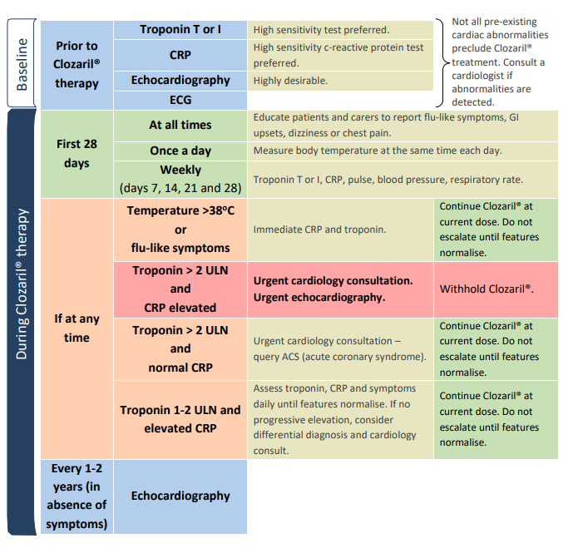

*Back to Table of Contents*

## Attachment C: Lester Tool

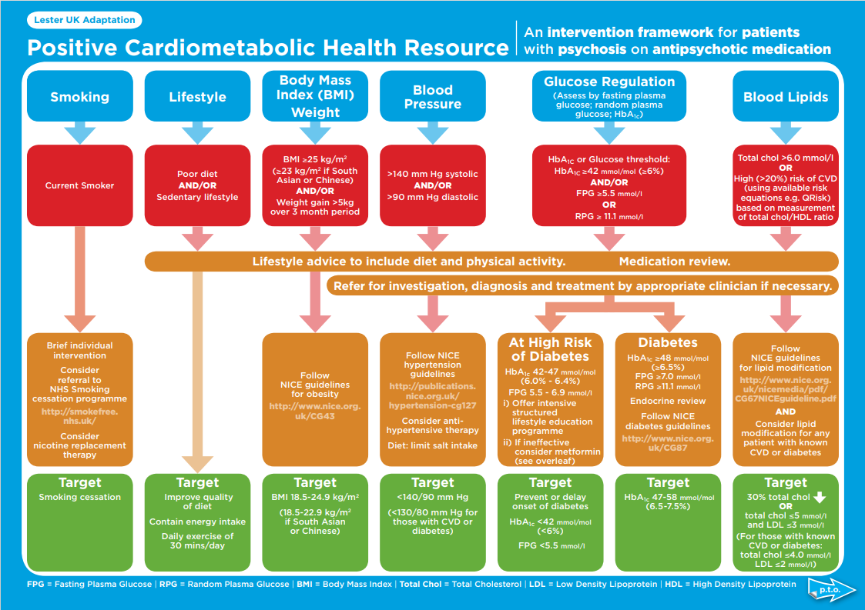

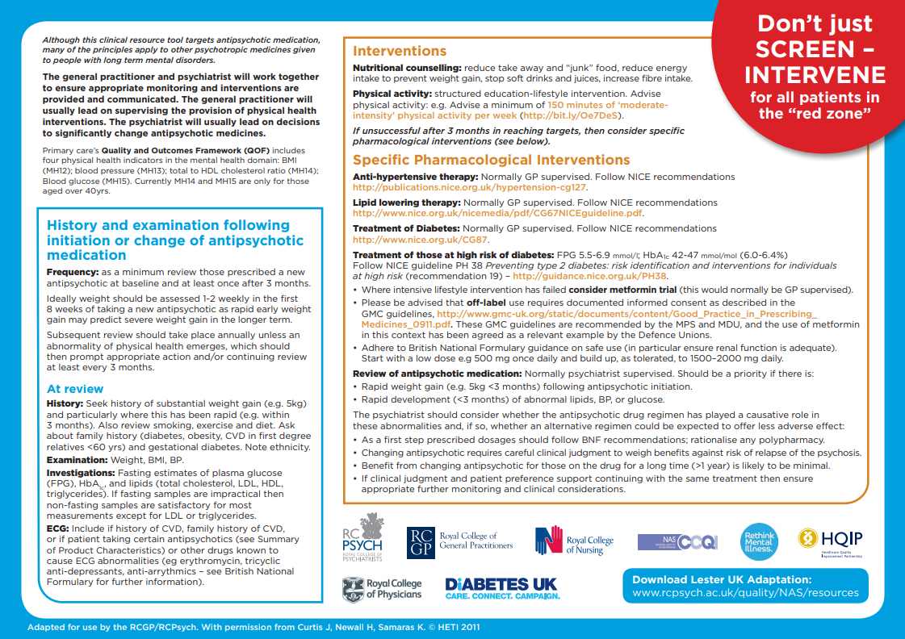

*Back to Table of Contents*

## Attachment D: Potential drug interactions with clozapine (Metro South Health Service District, Mental Health Services Shared Care Protocol,Health, 2016).

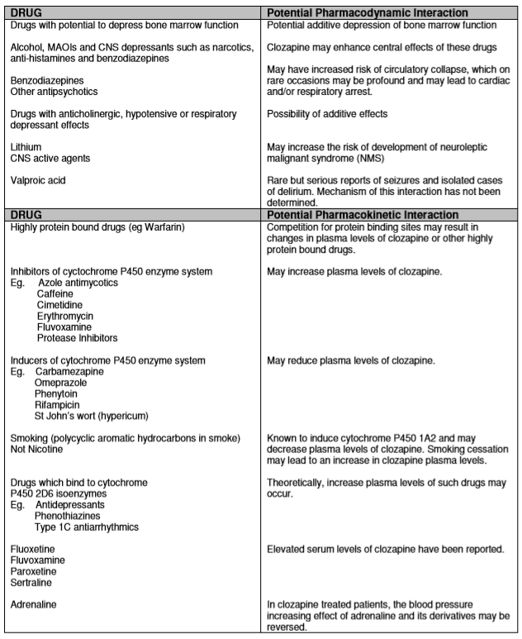

*Back to Table of Contents*

## 

## Attachment E: Porirua Protocol - adapted

**The Porirua Protocol**

When clozapine is initiated, all patients should be concurrently prescribed two tablets of docusate sodium with sennoside each night to prevent the onset of constipation.

Further management:

If the patient has not had a bowel movement for two days, increase the dose of docusate sodium with sennoside by one tablet in the morning and review the patient within 48 hours

* If the patient remains constipated, refer to GP or the Emergency Department. Consider impaction - if impacted, docusate sodium with sennoside should be stopped and the patient discussed with the mental health team and/or a gastroenterologist, manual dis-impaction and enemas may be required
* If not impacted, continue with two tablets of docusate sodium with sennoside, twice daily and review after 48 hours

If constipation persists, add one [polyethylene glycol (Movicol) sachet] twice daily and review the patient after 48 hours.

If the patient develops diarrhoea it may be appropriate to reduce the dose or withdraw treatment; close monitoring is essential to detect constipation

Image result for Little English Red-Flag **Red flags for constipation in patients taking clozapine that require urgent medical review:**

Moderate to severe abdominal pain which lasts for more than one hour

Any abdominal pain or discomfort which lasts for more than one hour with one of the following:

* Abdominal distension
* Diarrhoea, especially if bloody
* Vomiting
* Absent of high-pitched bowel sounds
* Haemodynamic instability
* An elevated white blood cell count
* Metabolic acidosis
* Additional signs of sepsis

*Back to Table of Contents*

## Attachment F : Clozapine pre-commencement checklist

|  |  |  |  |  |
| --- | --- | --- | --- | --- |
| **1st Stage – Pre-commencement** | Date/Time | Signature | Print Name | Designation |
| Documented trial of 2 anti-psychotic medications, and decision to commence clozapine is recorded in the medical record by the medical officer. |  |  |  |  |
| The decision to commence clozapine has been discussed with the relevant community team and documented in the medical record. Discussed with Dr …………………………………………………... |  |  |  |  |
| Participant/family has received printed information and counselling about clozapine, including the need for weekly blood tests and appointments. List those present at counselling session in electronic clinic record notes DHR. |  |  |  |  |
| Clozapine consent form is completed and signed by the participant/guardian (Note: form is to be uploaded to medical record). |  |  |  |  |
| Note: The treating community team should agree with the treatment plan and **have resources to adequately ensure compliance with medication and monitoring** |  |  |  |  |
| **2nd Stage Baseline Assessment** |  |  |  |  |
| **Blood Tests:** |  |  |  |  |
| Fating lipids, glucose, liver function test, troponin, CRP, blood group, white cell and neutrophil counts, electrolytes and renal function tests within 10 days prior to commencement Date taken ………. /……../…….. |  |  |  |  |
| **Observations:** |  |  |  |  |
| Record participant’s weight, height. BMI and baseline BP and HR. |  |  |  |  |
| **Medication review:** |  |  |  |  |
| Current medications reviewed for potential drug interactions |  |  |  |  |
| Pharmacy review |  |  |  |  |
| **Physical Co-morbidities:** |  |  |  |  |
|  |  |  |  |  |
|  |  |  |  |  |
| **Cardiac monitoring:** |  |  |  |  |
| Baseline electrograph (ECG): Date taken __ /__ /__ |  |  |  |  |
| QTc = _ _ _ (<450 males. <470 females) Other abnormalities ……………………………………………………………… |  |  |  |  |
| Baseline echocardiogram (ECHO) is required for all participants who have community commencement and all inpatients where possible. If unable to obtain a baseline echo, for inpatient services. Date taken _ _ / _ _/ _ _ Comment: …………………………………………………………………………………………………………..…………………………………………………………. |  |  |  |  |
| Chest x-ray if clinically indicated: YES/NO (e.g. clinically unwell, heart failure)  Date taken: _ _/ _ _/ _ _ Comment: ………………………………………………...………………………………………………………… …………….…. |  |  |  |  |

*Back to Table of Contents*

## Attachment G: AMHDS temperature monitoring at home agreement – print approved form agreement from forms register

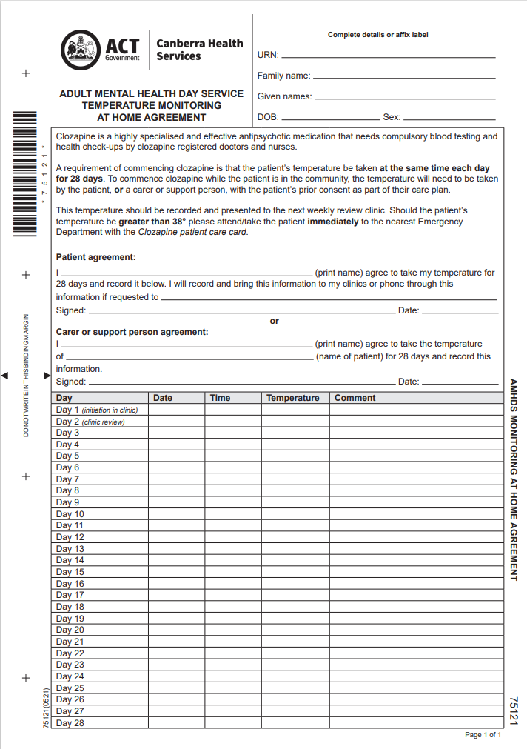

Sample

*Back to Table of Contents*

## Attachment H: GP clozapine initiation letter

GP/Practice address Team Address

**CLOZAPINE PATIENT**

Date:

Dear Dr

Patient Name: ……………………………………………………………….……………………………….…. DoB: ………/………. /…………...

Address: ……………………………………………………………………………………………………………………….…………………………………

Diagnosis: ……………………………………………………………………………………………………………………………………………………….

This letter is to inform you that the above patient has been initiated on/is on Clozapine, an S100 antipsychotic drug. Clozapine was initiated on …………/………. /………….. If managed correctly clozapine is a very effective drug. CHS staff monitor the patient’s FBC, BP, Troponin I/T with the initial titration. Ongoing supplies of the medication are wholly dependent on the results of the regular mandatory FBCs.

Sample

CHS requests ongoing physical health monitoring, or treatment such as management of metabolic syndrome, be done through primary care.

Primary care also needs to be aware of side effects of clozapine so that if they are reported to you or detected by you, they can be actioned (see table below).

**Change in Smoking Habit:** tobacco smoking significantly affects clozapine serum levels. NRT is not a substitute for the liver enzyme effects of tobacco smoking. Please contact your community Clinical Recovery Service (CRS) to plan smoking cessation if requested, as a dose reduction will be required.

Adverse Effects:

|  |  |  |  |
| --- | --- | --- | --- |
| Constipation/hypomotility | Awareness  Active open questioning  Regular self-monitoring (Bristol Stool Chart) | Often do not recognise or self-report  Consider long term laxatives e.g. Porirua Protocol  Contact CRS team | Occurrence up to 61%  Biggest cause of fatality with clozapine |
| Myocarditis/myopathy | Signs/symptoms: flu-like, tachycardia. Chest pain etc. | Immediate  Contact Psychiatrist, CRS, and cardiologist.  Send patient to the Emergency Department | Rare. Occurs mainly in 1st two months (myocarditis) or in 1st nine months (cardiomyopathy) |
| Blood dyscrasias | Awareness  Sore throat, fever, bruising | Immediate  Contact Psychiatrist, CRS | Mandatory monitoring by secondary care but patients may present between tests |

Possible adverse effects: neutropenia, leucocytosis, eosinophilia, weight gain, dysarthria, drowsiness, sedation, dizziness, postural hypotension, seizures, myoclonic jerks, movement disorders, hypersalivation (can cause aspiration pneumonia), benign hyperthermia, disturbances in sweating/temperature regulation, urinary incontinence/retention, neuroleptic malignant syndrome, pulmonary embolism/DVT etc.

Should you have any questions or concerns with this patient or their clozapine prescription, do not hesitate to contact either Dr …………………………………………………… or ……………………………………………… Clinical Recovery Service.

Yours sincerely,

*Back to Table of Contents*

## Attachment I: Nurse-led clinic workflow

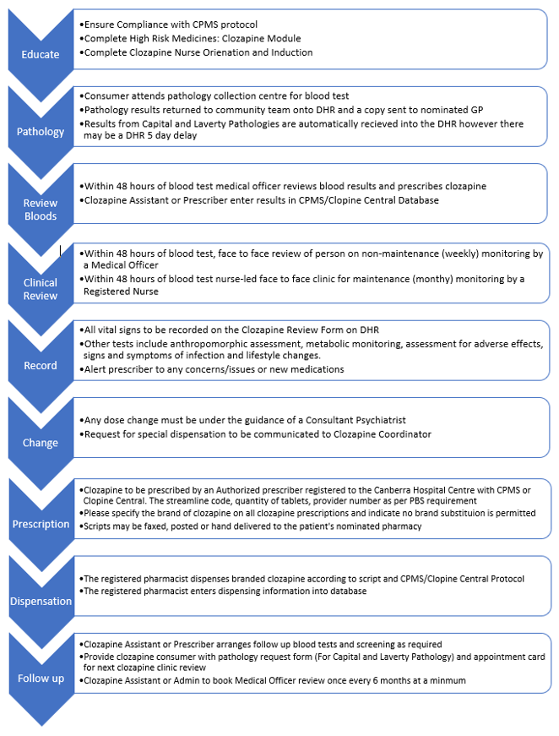

*Back to Table of Contents*

## Attachment J: Recommended AMHDS care pathway for weeks 1 to 4:

|  |  |
| --- | --- |
| **AMHDS Clinic Day** | **Recommended AMHDS Clozapine Care Pathway for weeks 1 to 4** |
| **Day 1**  **(Tuesday)** | Patient attends the day hospital in the morning and receives their first dose of clozapine.  Heart rate, temperature, and BP (observations) are taken before the first dose, 15 minutes after and then half-hourly thereafter for 2 hours and hourly for next 4 hours.  The patient stays at the day service all day.  A nurse special is to provide continuous visual observation of the patient in addition to the monitoring of vital and neurological signs (Cheshire and Wirral NHS, 2018**)**.  Emergency numbers are provided to the patient and carer.  The patient is accompanied home by a carer/ relative or healthcare worker.  AMHDS clinic nurse to add patient to Clozapine Team in DHR pool. Add Clozapine Alert in Flags in DHR. |
| **Day 2**  **(Wednesday)** | Patient attends the day hospital in the morning and has observations attended before receiving their clozapine dose. Observations should be recorded in DHR at 2 and 6 hours after the clozapine dose.  The patient stays at the day hospital all day.  The patient is accompanied home by a carer/ relative or healthcare worker. |
| **Day 3**  **(Thursday)** | Patient attends the day service in the morning and has observations attended prior to receiving their clozapine dose. The patient may leave the day service should they wish but must return for observations 6 hours after receiving their clozapine dose.  Patients who may be experiencing side effects should not leave the day service. |
| **Day 4**  **(Friday)**  **Dose must not be increased over the weekend.** | Patient attends the day hospital in the morning and has observations attended prior to receiving their clozapine dose.  The patient returns for observations 6 hours after receiving their clozapine dose and is provided with a weekend supply of clozapine, emergency phone numbers and phone number for AMHRU.  Pathology form to be given to patient /request order in DHR for bloods on Day 7. |
| **Day 5 & 6**  **(Saturday & Sunday)** | Patient to self-administer medication. Temperature to be taken by patient and to be phoned through to AMHRU Nurse in Charge (NiC).  NiC records temperature in DHR Flowsheets and notes. |
| **Day 7**  **(Monday)**  **Bloods- review -script** | Full blood count and troponins to be attended in the morning.  Patient attends AMHDS in the morning and has observations attended prior to receiving their clozapine dose.  Patient to be reviewed by the medical officer and dosage separated if indicated.  Script written and taken to UCH pharmacy by clinic nurse – clozapine stored in medication room.  The patient may leave the day hospital should they wish but must return for observations 6 hours after receiving their clozapine dose.  Should dosage be split into BD, the patient should be provided with evening dose to self-administer. |
| **Day 8 – 10**  **(Tuesday to Thursday)** | Patient attends the day hospital in the morning and has observations attended prior to receiving their clozapine dose. The patient may leave the day hospital should they wish but must return for observations 6 hours after receiving their clozapine dose. The patient should be provided with evening dose to self-administer. |
| **Day 11**  **(Friday)** | Patient attends the day hospital in the morning and has observations attended prior to receiving their clozapine dose and doses for the weekend.  Pathology form to be attended as order in DHR /given to patient for bloods on day 14.  Patient self-administers evening medication. |
| **Day 12 & 13**  **(Saturday & Sunday)** | Patient to self-administer medication.  Temperature to be taken by patient phoned through to AMHRU NiC.  NiC records temperature in DHR Flowsheets and notes. |
| **Day 14**  **(Monday)**  **Bloods- review -script** | Patient attends pathology - full blood count and troponins to be attended in the morning.  Patient attends the day hospital in the morning and has observations attended prior to receiving their clozapine dose.  Patient to be reviewed by the medical officer within 48 hours of pathology and dosage separated if indicated.  Script written and taken to UCH pharmacy by clinic nurse.  Medication to be provided to patient for day 15 evening and days 16-18. |
| **Day 15- 17**  **(Tuesday to Thursday)** | Patient to self-administer medication and phone through temperature to AMHDS clinic nurse.  AMHDS clinic nurse to phone patient once per day (minimum) to assess for any adverse reactions and temperature reading.  In the event of any adverse reaction or signs or symptoms of infection, clinic nurse to contact prescriber and request patient to come in to be reviewed ASAP or attend the Emergency Department if appropriate. |
| **Day 18**  **(Friday)** | Patient attends the day hospital in the morning and has observations attended prior to receiving their clozapine dose.  Pathology form to be attended as order in DHR /given to patient for bloods on day 21.  Consider norclozapine levels depending on titration schedule if 200-300 mg/day reached.  Medication to be provided to patient for day 19 evening and days 20-21. |
| **Day 19-20**  **(Saturday & Sunday)** | Patient to self-administer medication.  Temperature to be taken by patient and to be phoned through to AMHRU NiC.  NiC records temperature in DHR Flowsheets and notes. |
| **Day 21**  **(Monday)**  **Bloods- review -script** | Full blood count and troponins to be attended in the morning.  Consider norclozapine levels depending on titration schedule if 200-300 mg/day reached.  Patient attends AMHDS in the morning and has observations attended prior to receiving their clozapine dose. Patient to be reviewed by the medical officer.  Patient to be reviewed by the medical officer within 48 hours of pathology and dosage separated if indicated.  Script written and taken to UCH pharmacy by clinic nurse.  Patient to self-administer evening dose. |
| **Day 22- 24**  **(Tuesday to Thursday)** | Patient to self-administer medication and phone through temperature to AMHDS clinic nurse.  Clinic nurse to phone patient once per day to assess for any adverse reactions or signs of infection.  Consider norclozapine levels depending on titration schedule if 200-300 mg/day reached. |
| **Day 25**  **(Friday)** | Patient attends AMHDS has observations attended prior to receiving their clozapine dose.  Pathology form given to patient for bloods on day 28.  Medication to be provided for day 25 evening and days 26-27  AMHDS clinic nurse provides preliminary ISBAR handover and monitoring schedule, including any forward booked tests and appointments, to CRS clozapine assistant in anticipation of transfer to CRS clozapine clinic. |
| **Day 26-27**  **(Saturday & Sunday)** | Patient to self-administer medication.  Temperature to be taken by patient and to be phoned through to AMHRU NiC.  NiC records temperature in DHR Flowsheets and notes. |
| **Day 28**  **(Monday)**  **Bloods- review -script** | Full blood count and troponins to be attended in the morning.  Patient to be reviewed by the medical officer**.**  Consider norclozapine levels depending on titration schedule if 200-300 mg/day reached.  If further titration is not required, patient is given ongoing supply of medication and pathology form for FBC with “rule 3 exemptions” in DHR.  Script written and taken to UCH pharmacy/community pharmacy by clinic nurse.  Review of booked appointments and contact list provided again. Encourage use of diary to schedule test and clinic appointments.  Provide appointment card to patient for their next medical office review and clozapine clinic in CRS community team.  AMHDS clinic nurse to provide final ISABAR handover and complete documentation for episode of care.  Ensure patient’s clinical manager or primary team have included clozapine therapy in DHR *Care Plan* and this has been discussed with the patient and/or carer guardian. |

*Back to Table of Contents*

## 

## Attachment K: Physical health in care plan (clozapine therapy)

| **Person’s Recovery Goal- Physical Health**  **Clozapine Therapy** | **Date added** | **Supports to help the person achieve their goals** | **Person(s) Responsible** | **By When** | **Action Taken and by whom** |
| --- | --- | --- | --- | --- | --- |
| **Maintain a regular routine for blood tests and having health checks**  (Clozapine in rare cases can lower the amount of white blood cells which are important in fighting infection) |  | * The doctor/clozapine assistant (nurse) will give me a blood test form * My clinical manager or clozapine assistant (nurse) will help me manage my appointments | * I will attend ACT Pathology or a blood testing centre for the test within 48 hours of seeing the doctor for my 4 weekly Complete Blood Examination (CBE) blood test * The blood test is weekly during first 18 weeks * I understand a blood test may need to be done more often if the test result is too low or I become unwell * I will book appointments with the clozapine doctor or nurse-led clinic ahead of time * I need to take the prescription to the pharmacy as soon as possible as this is an important part of the cycle (or my clozapine assistant (nurse) will deliver this to the pharmacy) * I need to tell the doctor/nurse how many tablets I have left at home and if I am missing doses * IMPORTANT: If I have a sore throat, fever (temperature over 38 degrees) or flu-like symptoms I need to see the doctor and may need extra blood tests |  |  |
| **Maintain health and fitness**  (Heart disease in rare cases can cause swelling and/or enlargement of the heart) |  | * Each visit the doctor/nurse will check my heart rate, temperature and BP * The doctor will give me a form for the ECG & ECHO each year that will be bulk billed (free) | * Every year I will have an echocardiogram (ECHO) & electrocardiogram (ECG)   IMPORTANT: If I experience chest pain, fast/irregular heartbeat or breathing problems I need to see the doctor and/or go to the hospital Emergency Department  NOTE: I need to tell health staff in ED or medical hospitals that I am on clozapine therapy |  |  |
| **To get the best effect of the medication with as few side effects as possible.**  (It is important to maintain stable levels of clozapine in the blood to help decide the best dose of medication) |  | * The doctor will give me a form for the test at least every 6 months * The test needs to be done about 12 hours after the last clozapine dose | * I will take clozapine consistently and as prescribed   IMPORTANT: I need to tell the doctor/nurse if I:  - stop or start smoking  - change how much I use caffeine or energy drinks  - start or stop new medication  - STOP taking clozapine or miss the dose for more than 2 days (48 hours)  - feel dizzy, drowsy or have a seizure see the doctor and/or go to the hospital Emergency Department   * As part of the routine monitoring requirement every 6 months I will see the specialist psychiatrist to review my progress and change the dose if needed so I can get the best out of life. My clinic clozapine assistant (nurse) will organise this. |  |  |
| **To know what the side effects are and keep them manageable**  (Side effects can include:   * Constipation, * increase in weight that can lead to diabetes * urinary incontinence * excess salivation |  | * The doctor/nurse will give me a form to have a blood glucose level and possibly an HbA1C (diabetes test) and cholesterol check every 6 months usually with the clozapine level. Other tests are done at this time to check electrolytes (kidney & liver), Troponin (heart) and C-RP (infection) * The doctor/nurse will weigh me and measure my waist to get a Body Mass Index (BMI) * The doctor may refer me to a nurse, diabetes educator dietician, podiatrist or a lifestyle program * The pharmacist can answer some questions and give advice | I will:   * Eat a healthy high-fibre diet * Drink at least 2 litres of water daily (and keep soft drinks and alcohol to a minimum) * Clean my teeth morning and night * Exercise regularly * Reduce or quit smoking and inform my doctor/nurse of any changes in my smoking habits * Tell the doctor/nurse if side effects are a problem as there may be ways to manage this (e.g. Kwells may be recommended for excess salivation)   IMPORTANT: I need to tell the doctor about any:   * constipation that is painful, belly pain, cramping and unable to pass wind * trouble passing urine or passing large amounts |  |  |

*Back to Table of Contents*

## Attachment L: Inpatient unit clozapine initiation flowchart

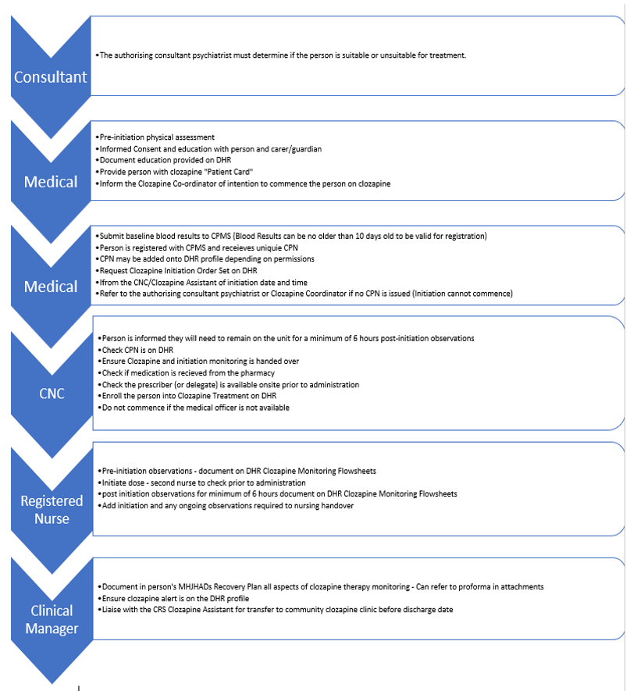

*Back to Table of Contents*

## Attachment M: Minimum recommended monitoring and test schedule 9

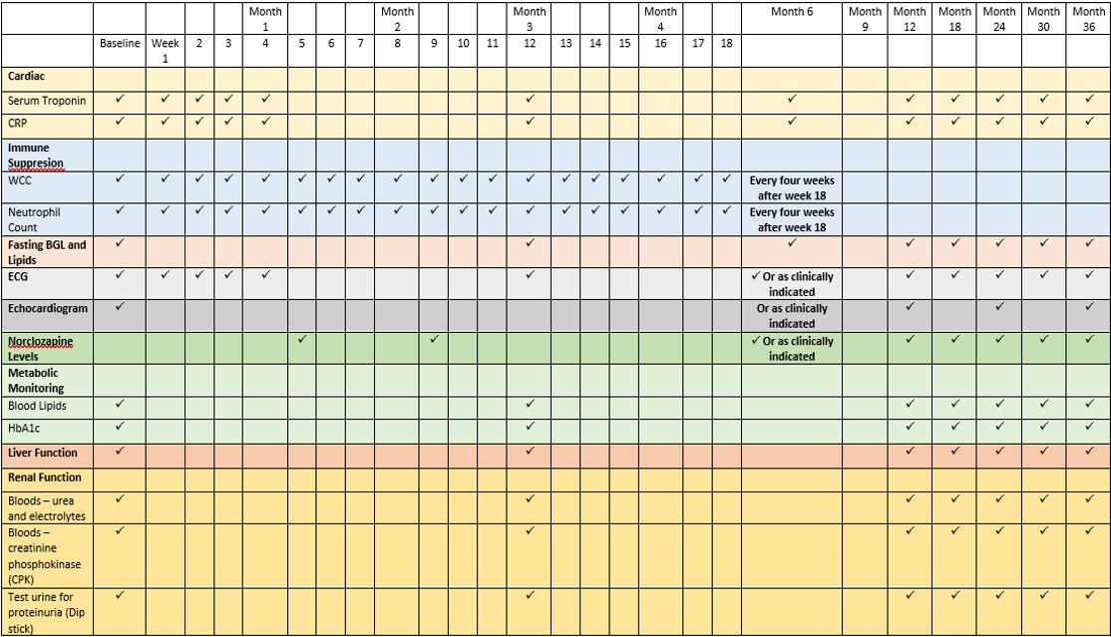

*Back to Table of Contents*

## Attachment N: Clozapine patient care card

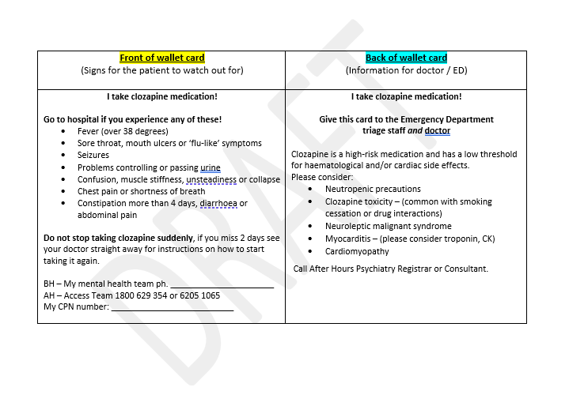

*Back to Table of Contents*

## Attachment O: Charter of Health Care Rights

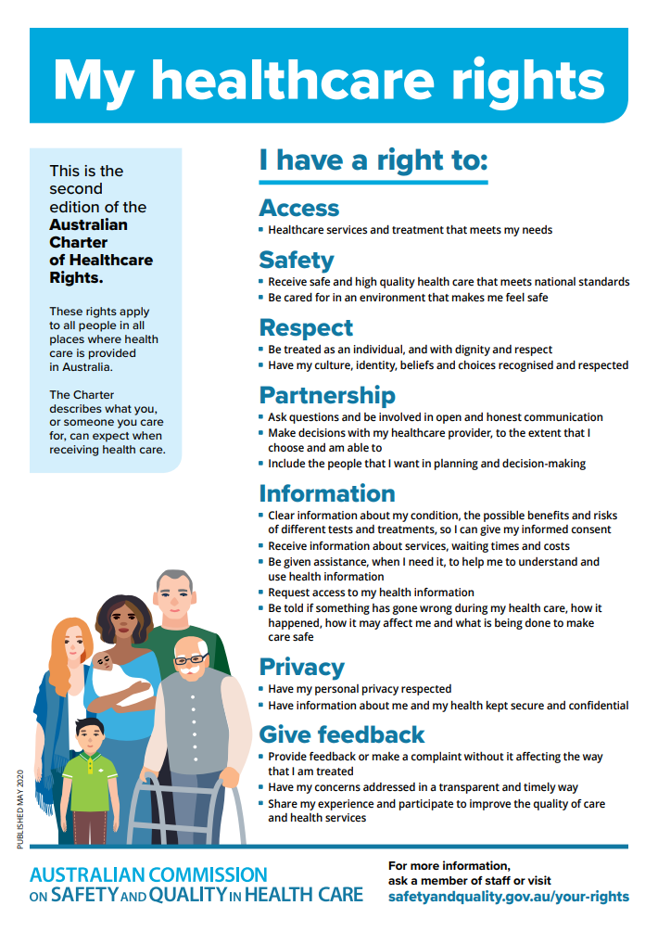

*Back to Table of Contents*