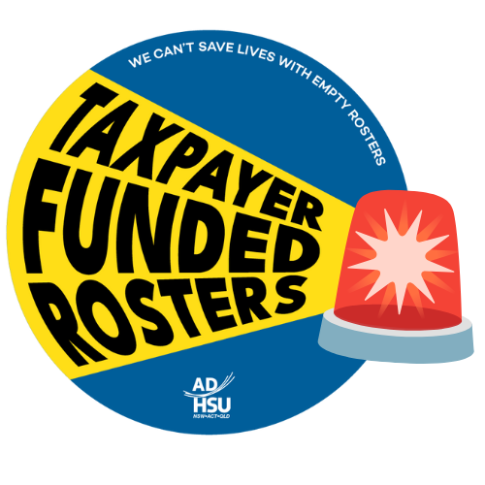**Suggested slogans for**

**Taxpayer Funded Rosters**

**chalking**

* Staff Shortages are Executive Choices #ADHSU
* We Can’t Save Lives with Empty Rosters #ADHSU
* Lives Over Budgets - Fix the Rosters Now! #ADHSU
* Budget-Driven Cuts, Life-Threatening Delays #ADHSU
* Understaffed by Executives, Overburdened by Emergencies #ADHSU
* This Emergency Ambulance is a *insert suburb* resource
  + You can take a picture of the chalked ambulance next to a landmark in another area!

